

DXC RealTime Projects

AZ-900, DP - 203



June 10, 2022

DXC TECHNOLOGY PVT.LTD.

Name: SUPRIYA BHARATHA

Reg No: DXCAB1211

**Project 1 Name: Smart Vehicles**

Date: 10th JUNE 2022

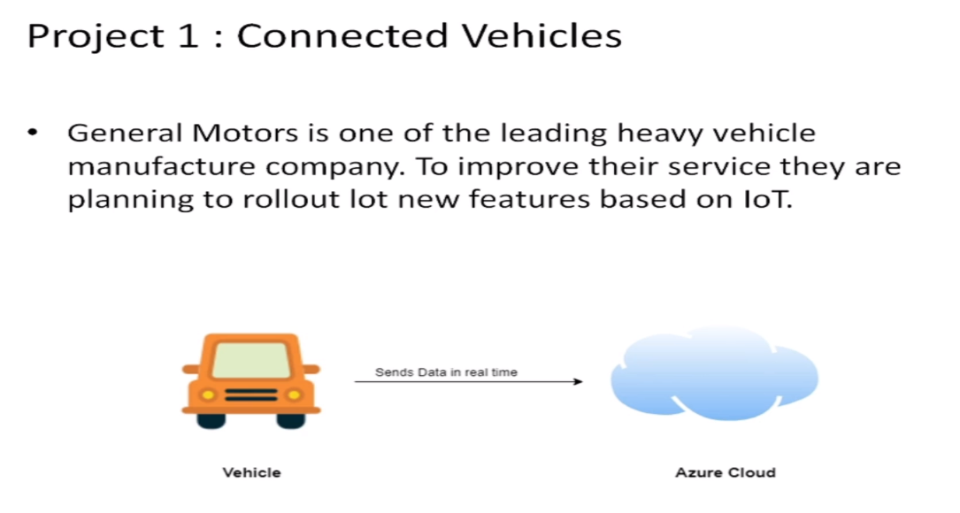

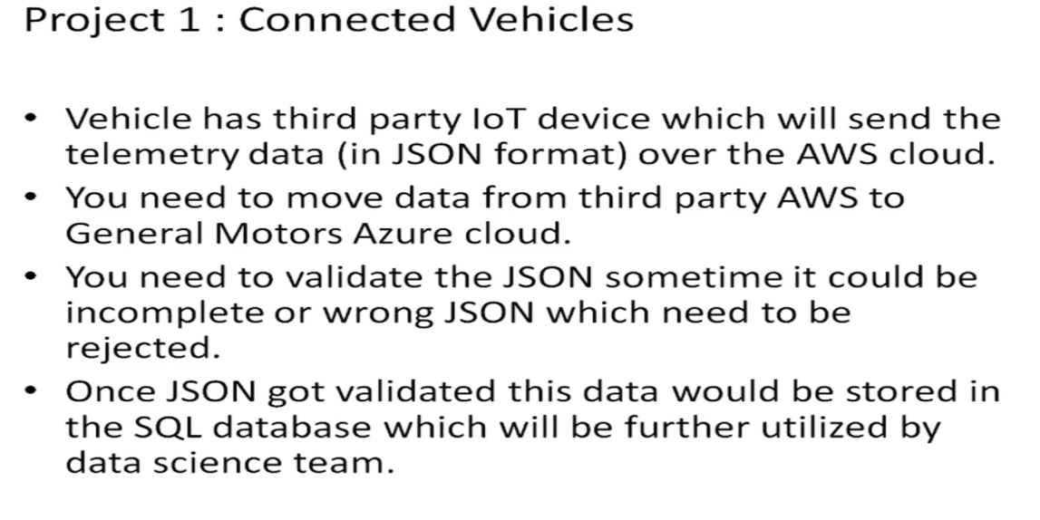

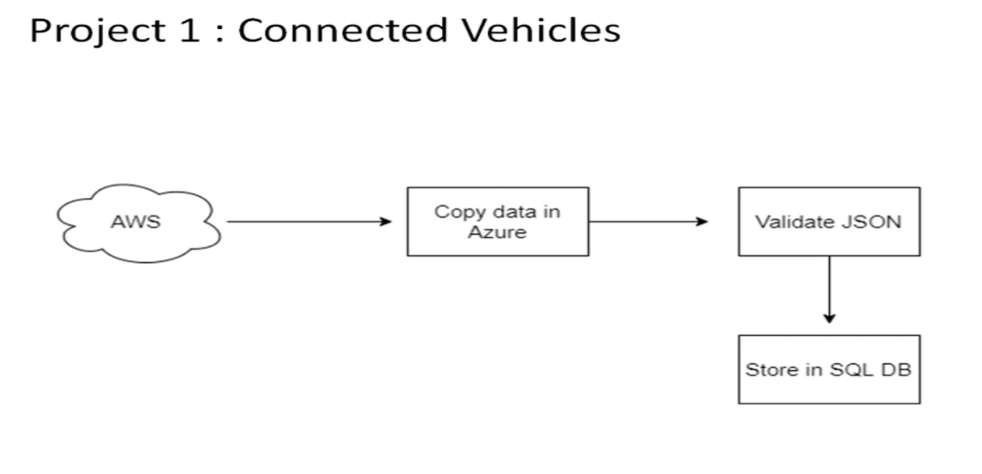

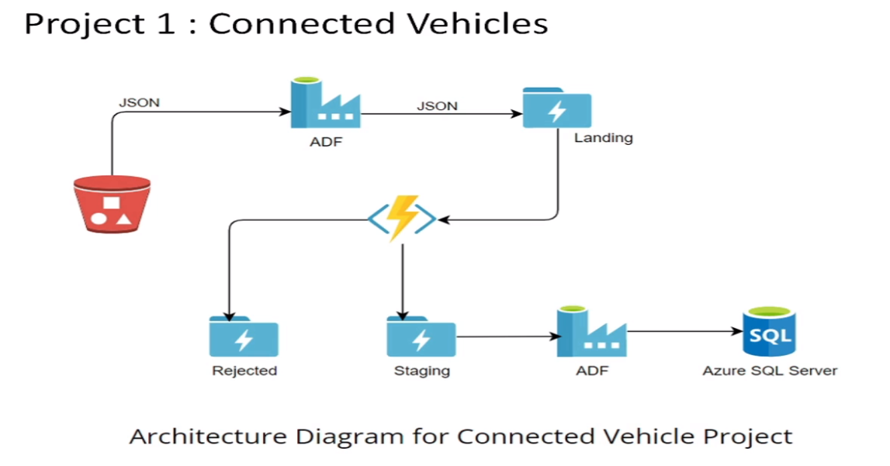

* **Practical Lab: Create Azure Data Factory Account For Data pipelines**

**STEP 1:** Go to azure portal and search for data factories and open select it.

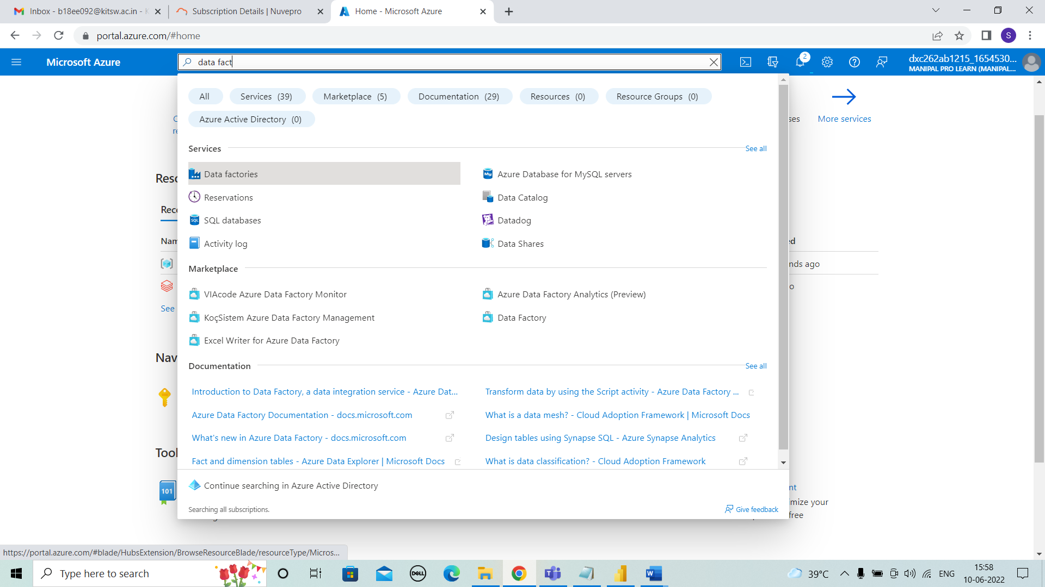



**STEP 2:** After selecting azure portal ,click on “+ create” for creating datafactory.

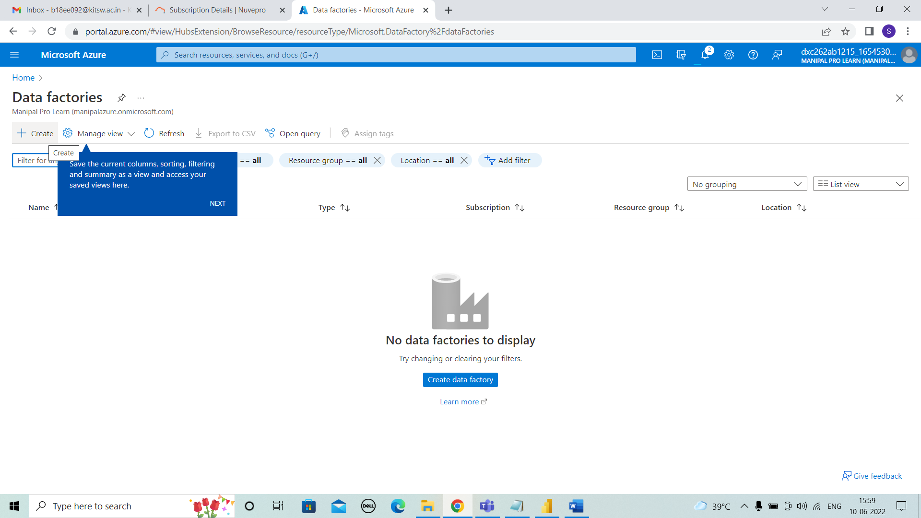



**STEP 3:** Here, we have give the details of resource group , Name ,version we used. Then next to git configuration.

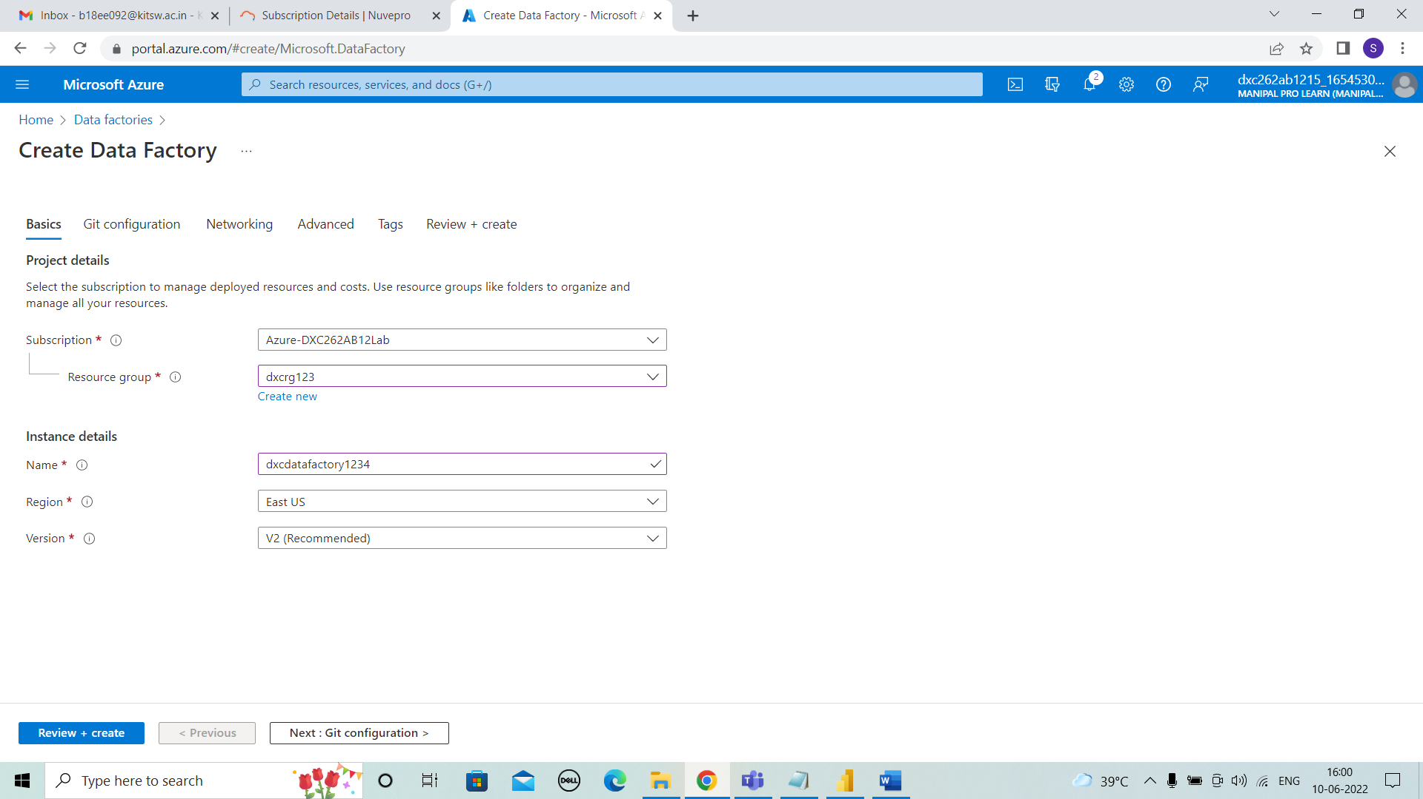



**STEP 4:** The details should be as shown in image for git configuration. Then, next to review+create.

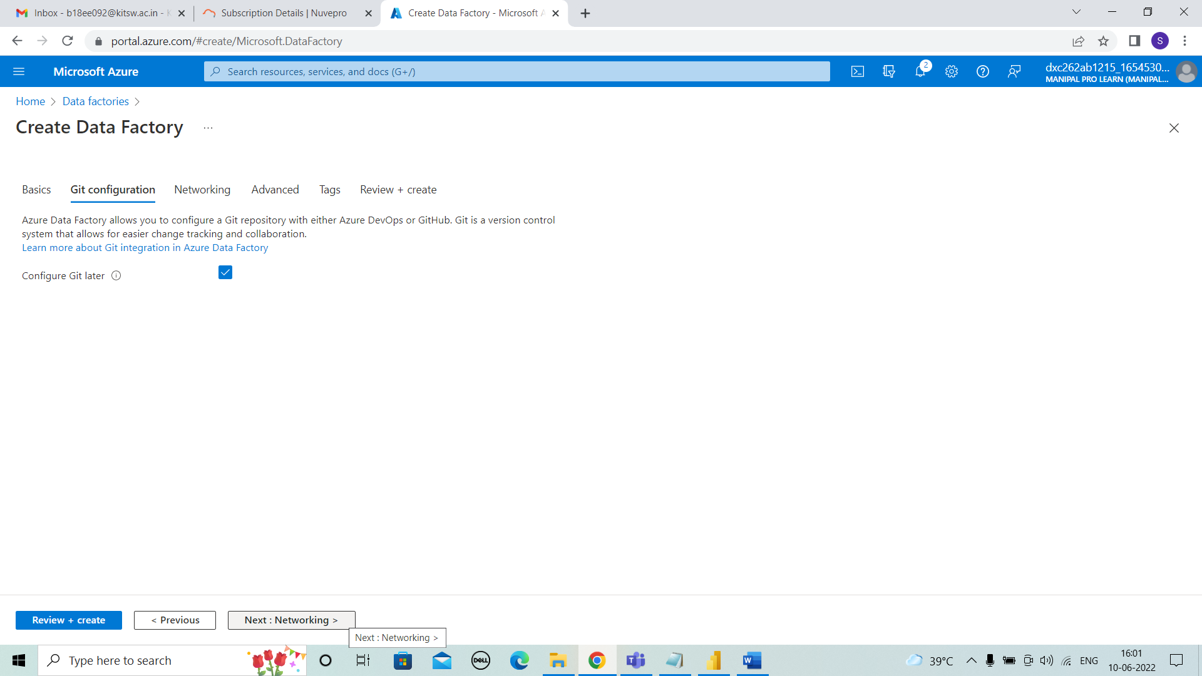



**STEP 5:** In review + create we need check and click on create below.

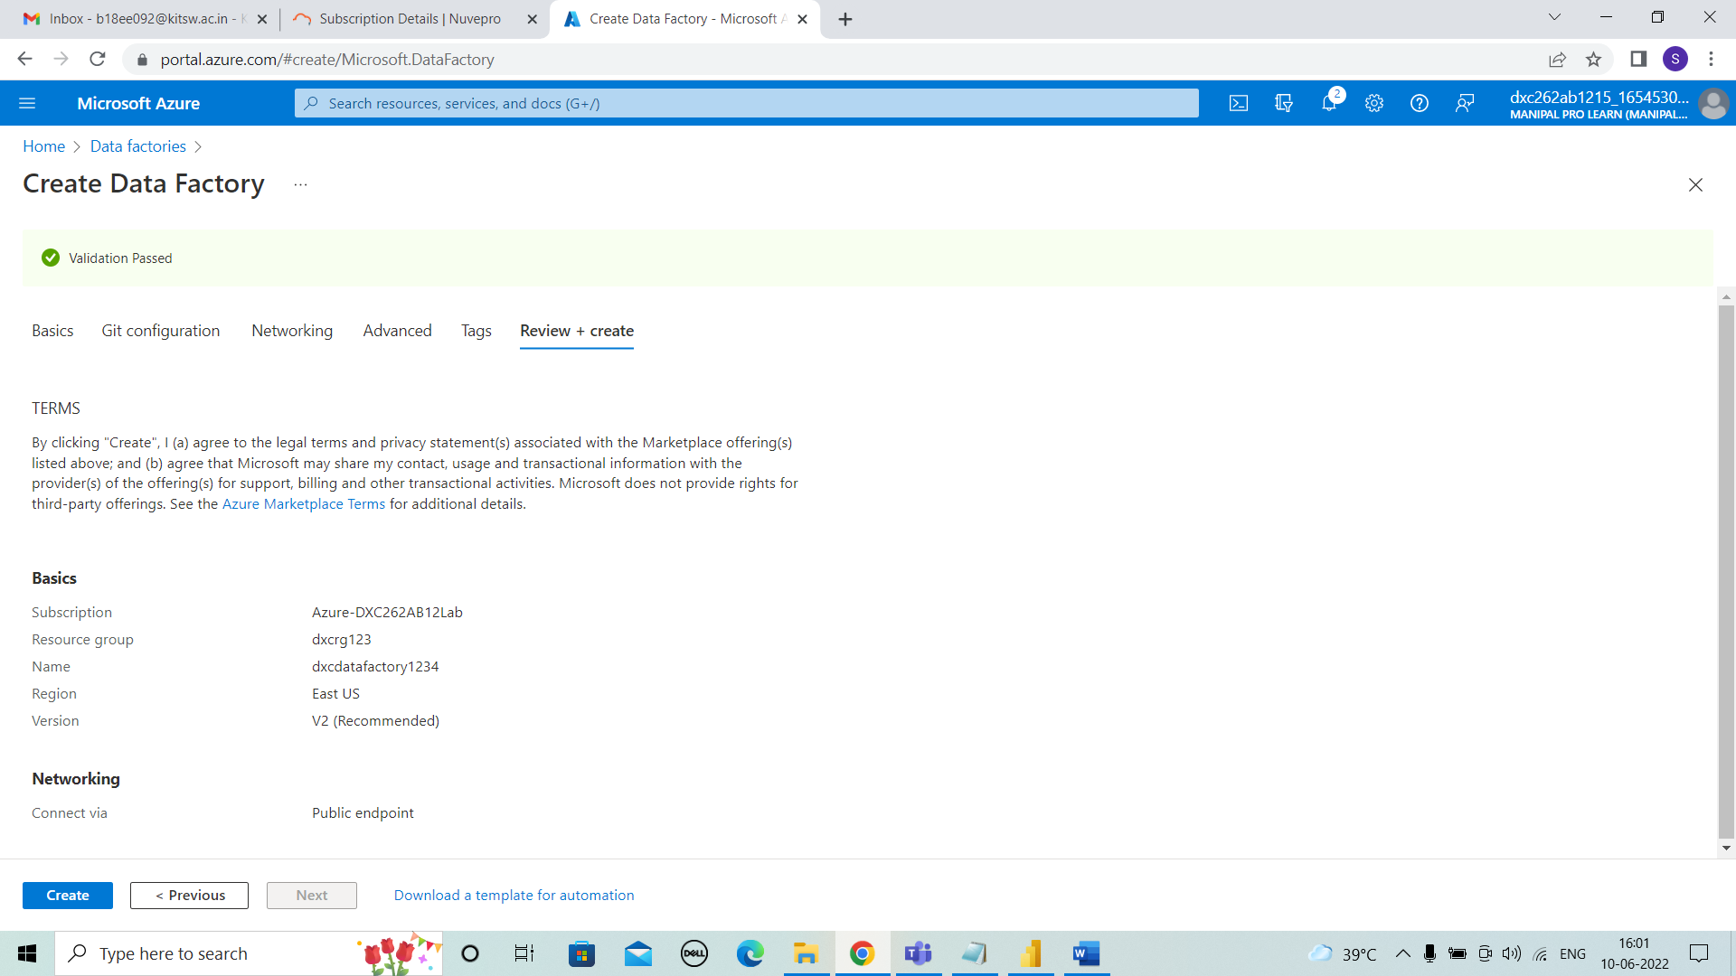



**STEP 6:** After clicking on create, deployment will be in progress.

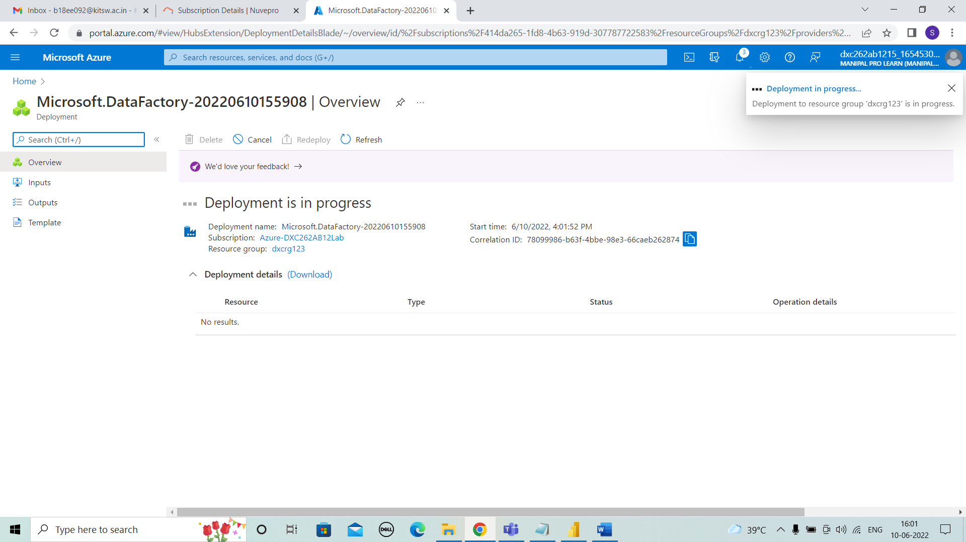



**STEP 7:** After few seconds or minutes the deployment is completed.

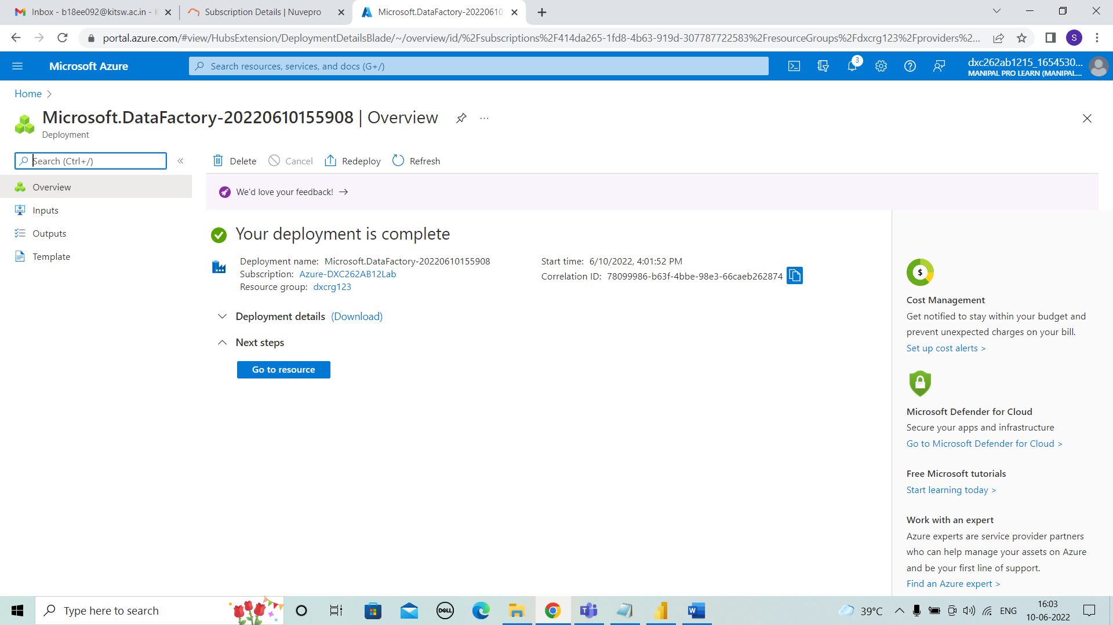



**STEP 8:** In resources , open azure data factory studio.

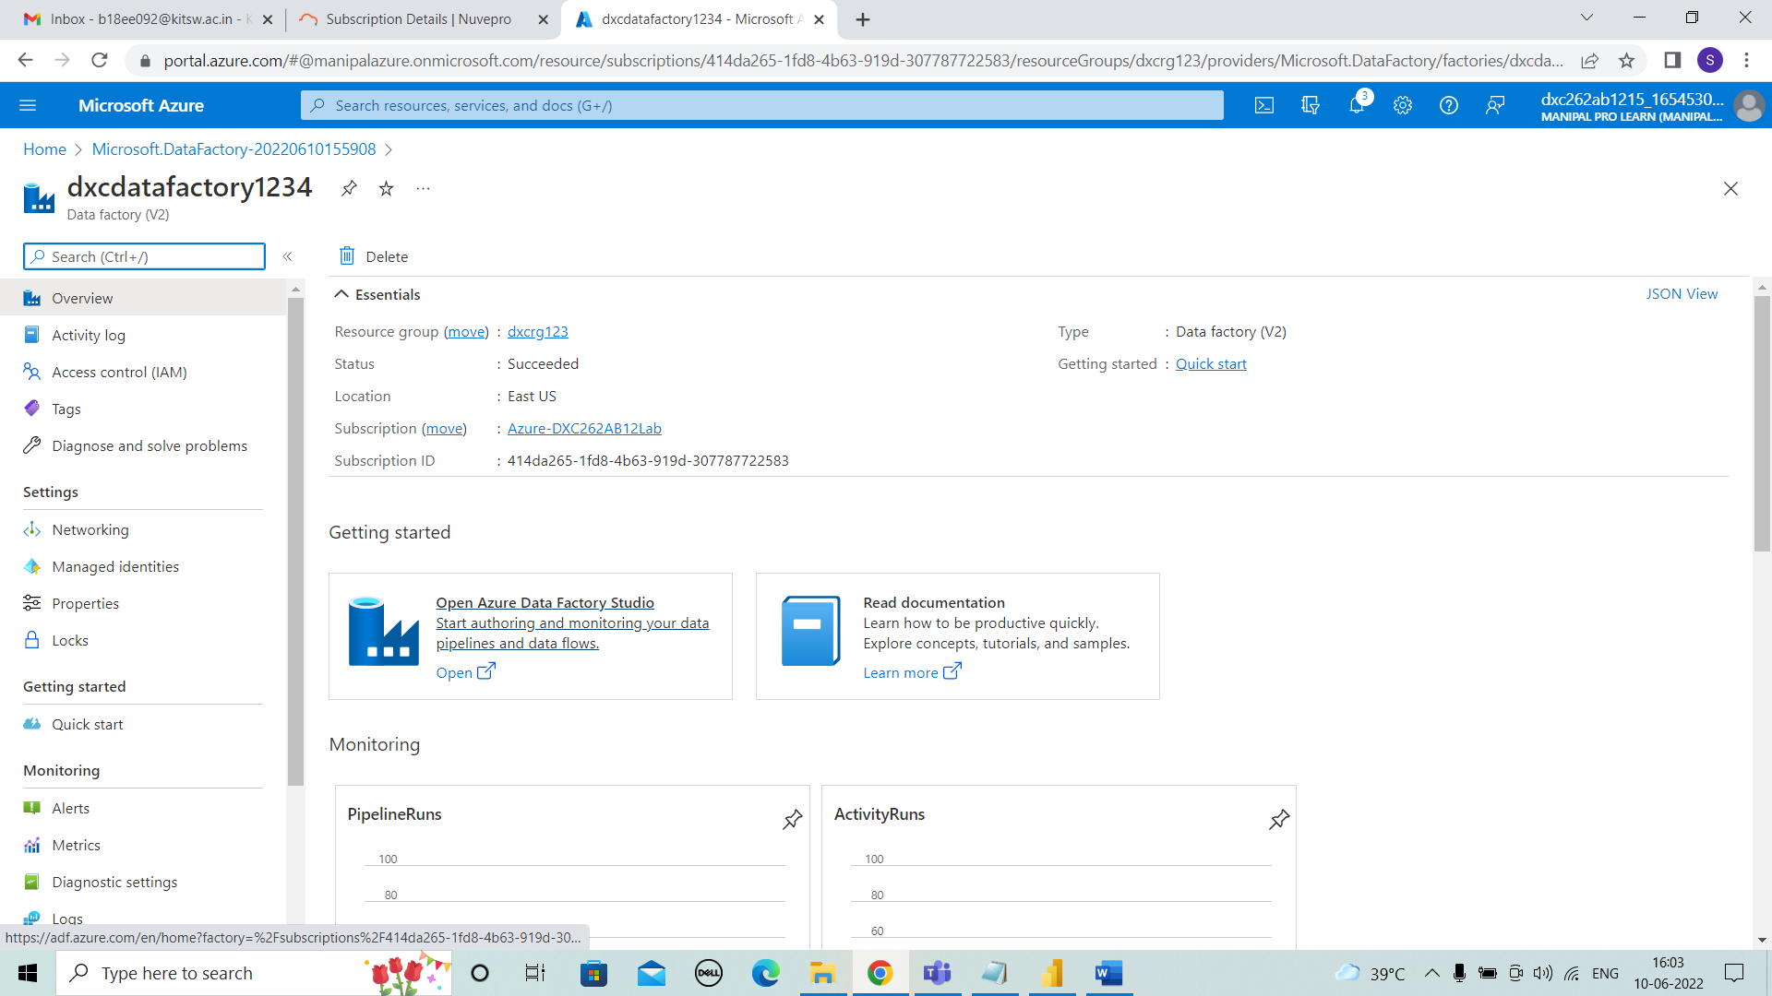



**STEP 9:** After opening data factory new tab, enter into ingest which is shown below.

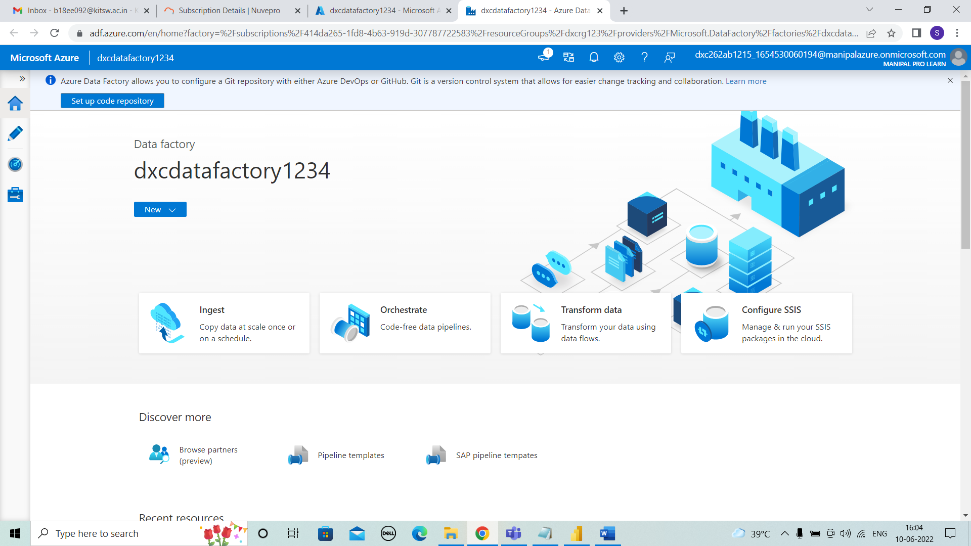



**STEP 10:** CREATING STORAGE

Search for Storage accounts and select it.

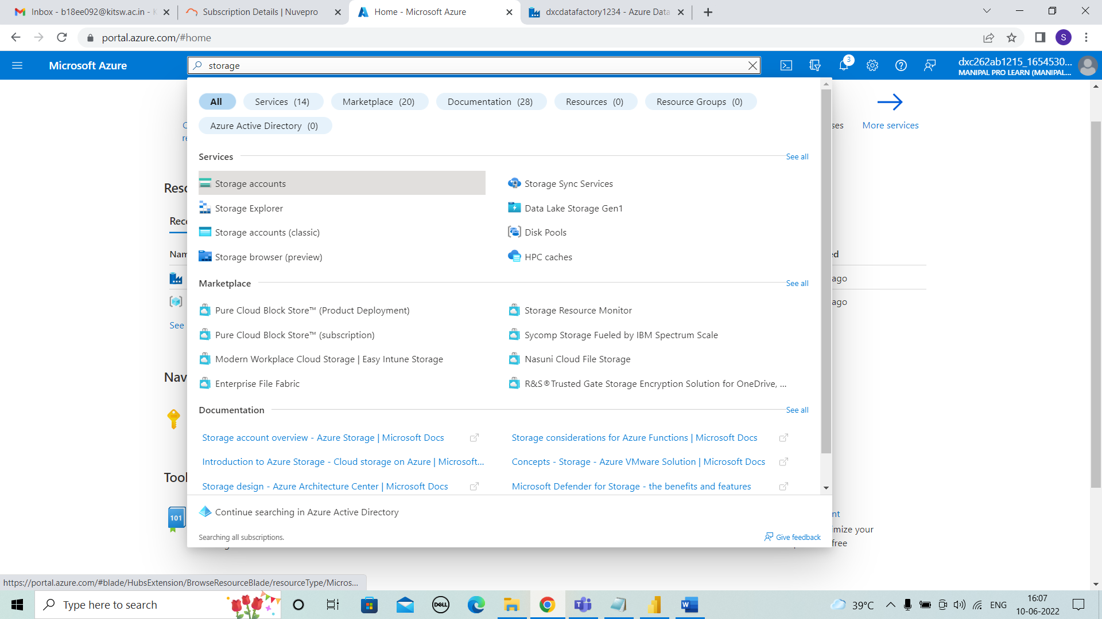



**STEP 11:** After entering into storage account click on “+ create” .

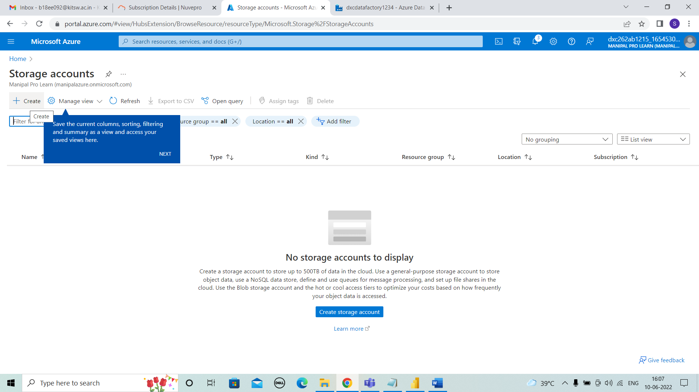



**STEP 12:** For creating we need to give the basic details of resource group, storage account name . Then, next to review+create.

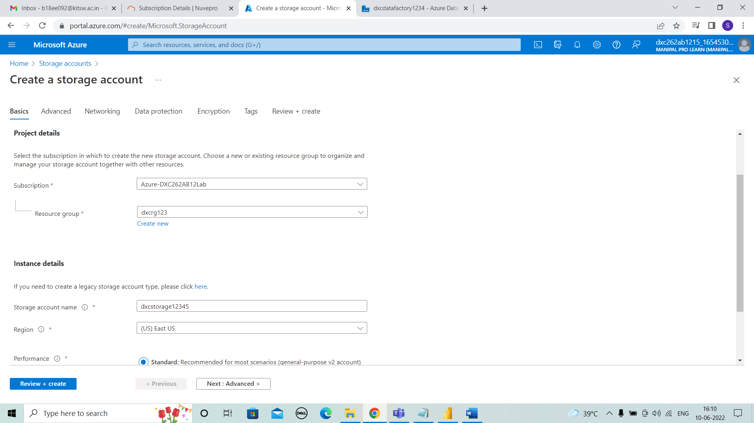



**STEP 13:** In review + create the validation is passed and then click on create.

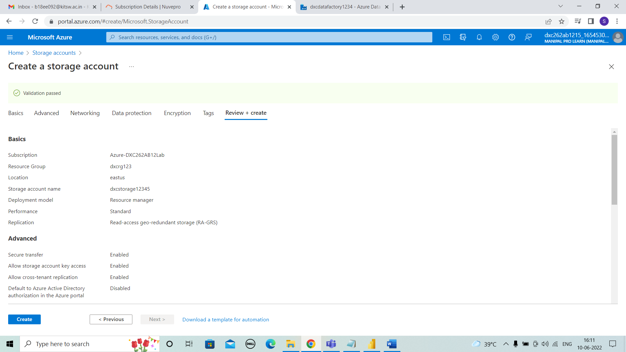



**STEP 14:** After create the deployment will be in progress.

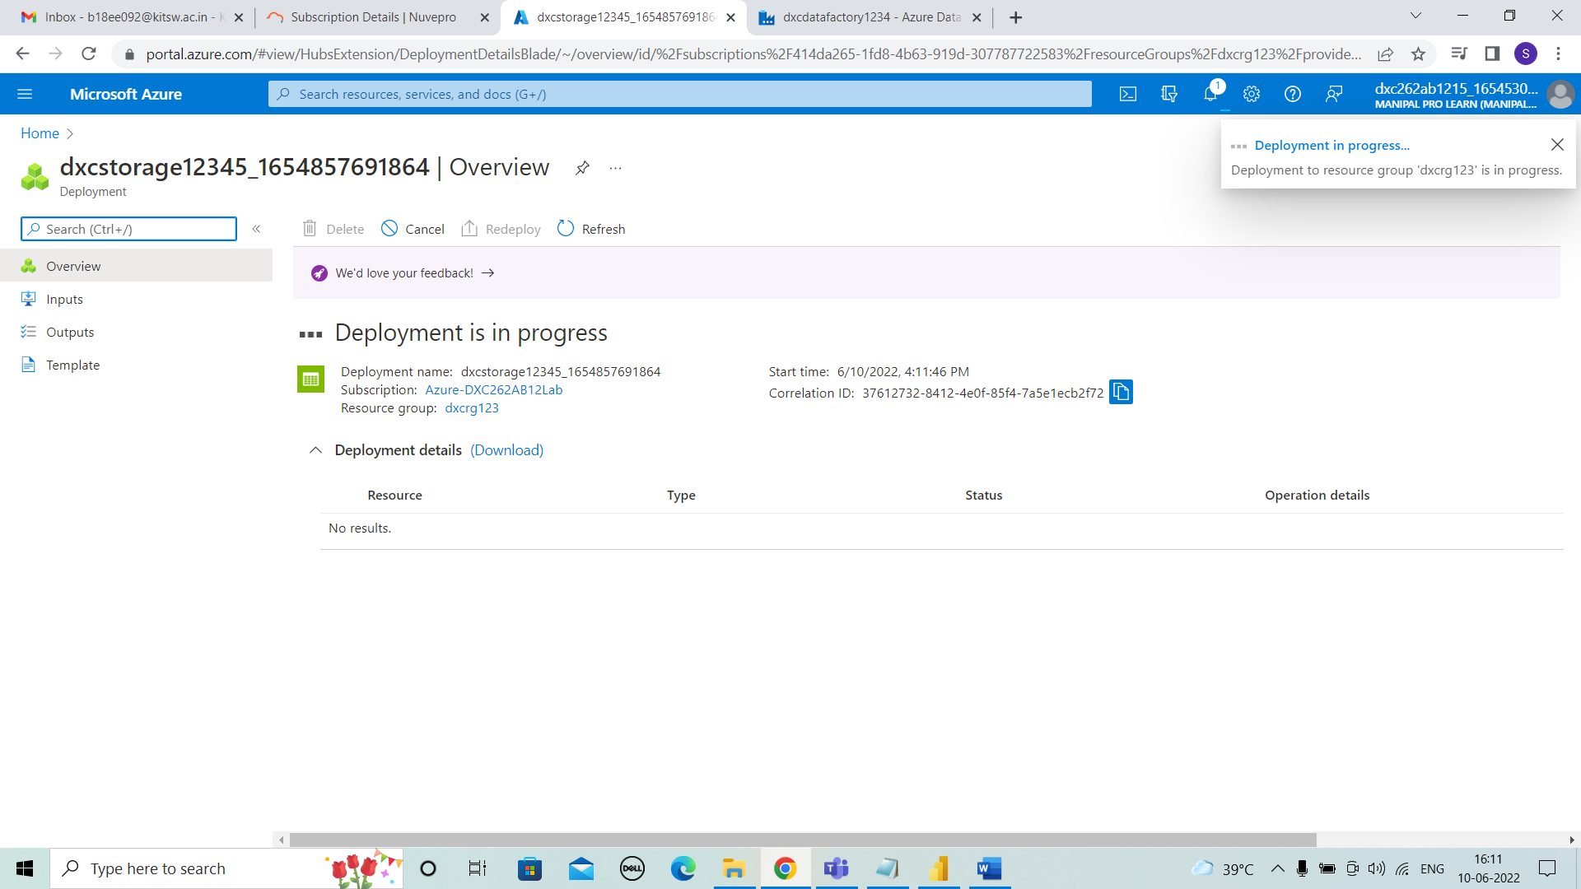



**STEP 15:** After few minutes the deployment is completed and proceeded. Then enter go to resource.

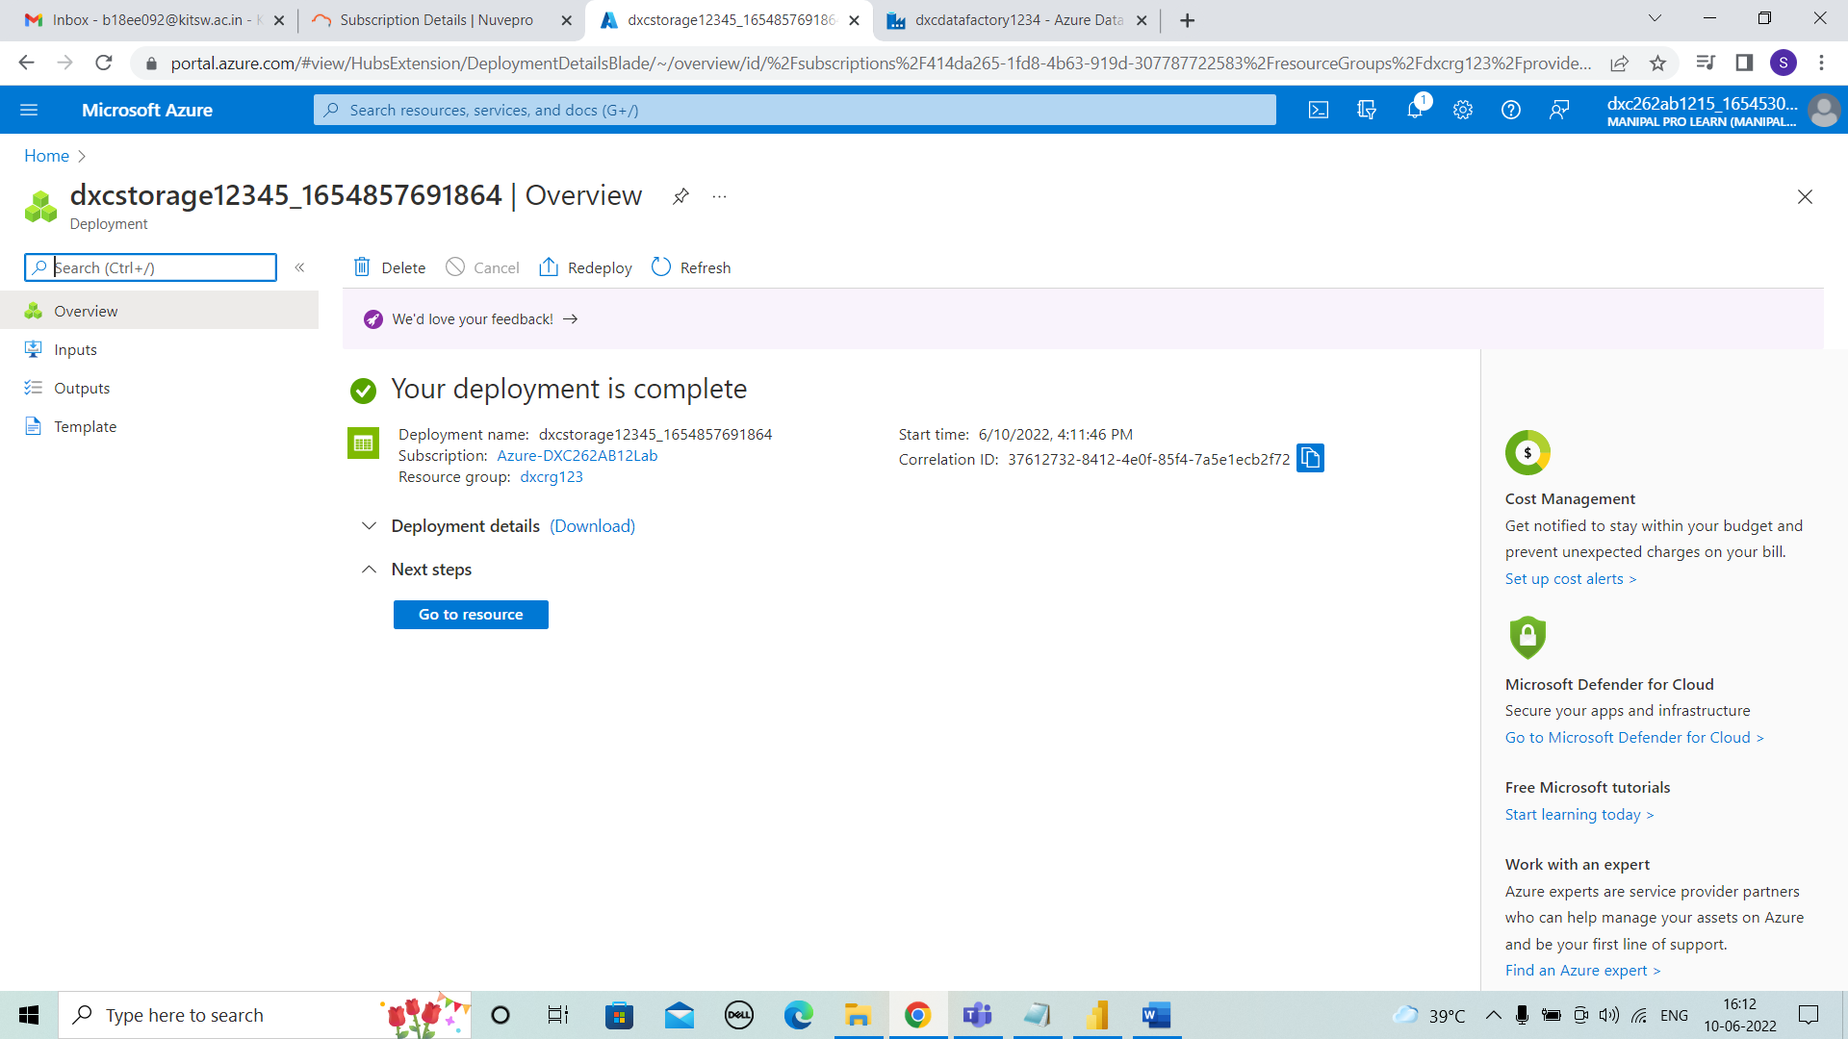



**STEP 16:** Here, the overview is appeared.

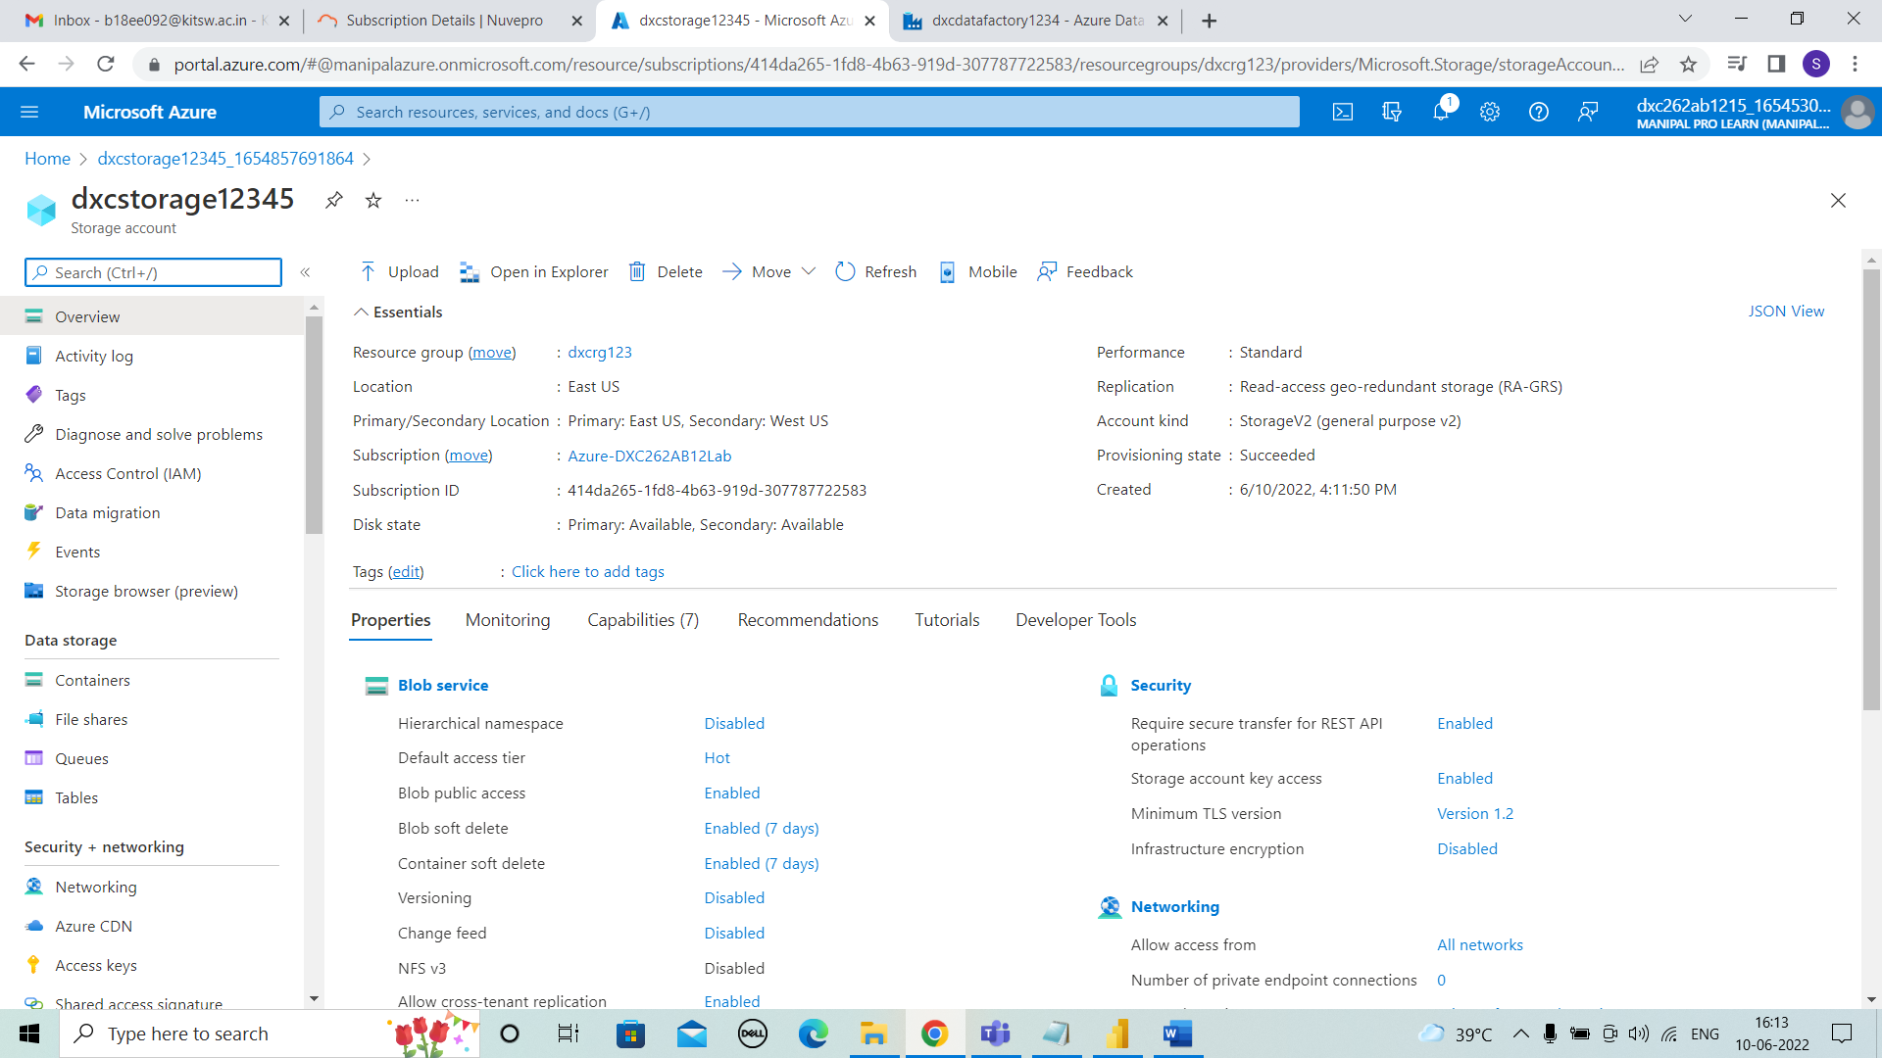



**STEP 17:** To create containers ,we select containers on left side. To add new containers we use “+ container”.

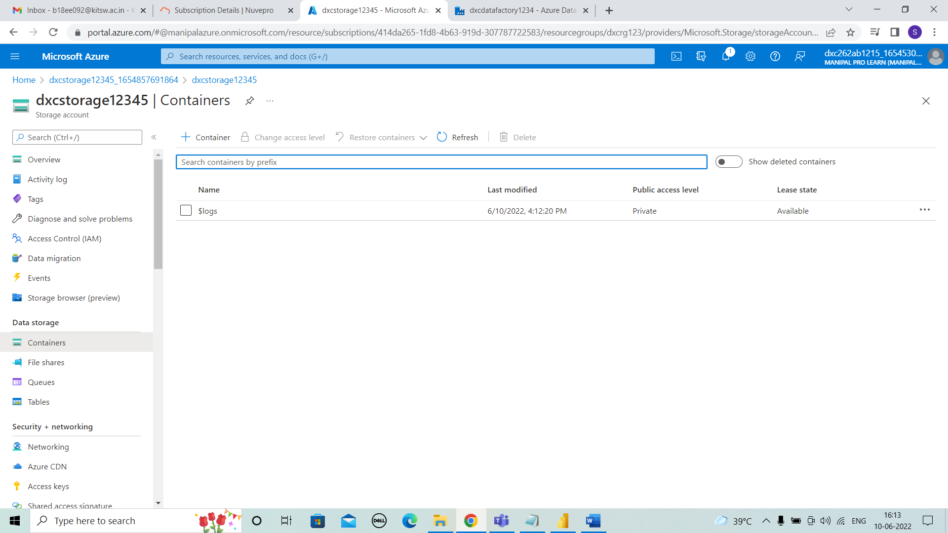



**STEP 18:** Here, first we have to create the source container. I named source container as “Sourceblob1” and create it.

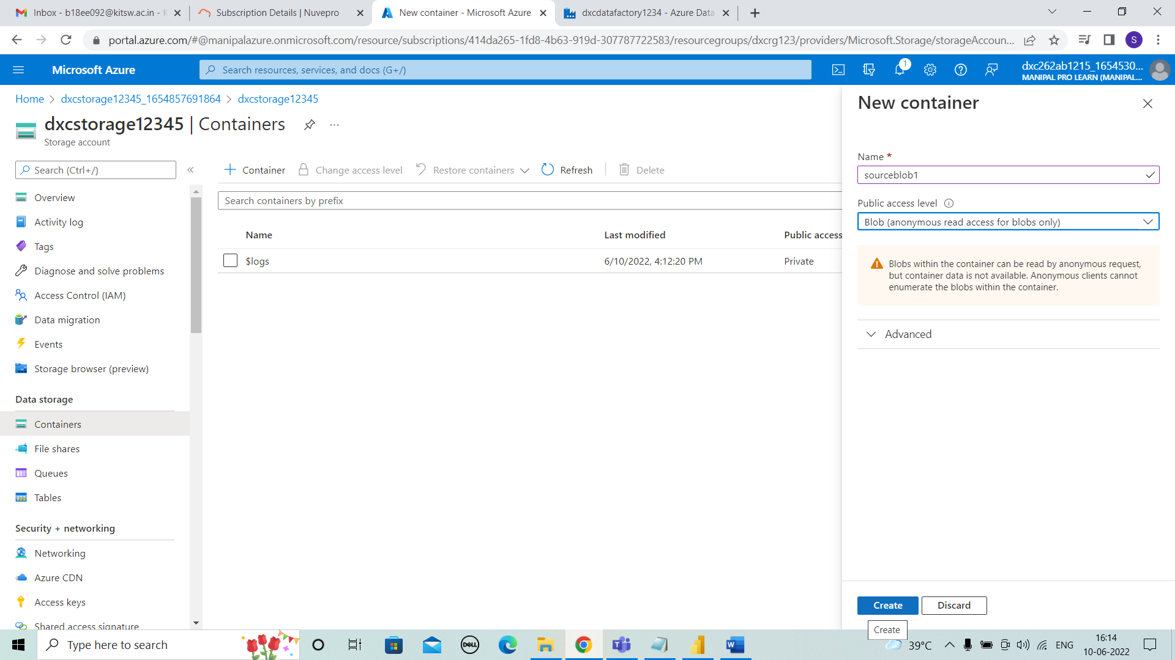



**STEP 19:** As we can see the sourceblob 1 is created.

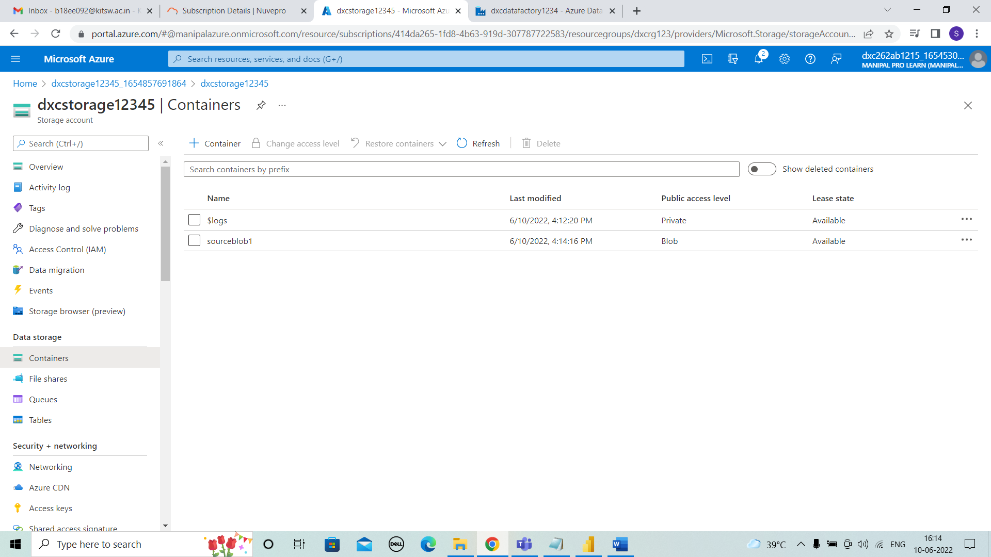



**STEP 20:** And second we have to create the destination container. I named source container as “destinationblob1” and create it.

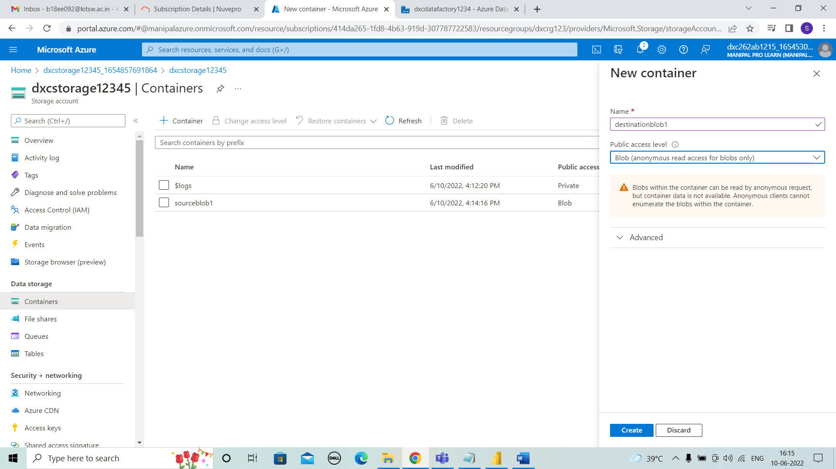



**STEP 21:** And the destinationblob1 is also created.

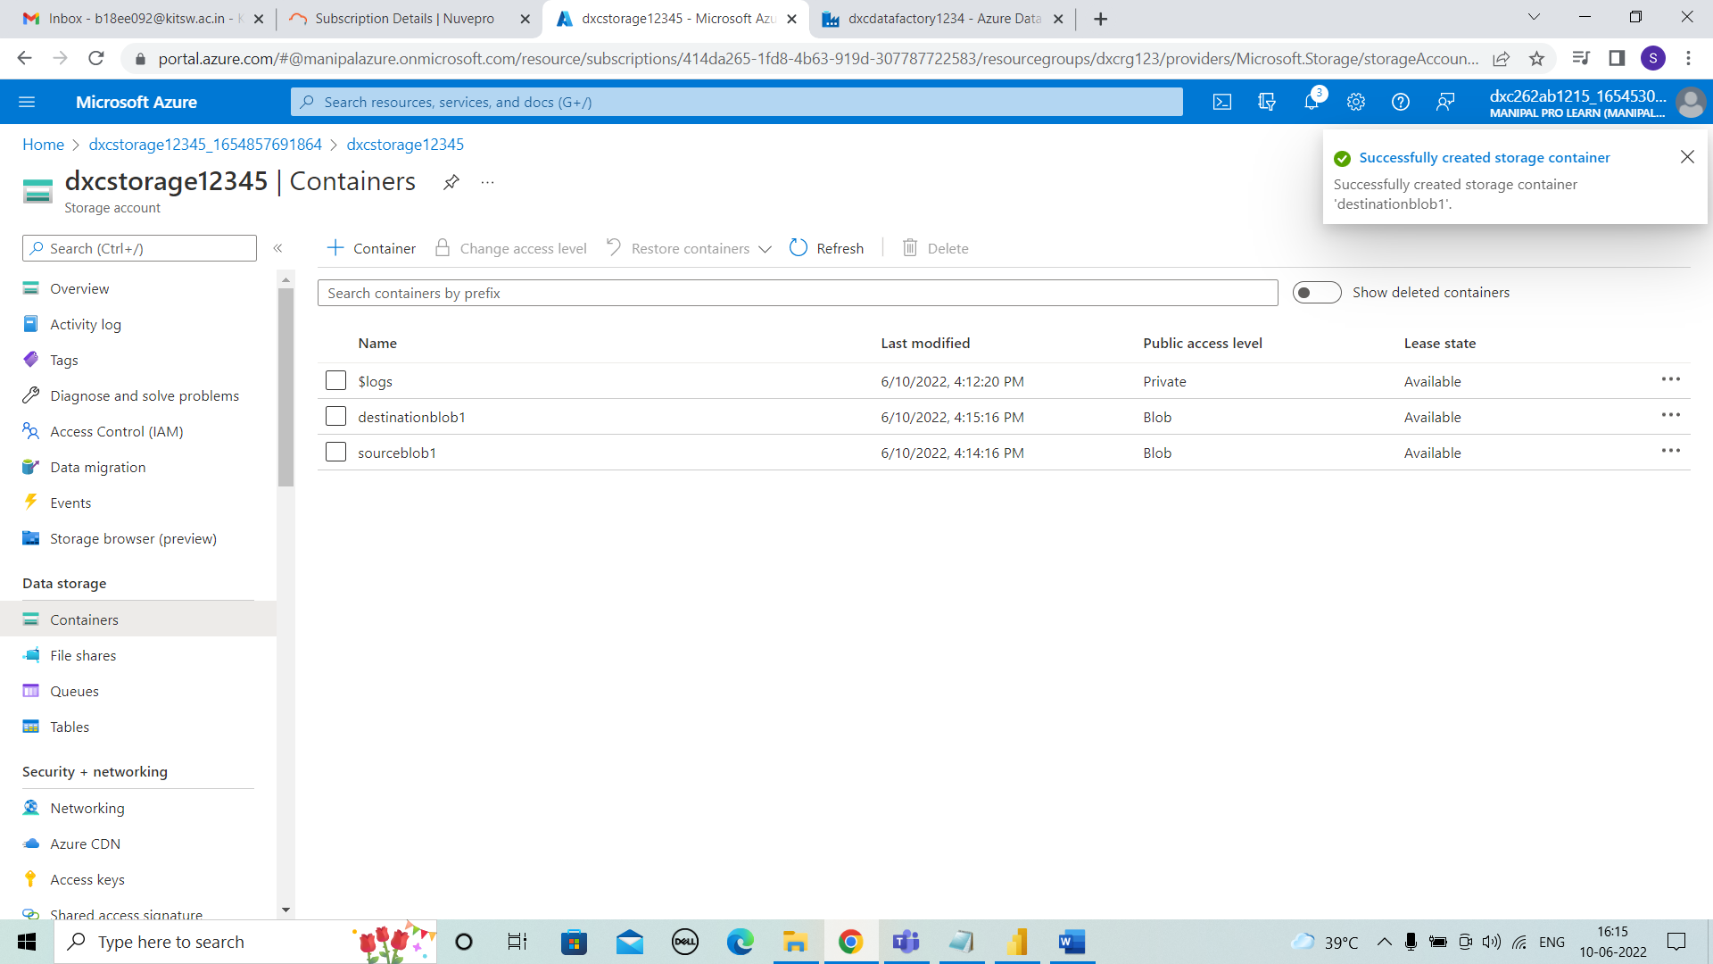



**STEP 22:** We can upload any details into the containers. Here, I uploaded the “1000_companies.csv” file in sourceblob1.

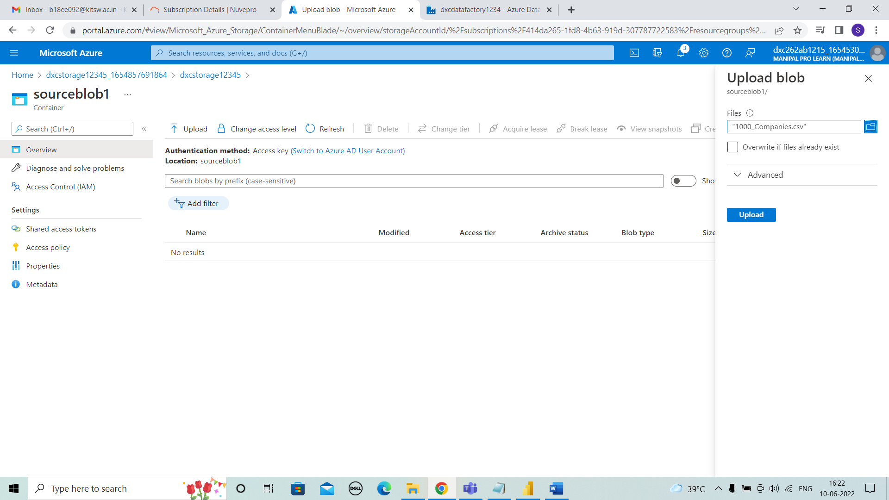



**STEP 23:** The file is uploaded as shown below.

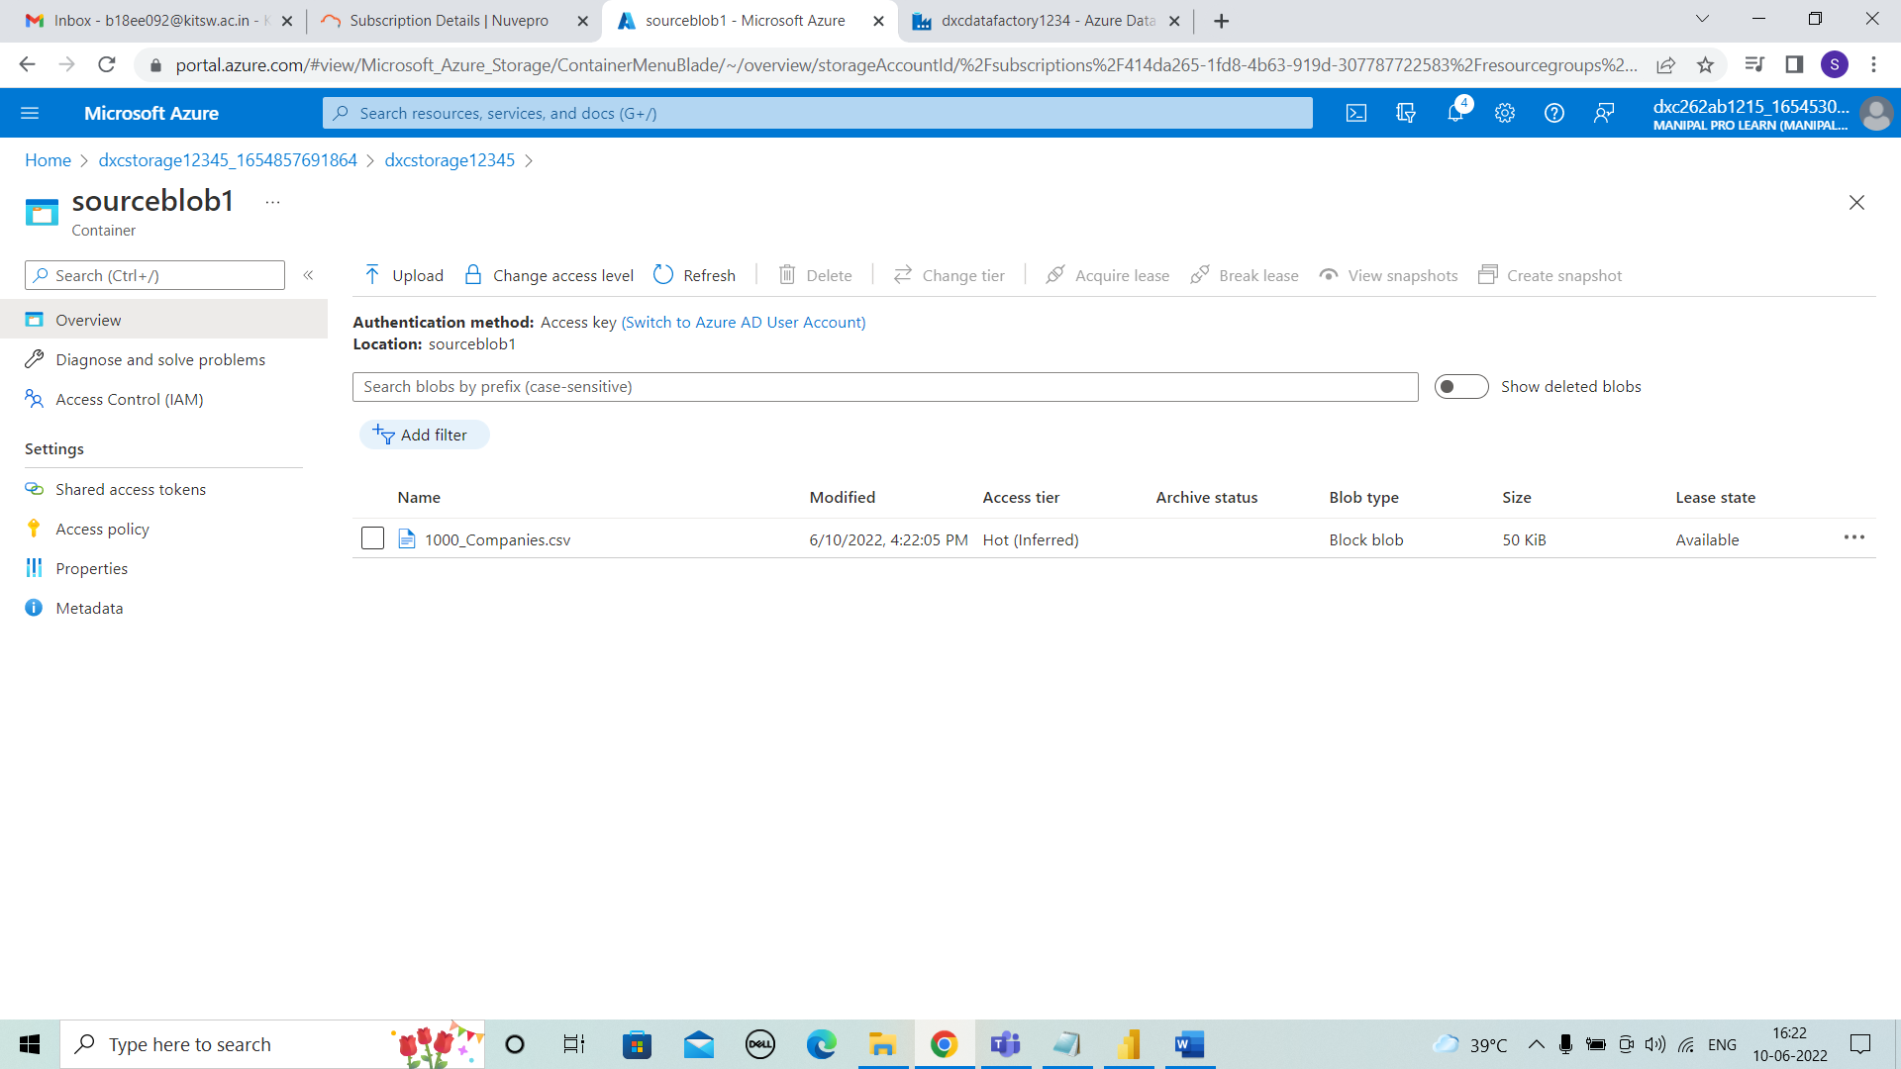



* **Practical Lab: Create ADF Pipeline End to end pipeline with triggers enabled**
* **Practical Lab: Create Azure blob trigger logic**

**STEP 1:** COMING BACK TO DATAFACTORY

And coming to data factory that we created before.

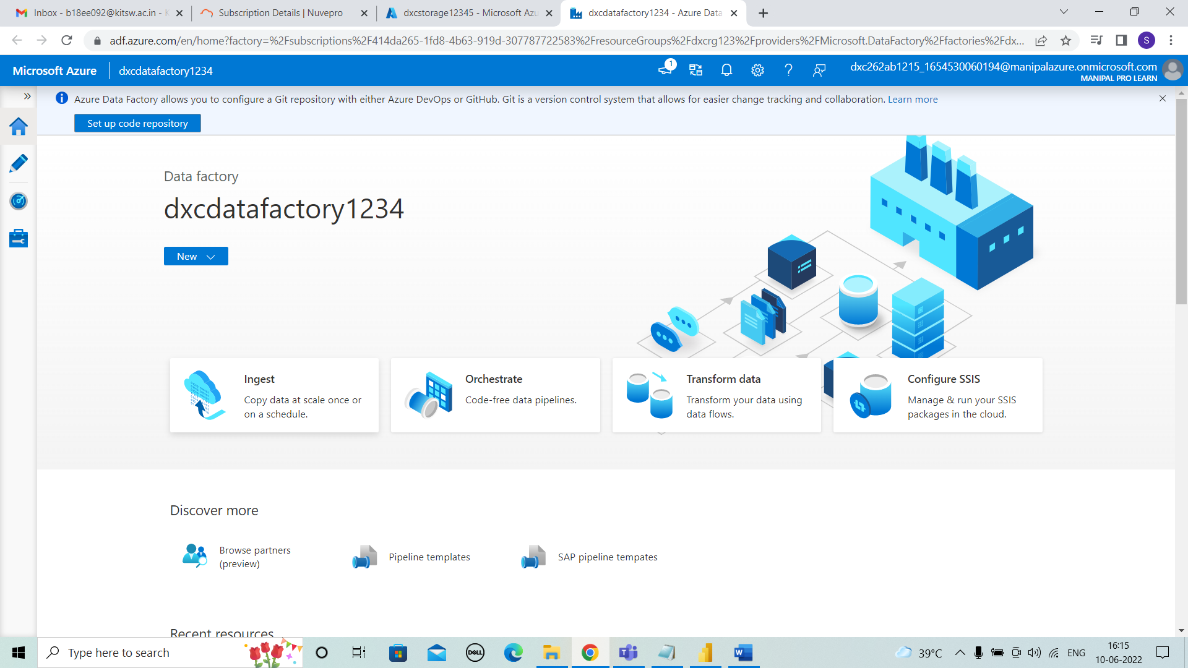



**STEP 2:** After entering into the ingest, we have to select built-in copy task. And then click on next.

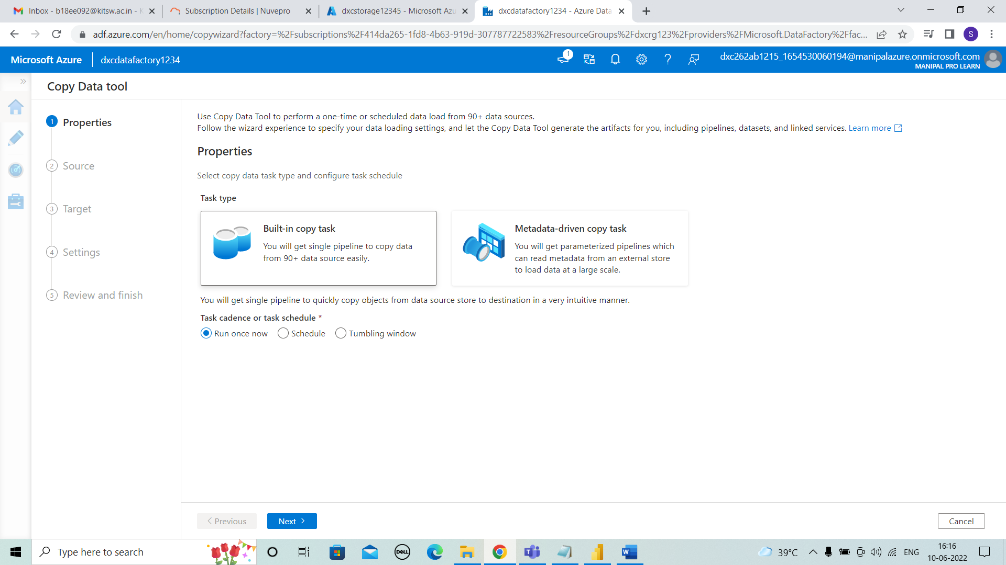



**STEP 3:** We can see the source data where source information is given.enter source type and add new connection as shown below.

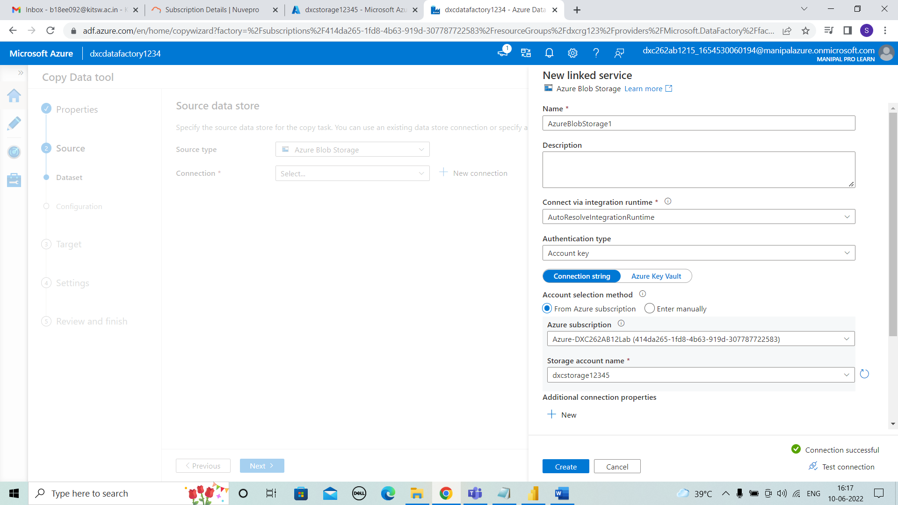



**STEP 4:** After connection, the file or folder need to uploaded.

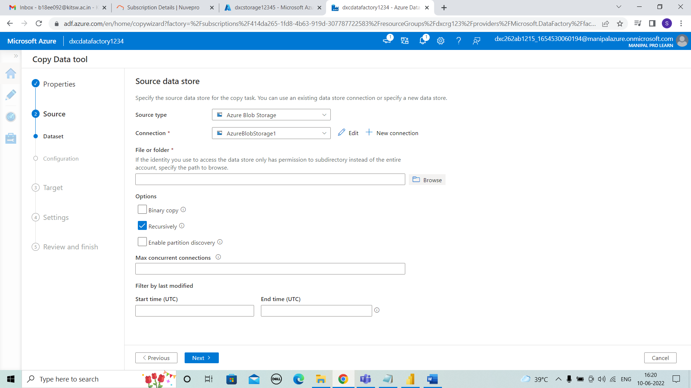



**STEP 5:** As previously we uploaded “1000_companies.csv” file in sourceblob1.Now, we can browse and select it.

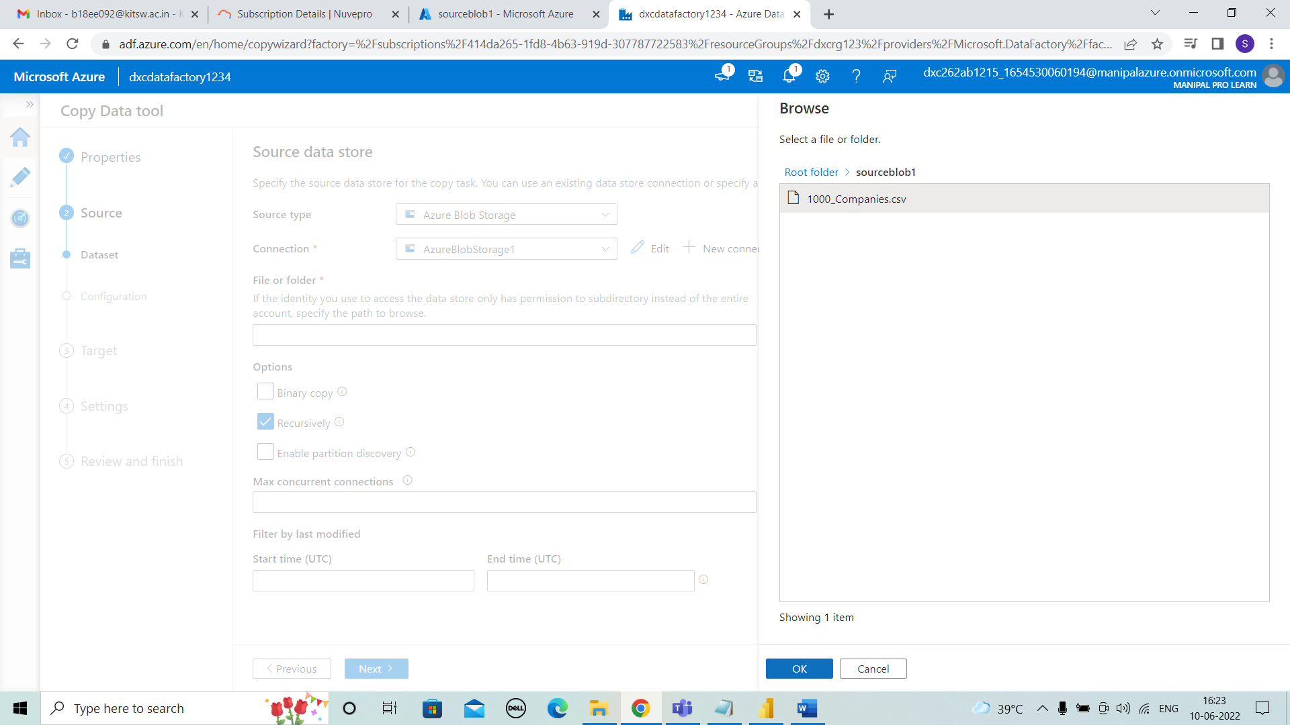



**STEP 6:** The file is uploaded and click on next.

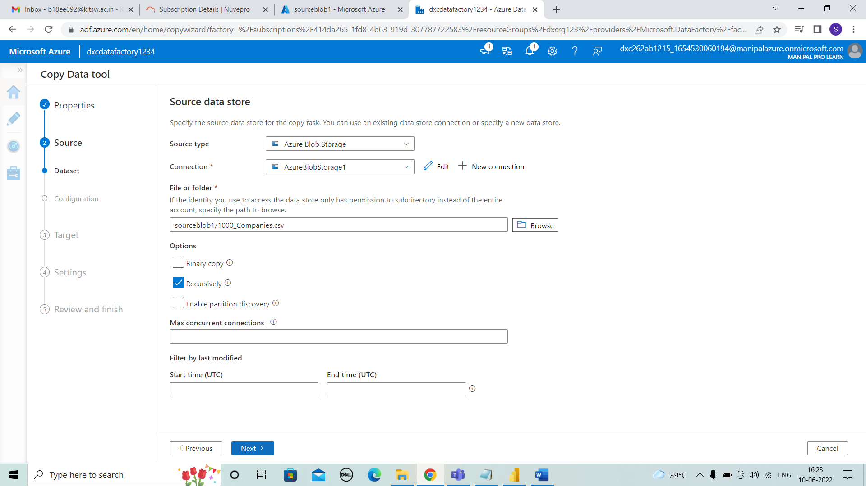



**STEP 7:** The file format settings are as shown.

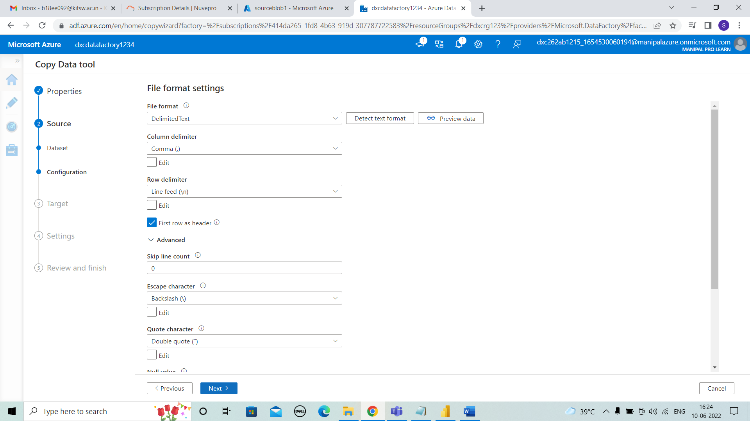



**STEP 8:** Now destination data store. Enter target type and connect.

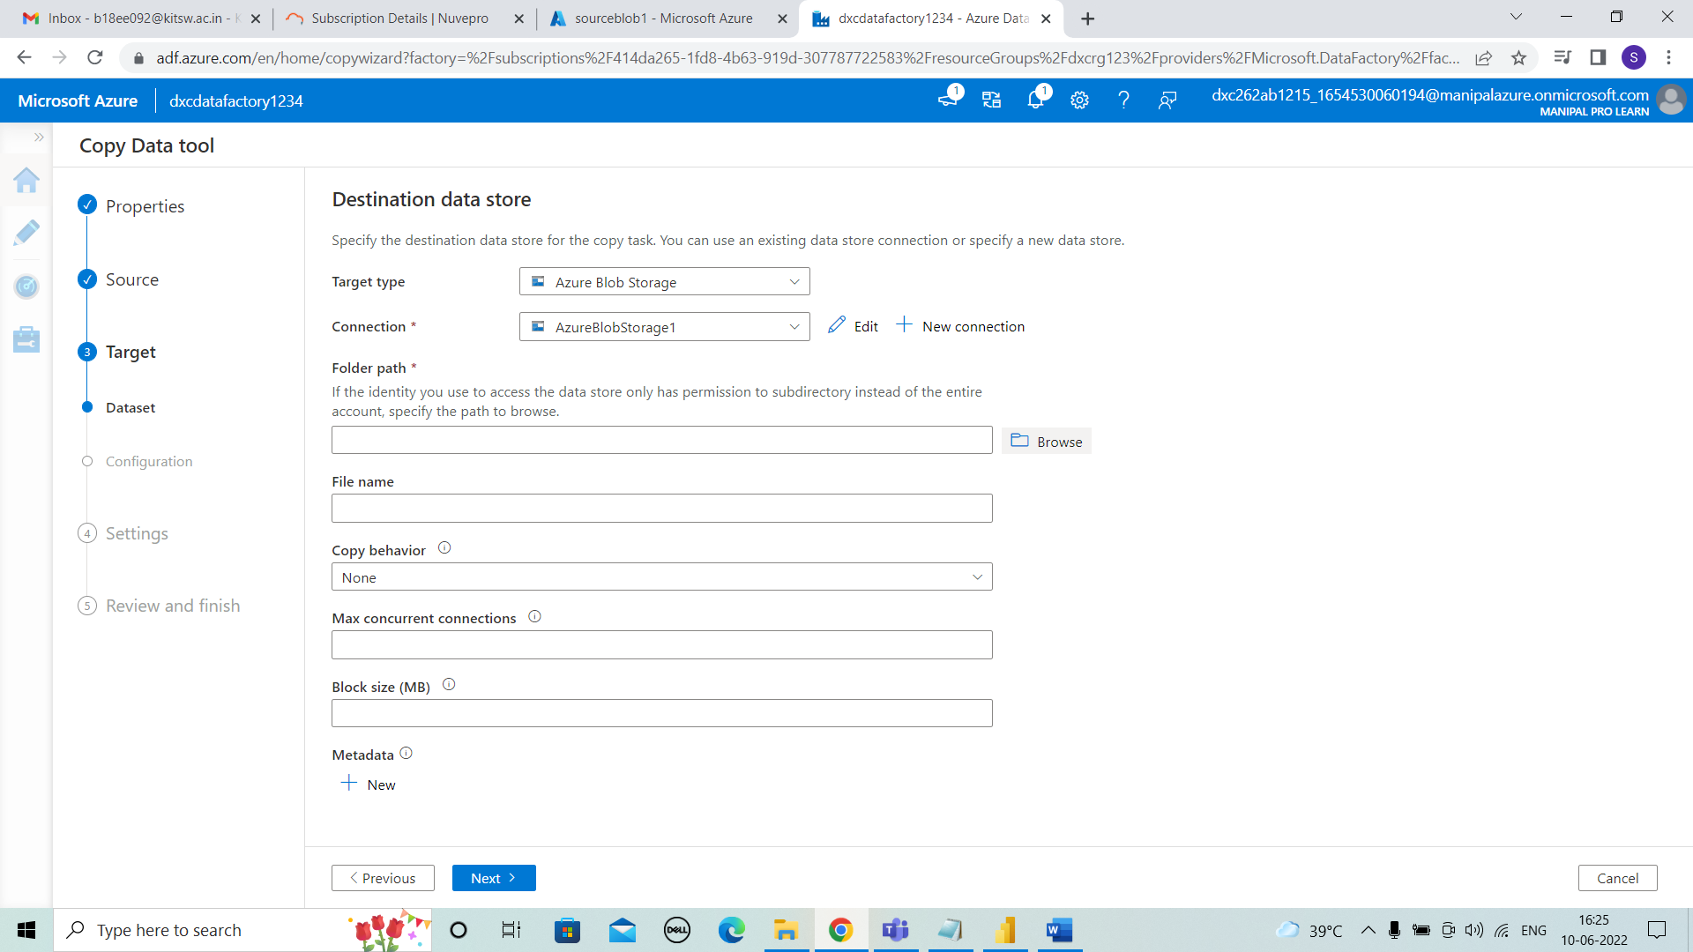



**STEP 9:** As the data need to be transferred from source to destination. No need to upload any file in it.Just need to select destinationblob1.

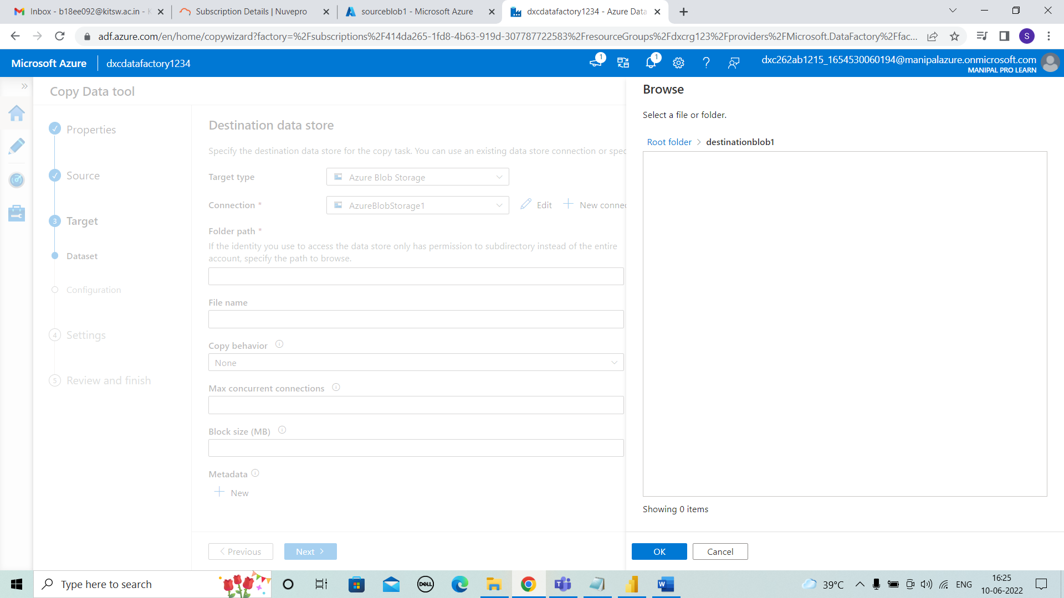



**STEP 10:** As the details are as shown and click on next.

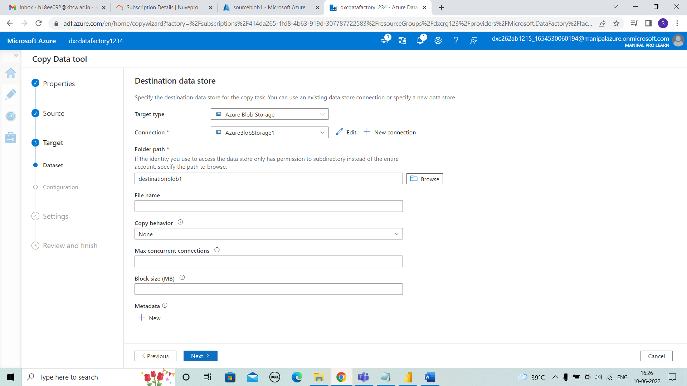



**STEP 11:** We enter into file format settings and details should as shown below.

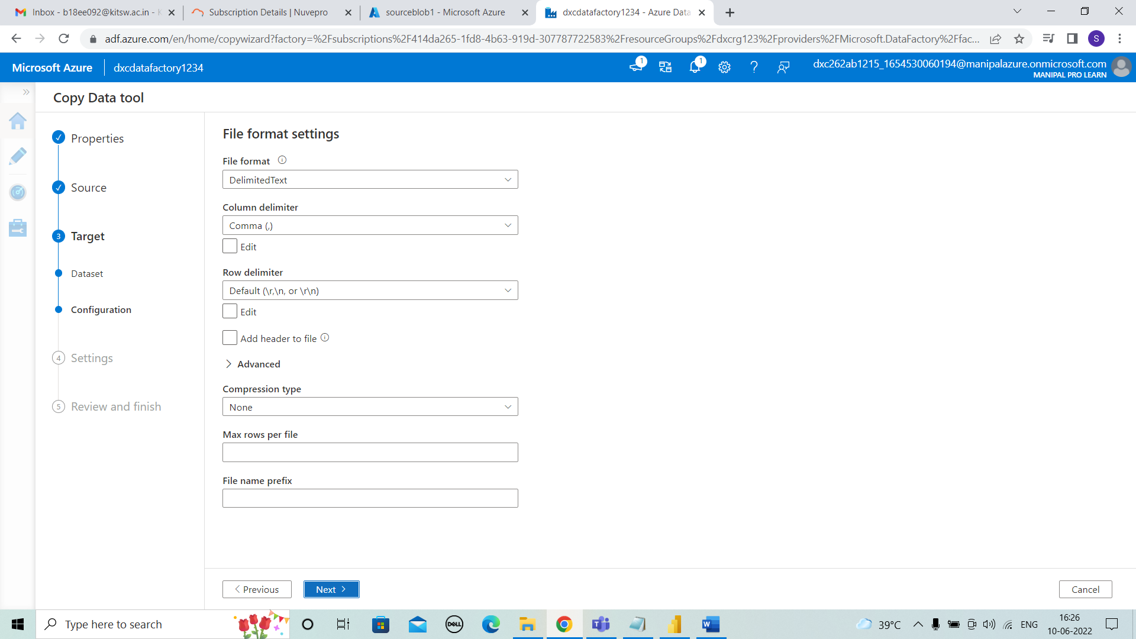



**STEP 12:** We enter into settings where we can change the name for pipelines or remain same.

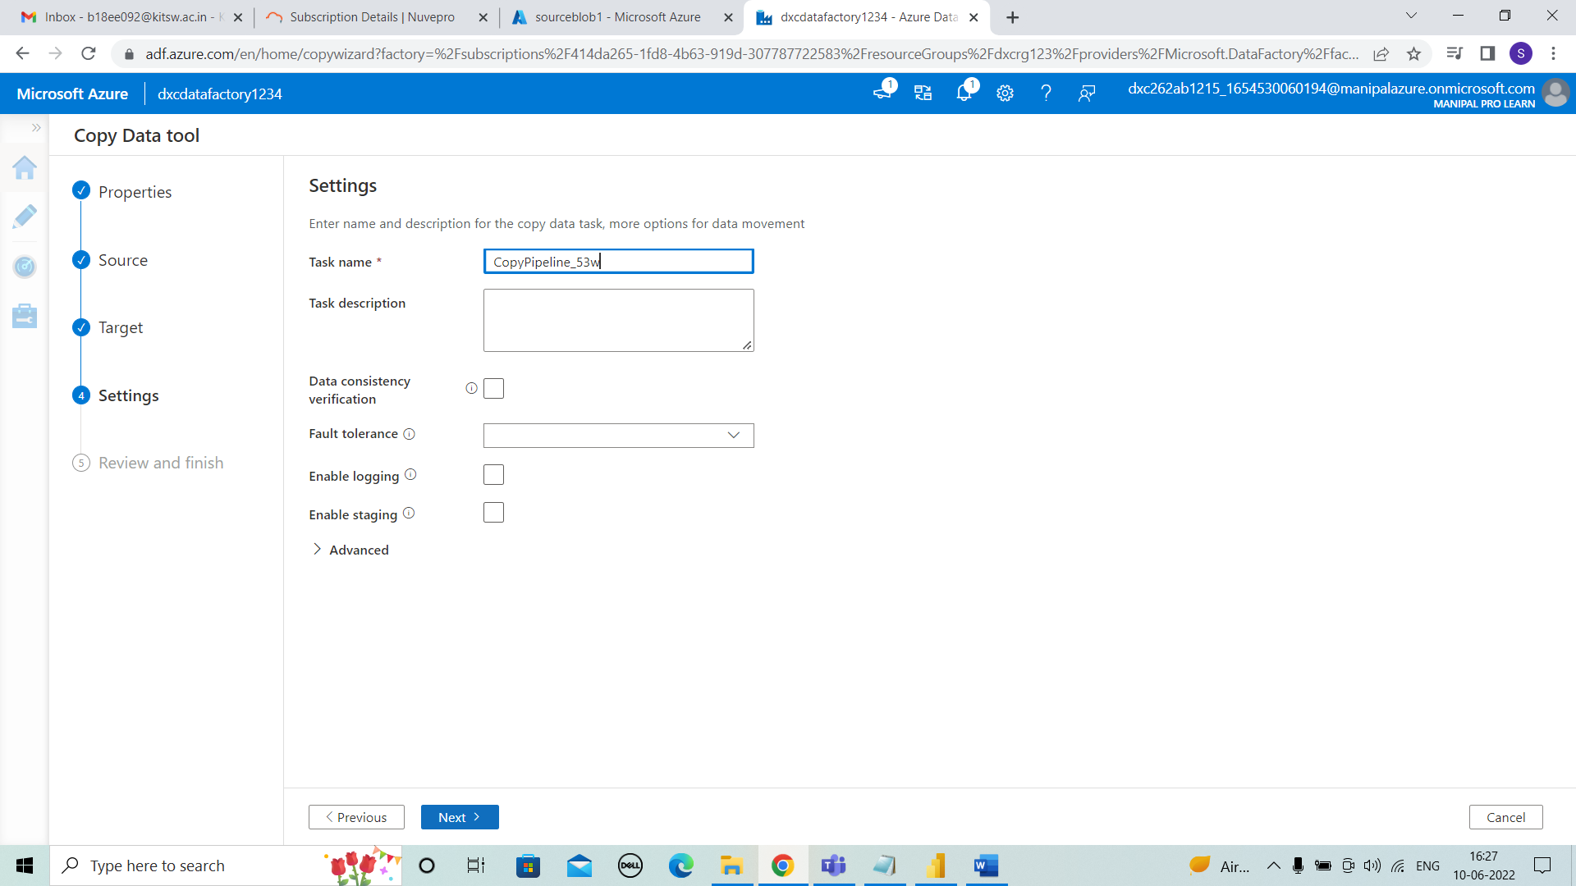



**STEP 13:** Here comes to summary we can see azure blob storage for source and azure blob storage for destination. And click on next.

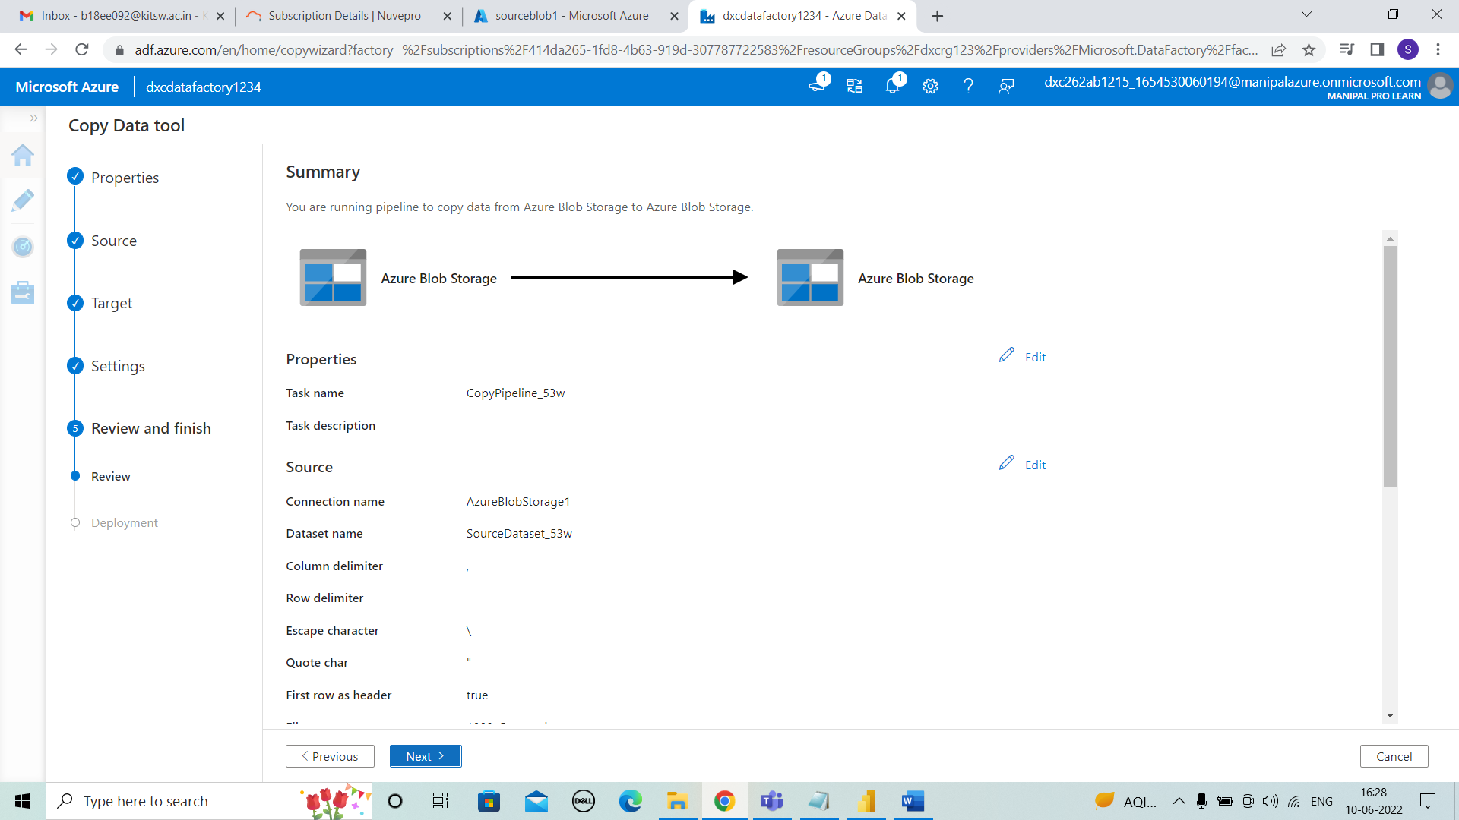



**STEP 14:** Then deployment and click on finish.

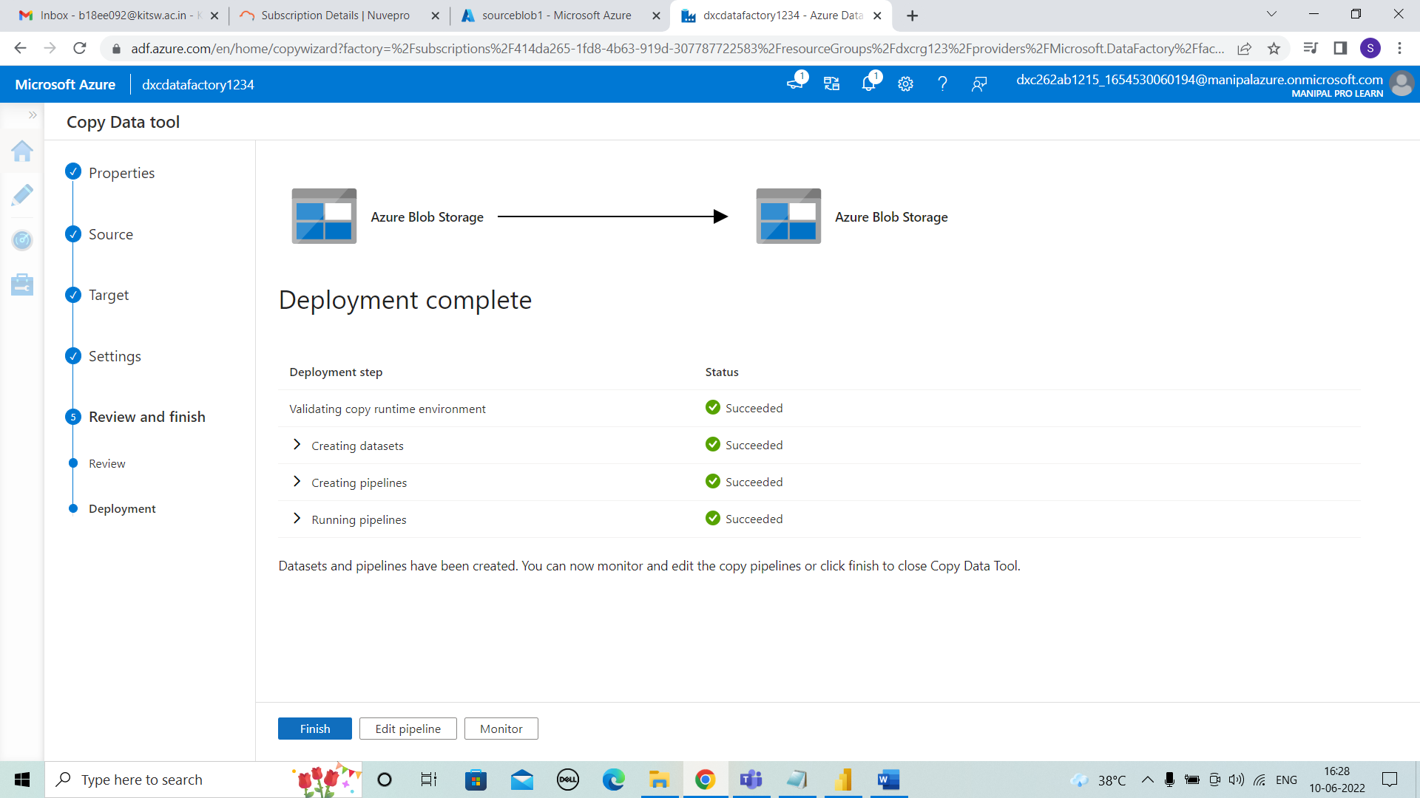



**STEP 15:** After the pipeline created we can see the data (100_companies.csv) is in destinationblob1.

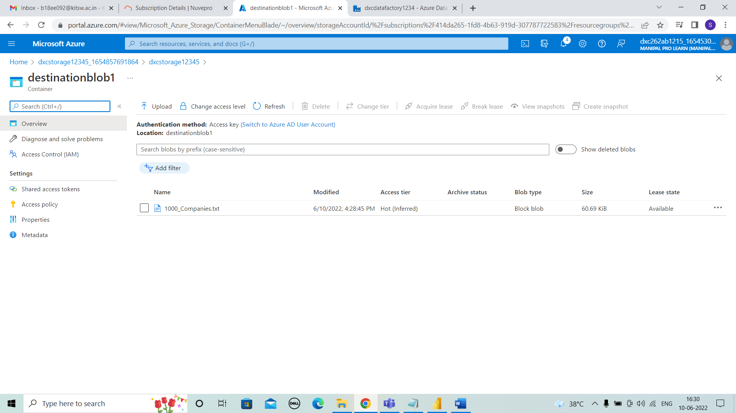



**STEP 16:** For running a pipeline select monitor in datafactory and rerun it, it will get succeeded as shown below.

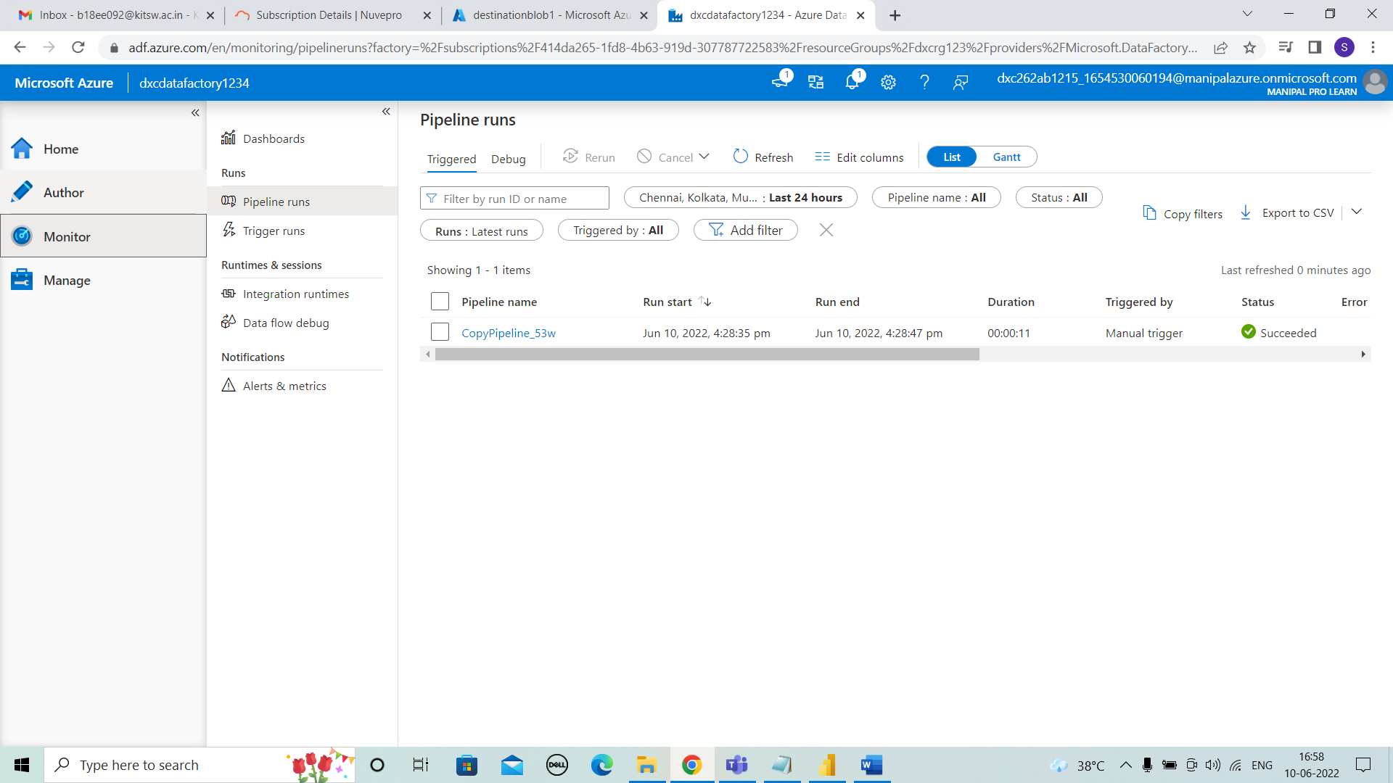



**STEP 17:** Select author and we can view the pipeline that created previously.

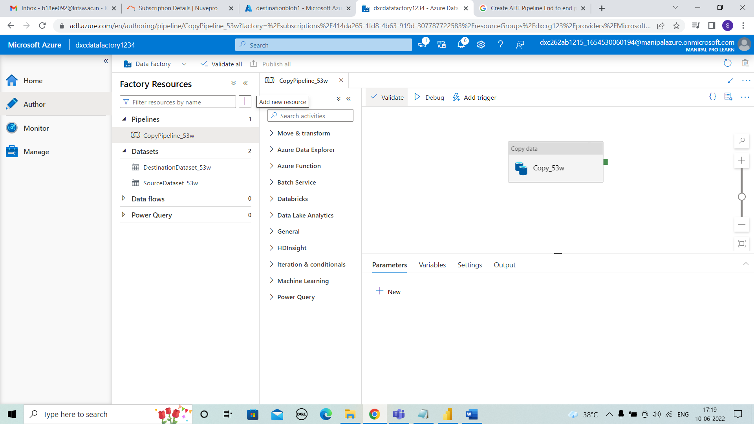



**STEP 18:** Validate the pipeline as shown and close it.

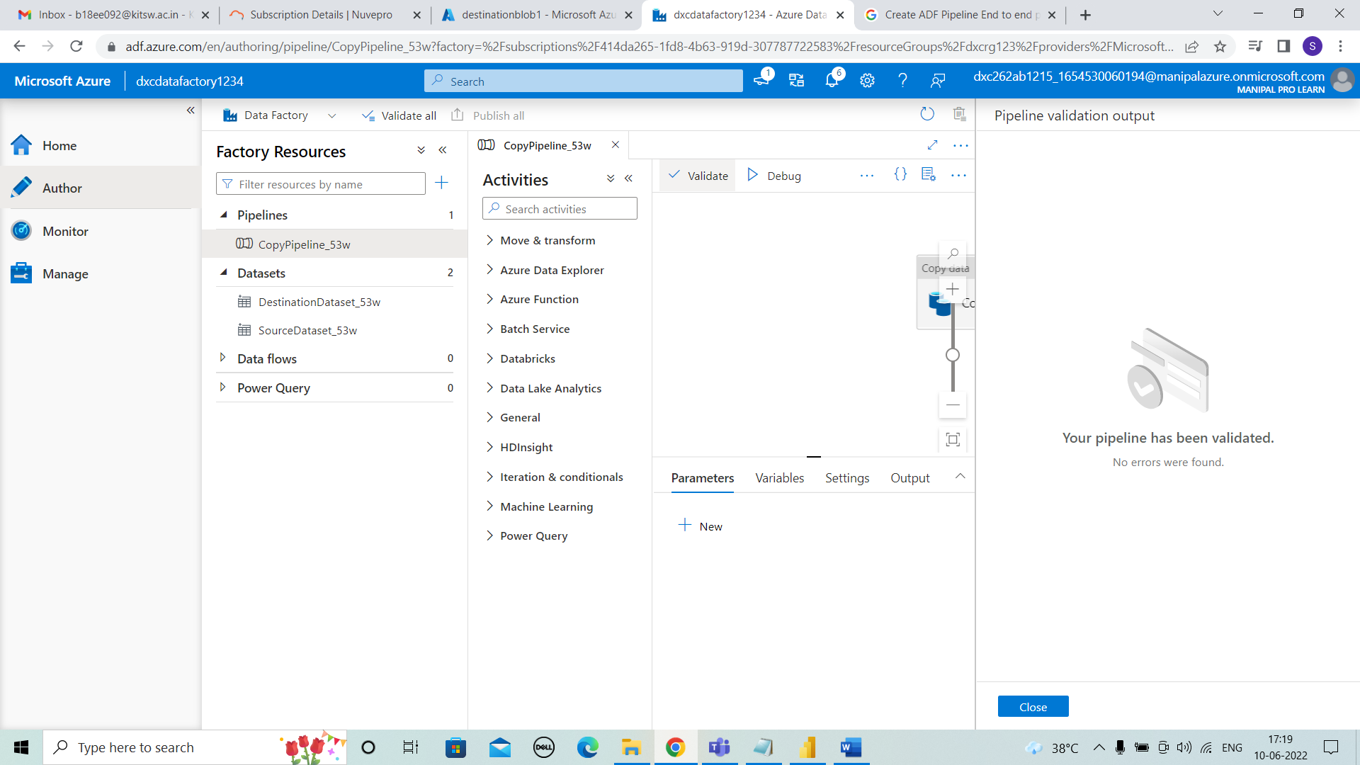



**STEP 19:** Then choose trigger now for pipeline or we can schedule to run by choosing new trigger option.

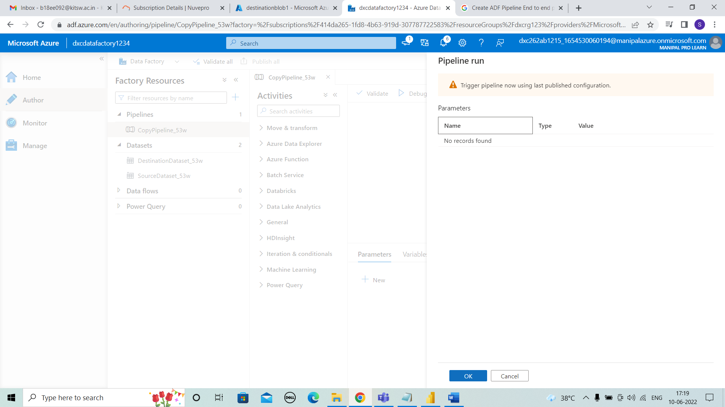



**STEP 20:** The trigger is ran successfully and publish the pipeline.

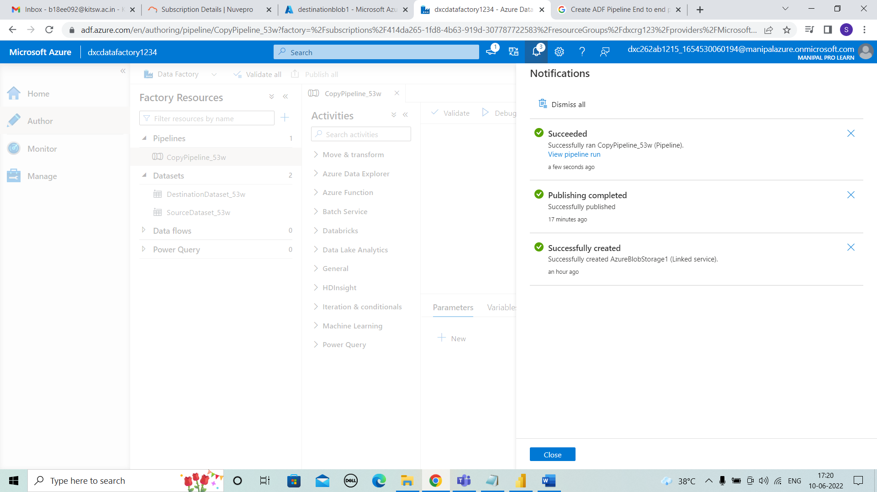



* **Practical Lab: Create Azure SQL Server and Database**

**STEP 1:** Search azure SQL and select it.

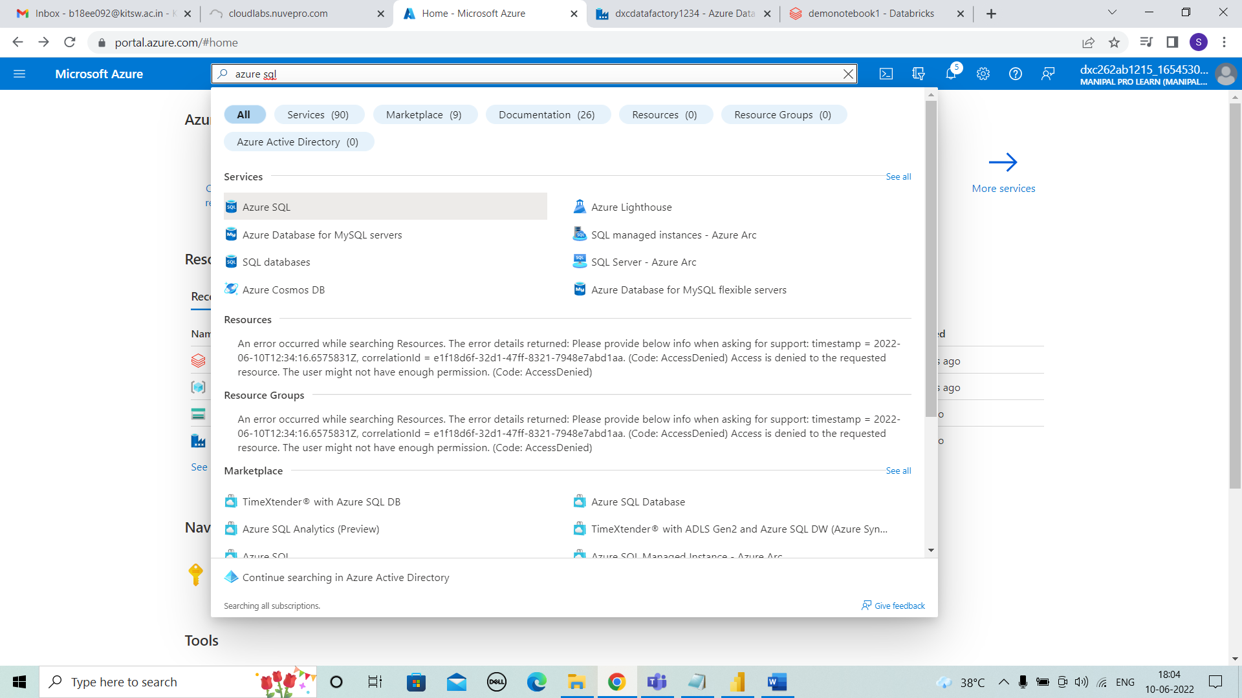



**STEP 2:** After selecting azure SQL . Click on “+ create”.

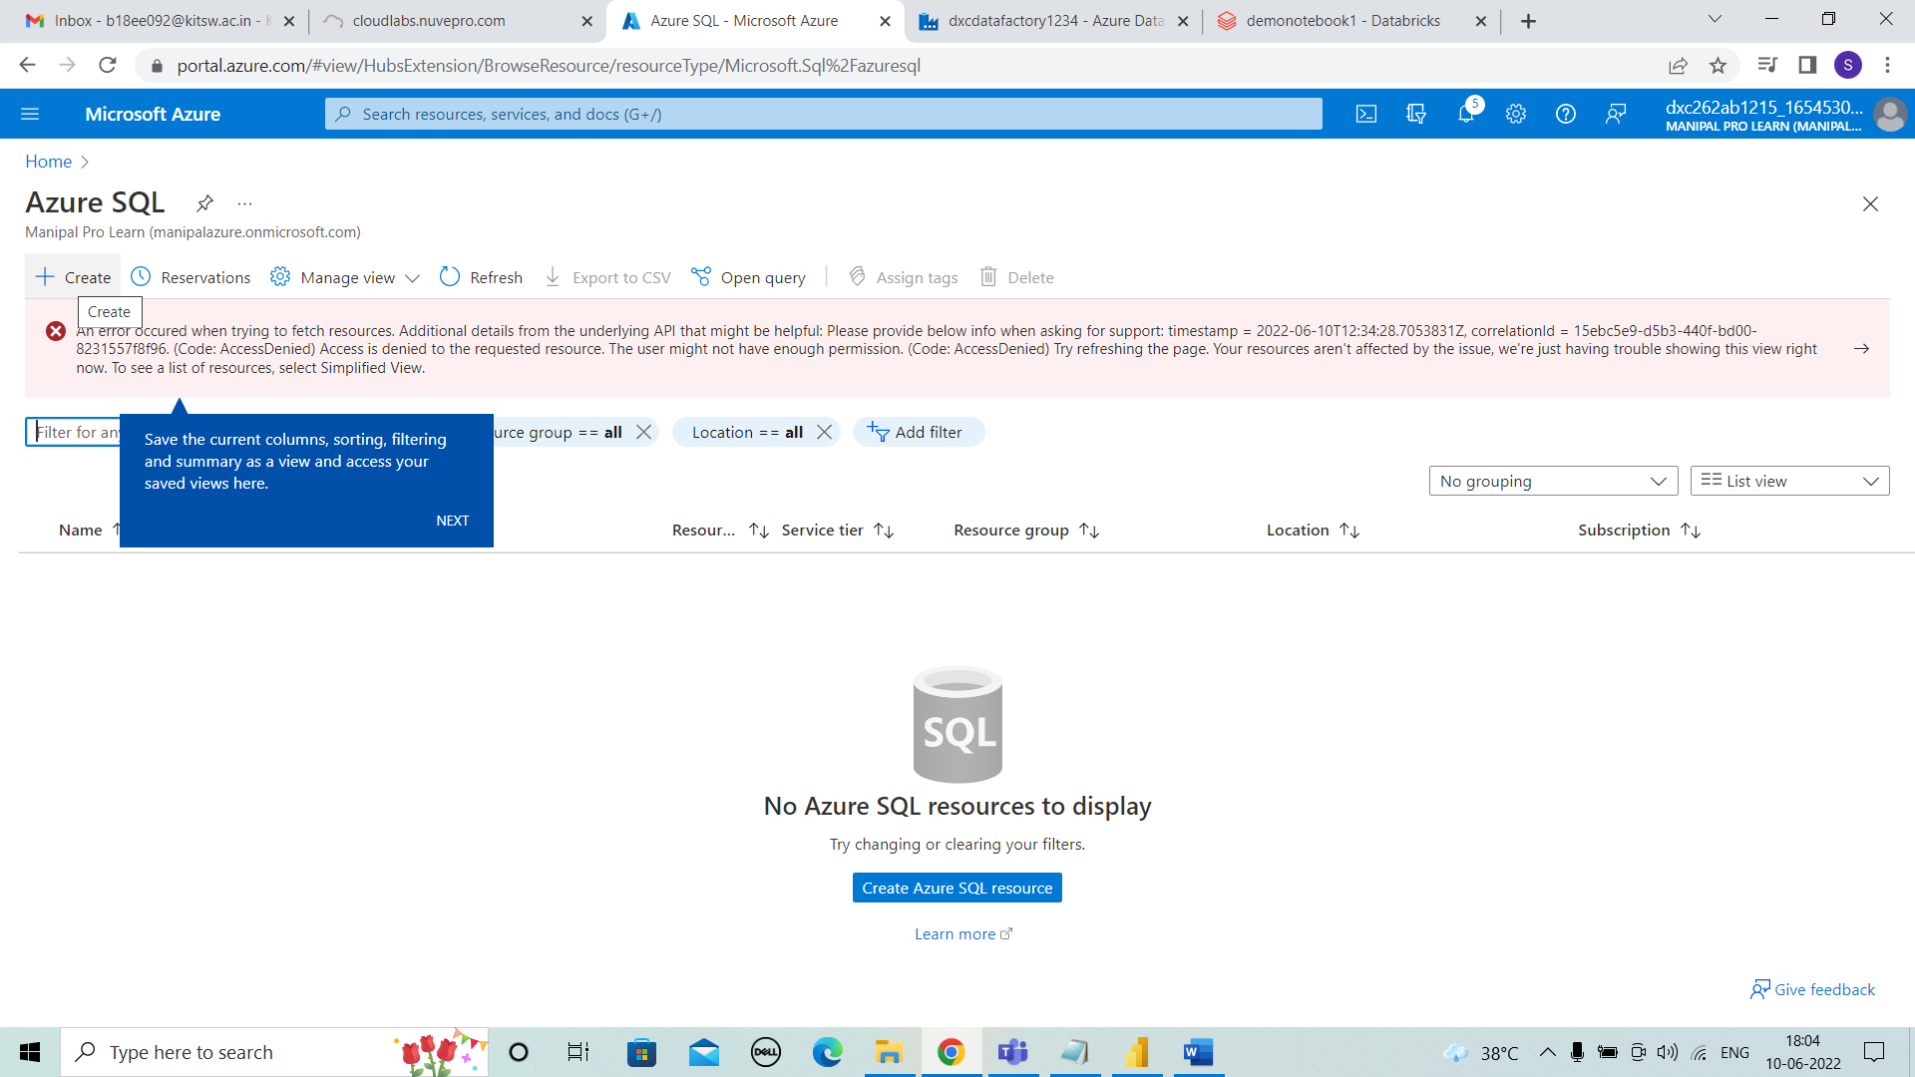



**STEP 3:** Select SQL databases and single databases and click on create.

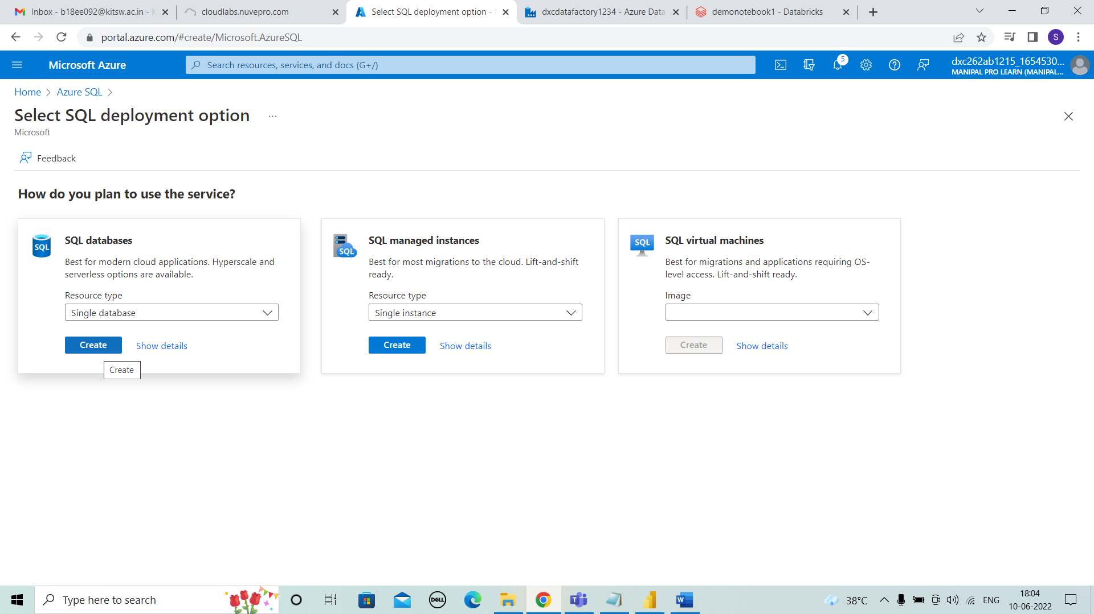



**STEP 4:** Enter the details of resource group, database name, Now select server.

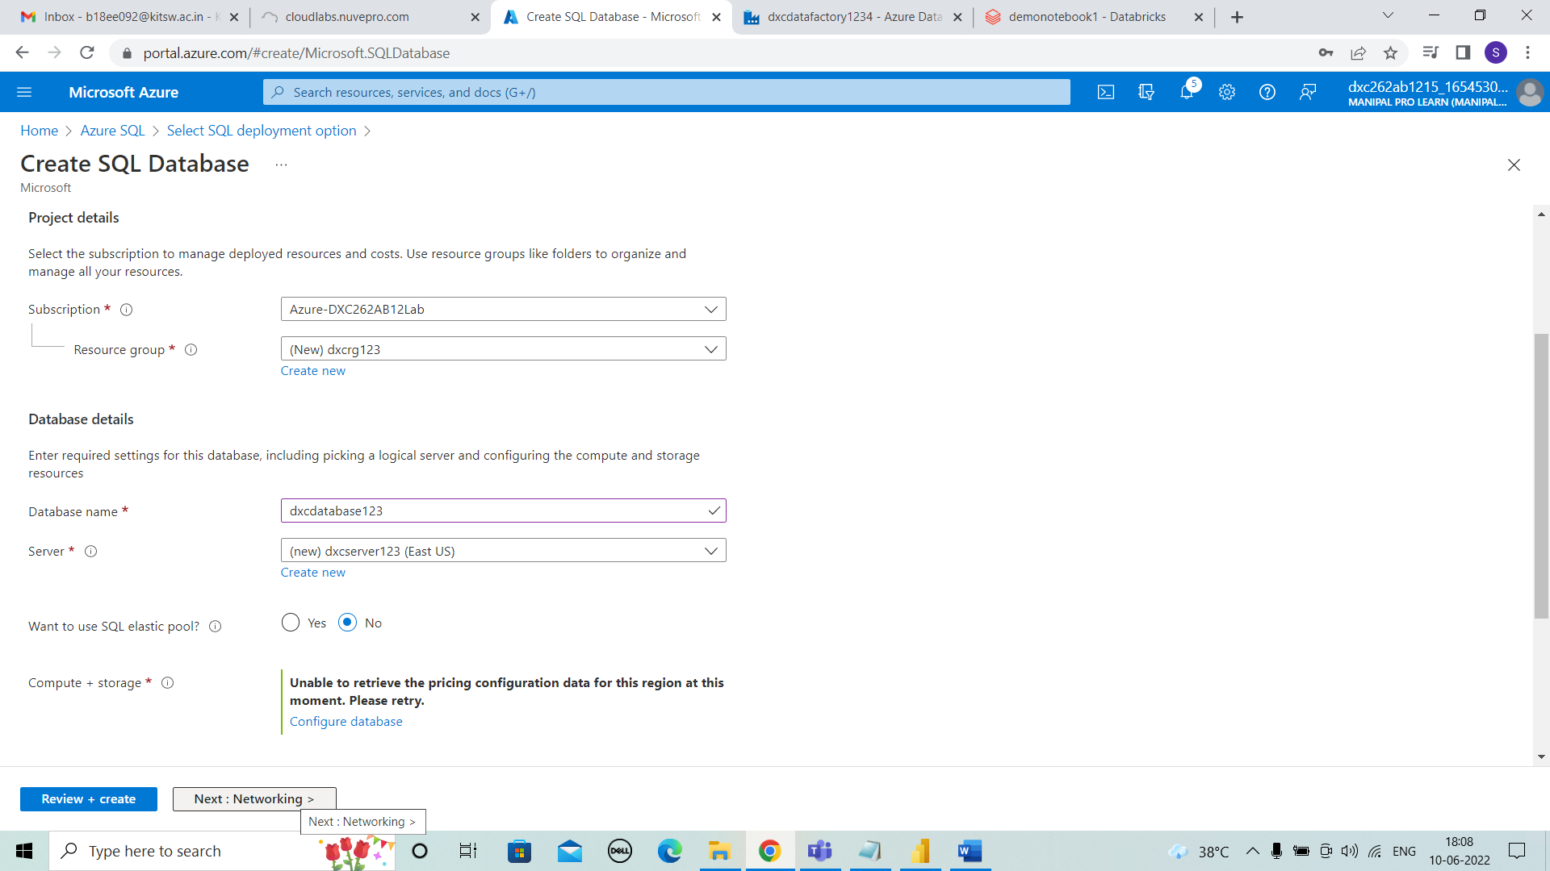



**STEP 5:** Now for creating the server enter the server name and server admin login, password, confirm password.

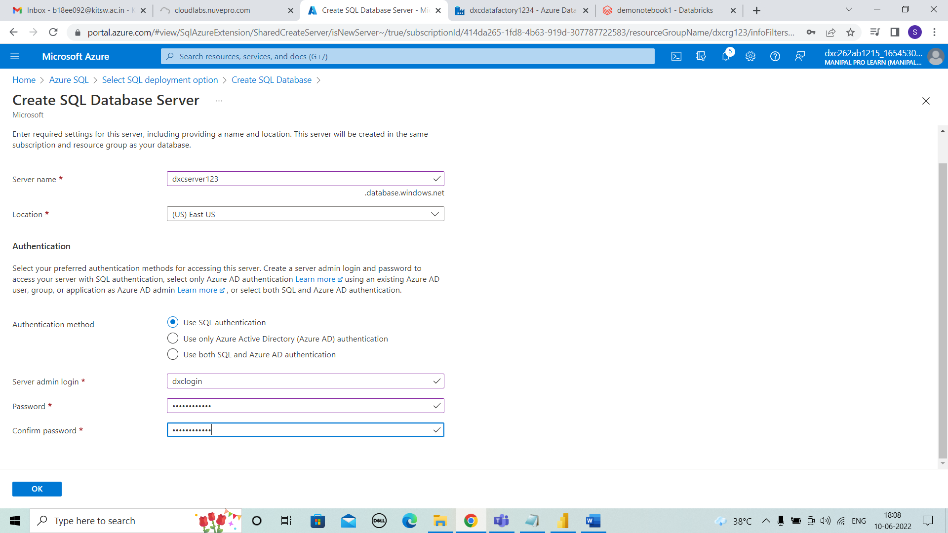



**STEP 6:** After entering server details , then click on review+create.

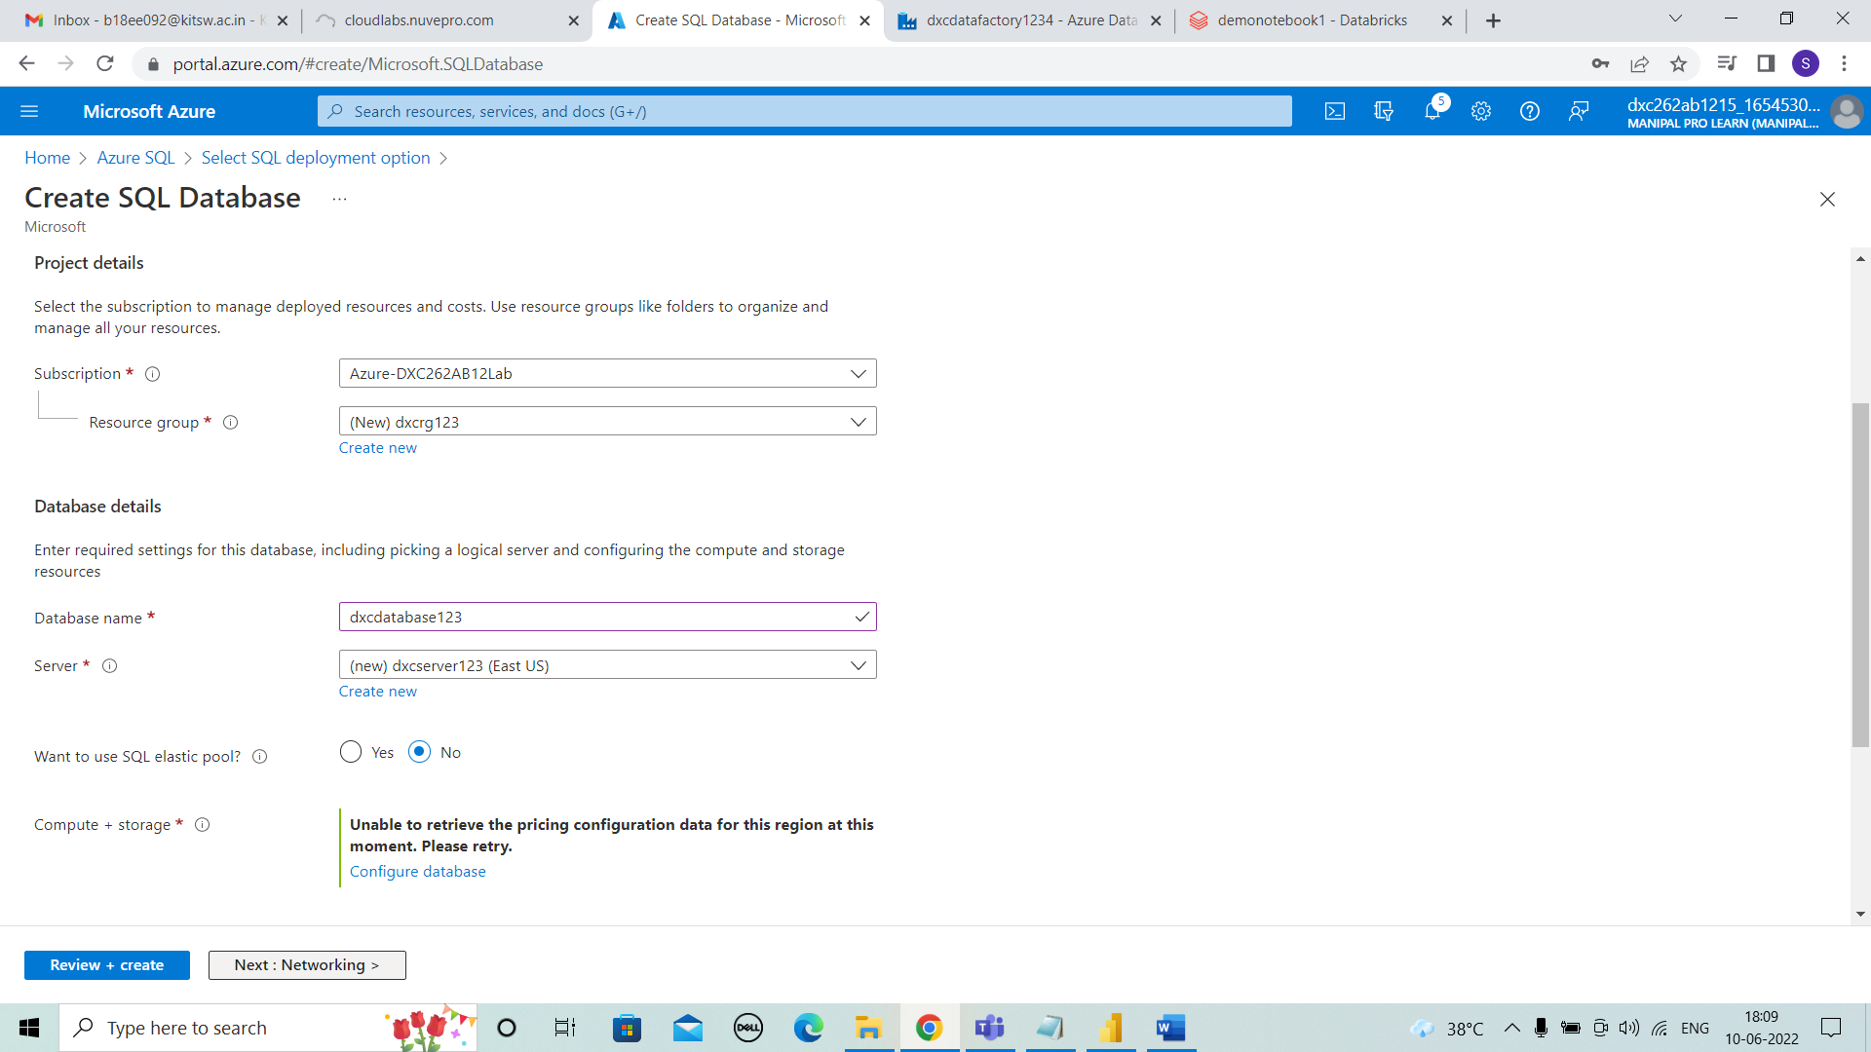



**STEP 7:** Click on create after reviewing the details and the process is validating.

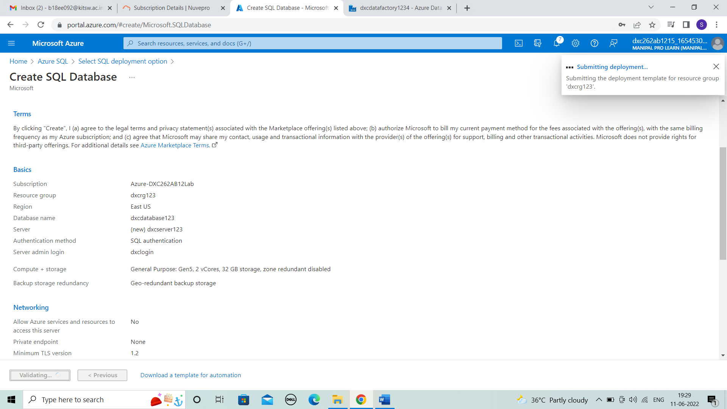



**STEP 8:** Then deployment is in progress.

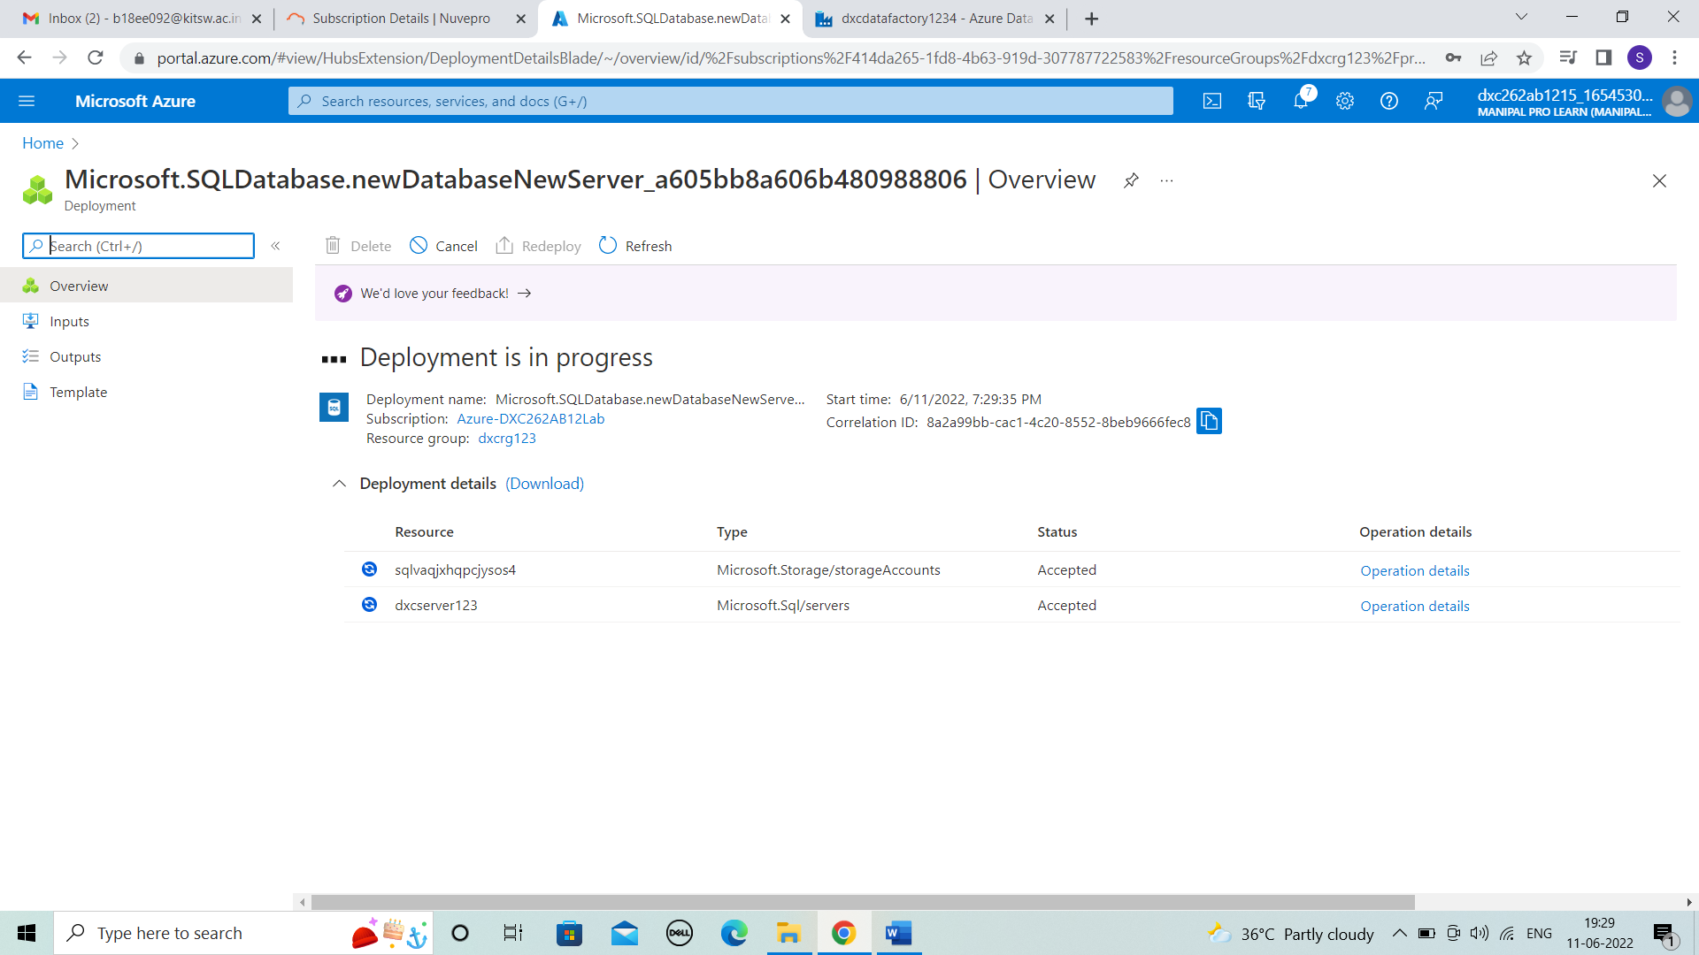



**STEP 9:** After few minutes the deployment is completed and then go to resource.

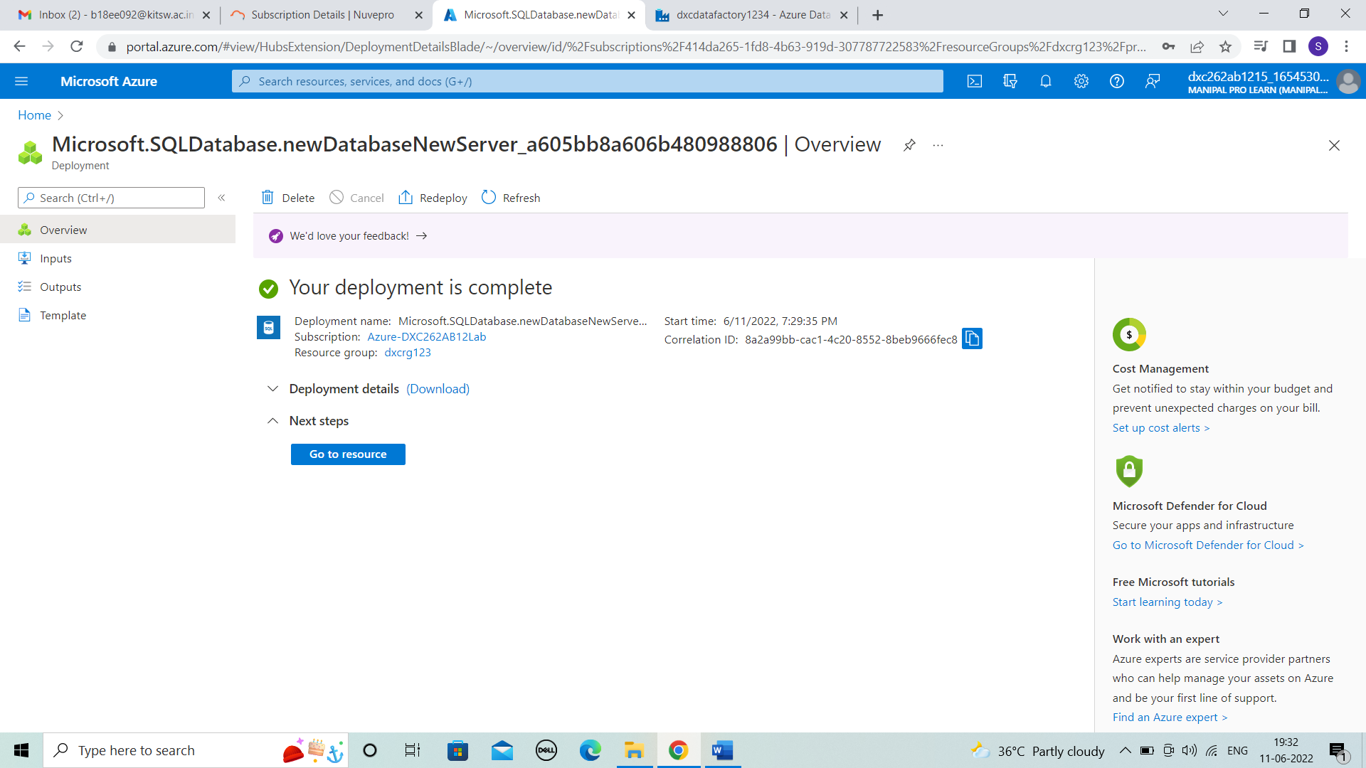



**STEP 10:**  In resource we can observe overview the details of database.

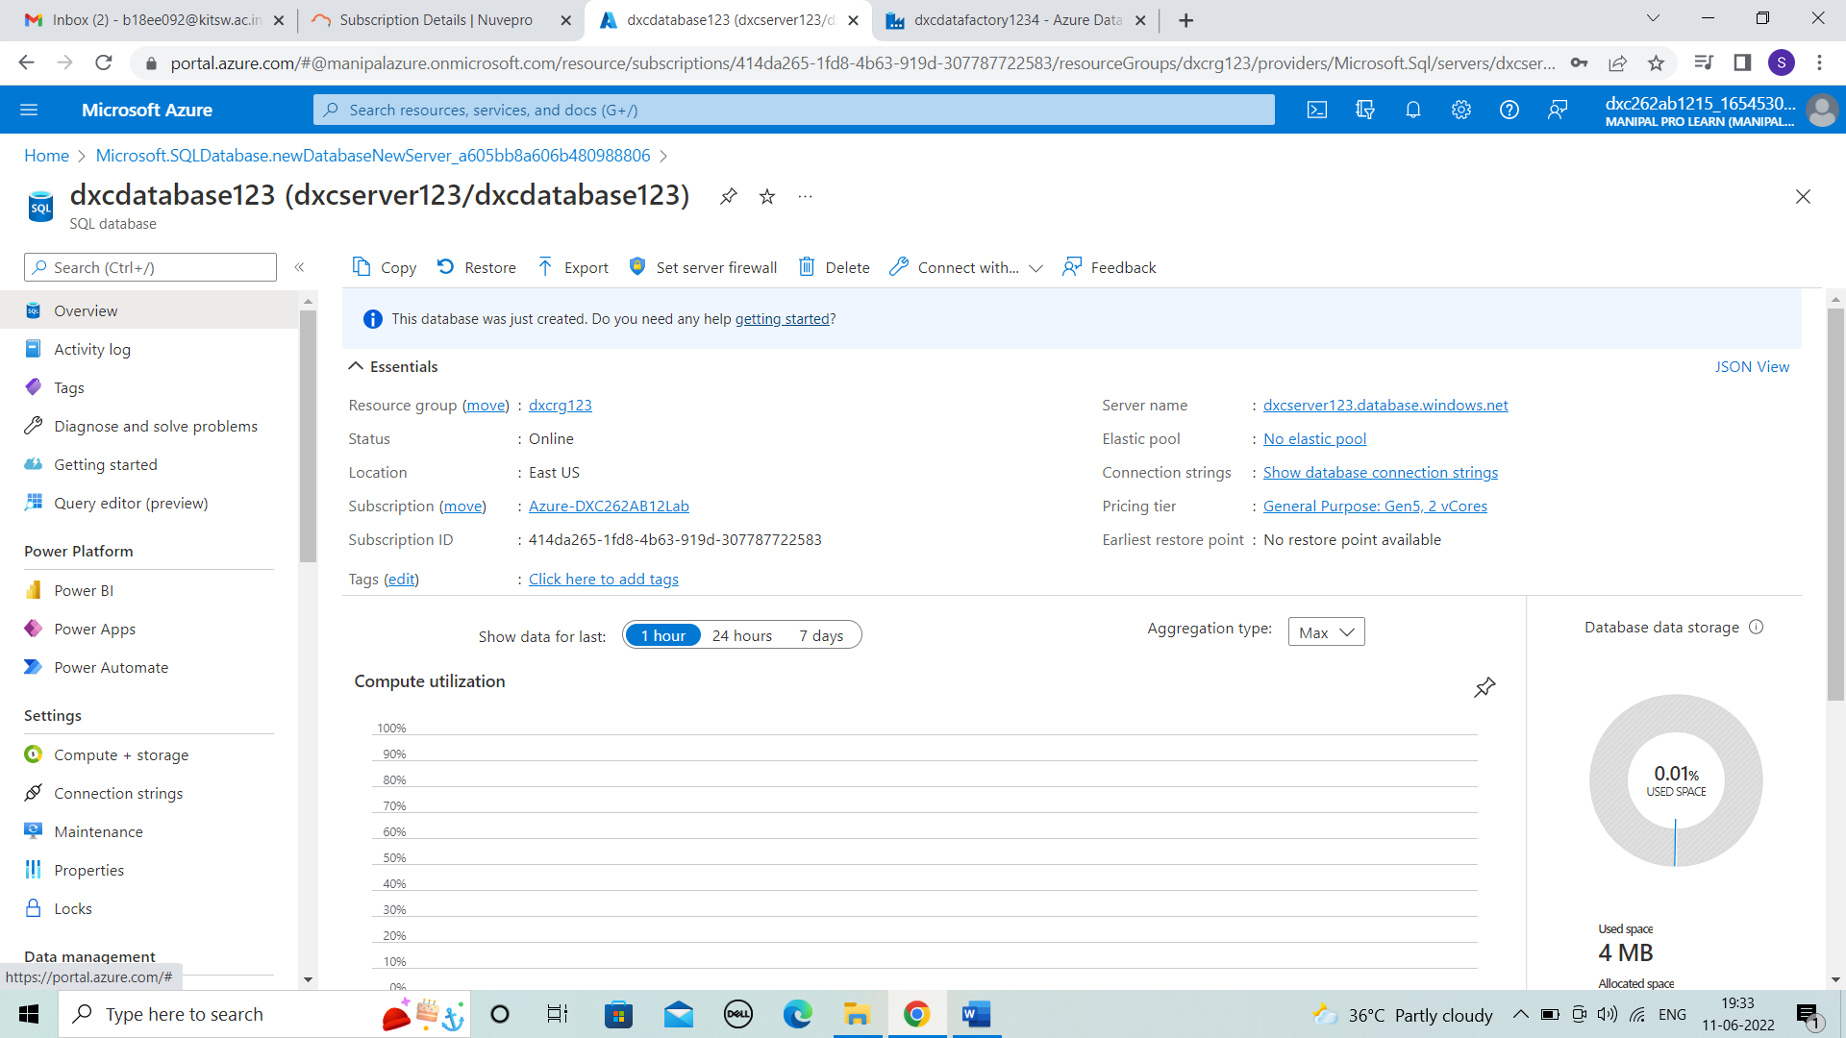



* **Practical Lab: Add another pipelines for moving data from Staging to SQL DB**

**STEP 1:** Now, in data factory we need to add another pipeline for staging the data to SQL DB. Click on ingest.

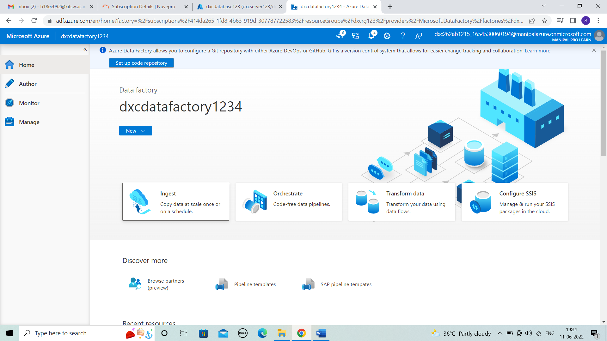



**STEP 2:** Click on next for built in copy task.

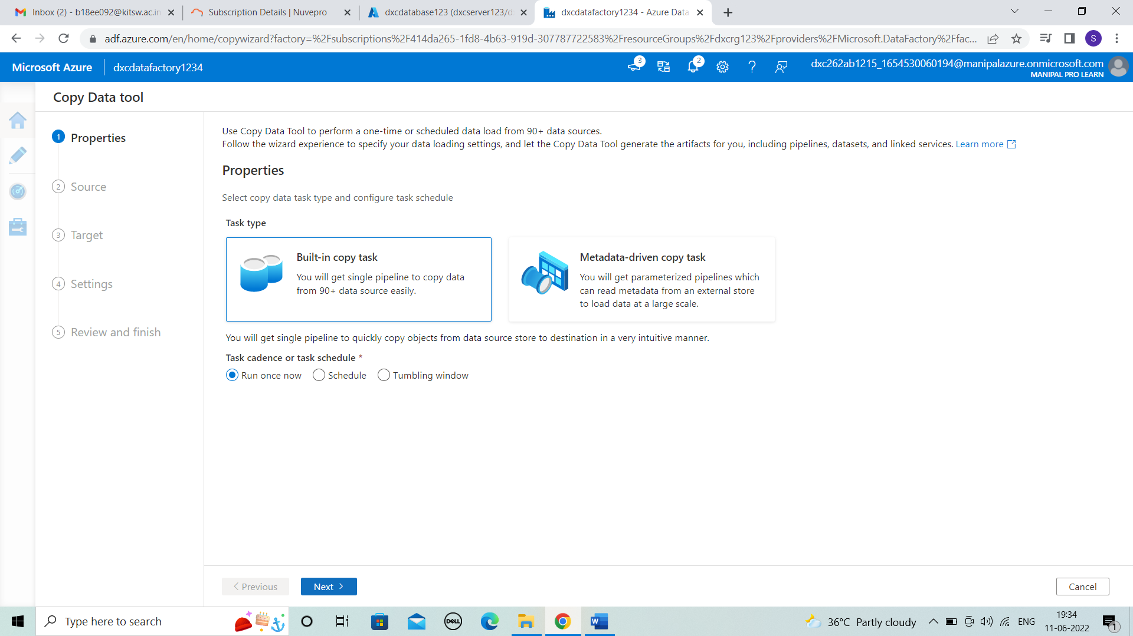



**STEP 3:** In source data store connect with blob storage and browse the data .

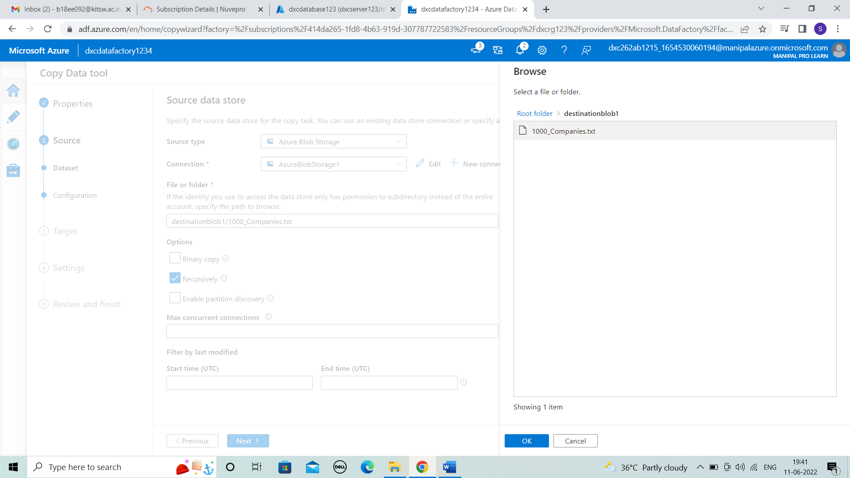



**STEP 4:** After browsing then click on next.

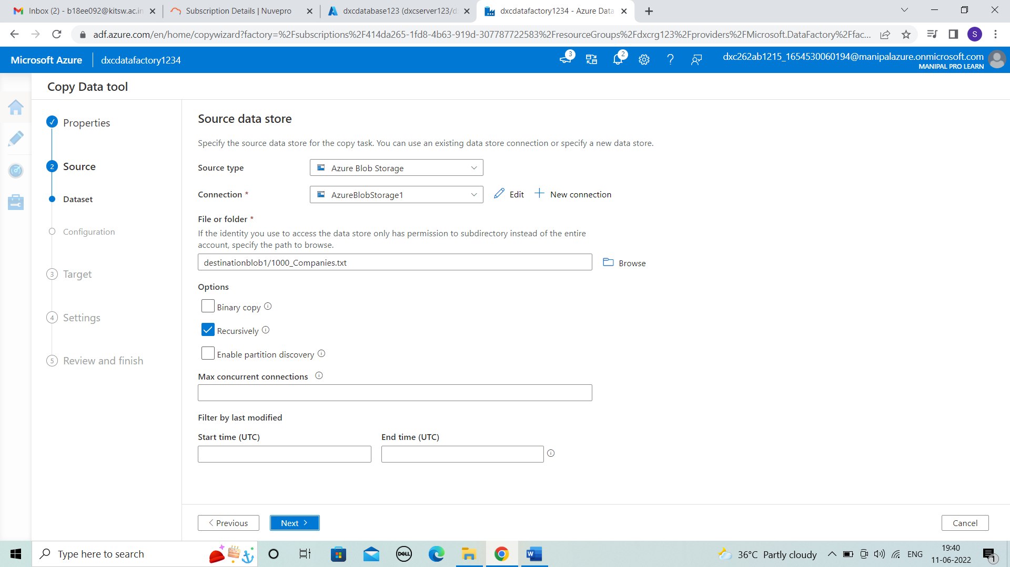



**STEP 5:** In target , click on next for file format settings.

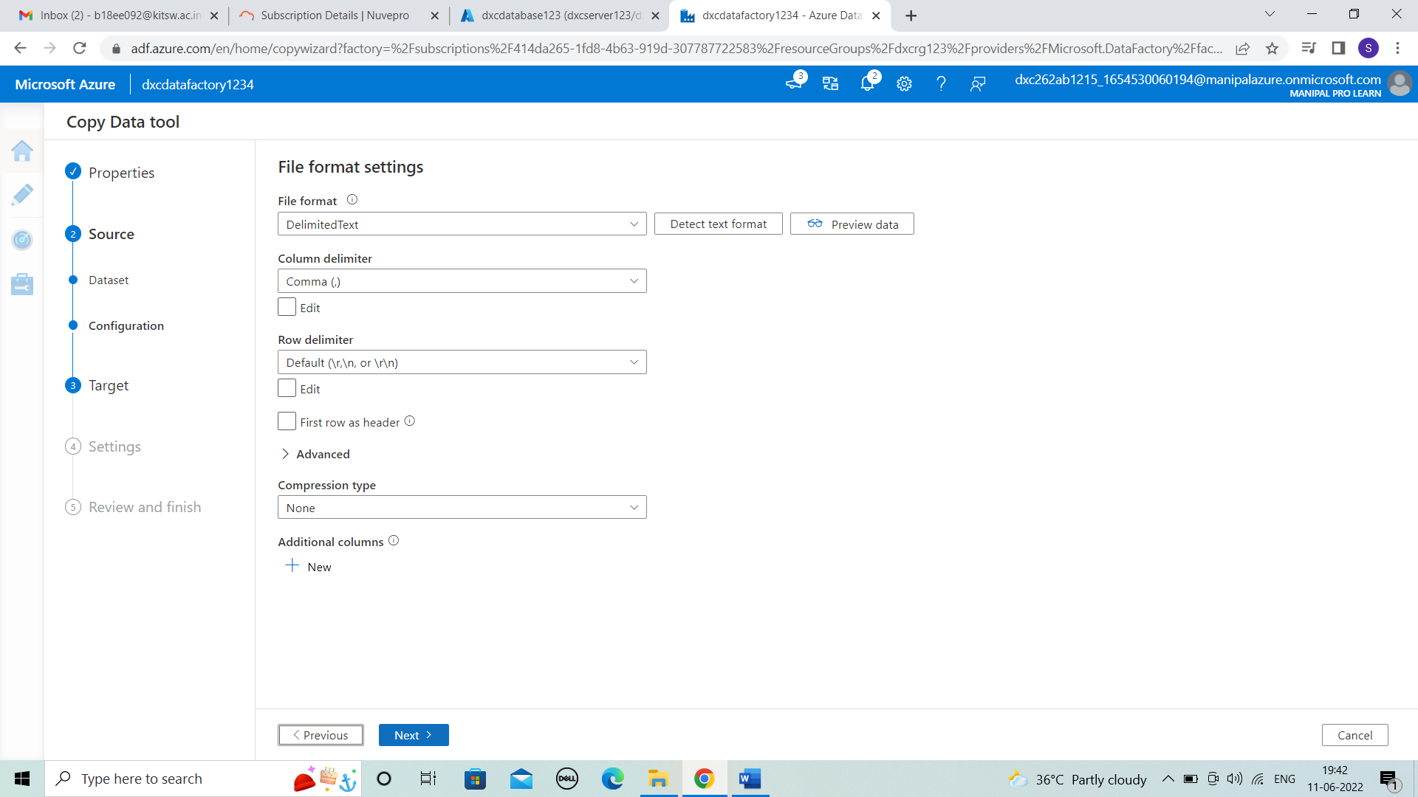



**STEP 6:** In destination data store create new connection , by new linked service by entering the details of server name, database name and test connection . Then, click on create.

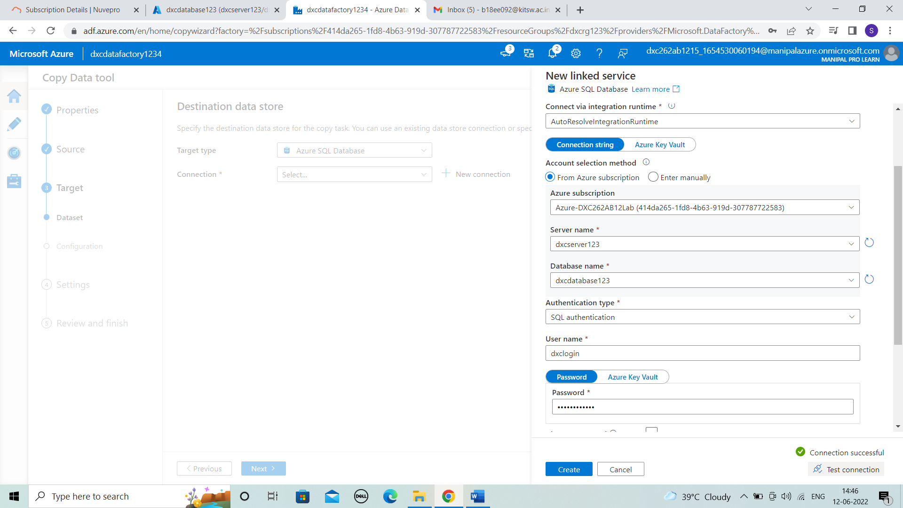



**STEP 7:** Enter the target details as the file that uploaded.

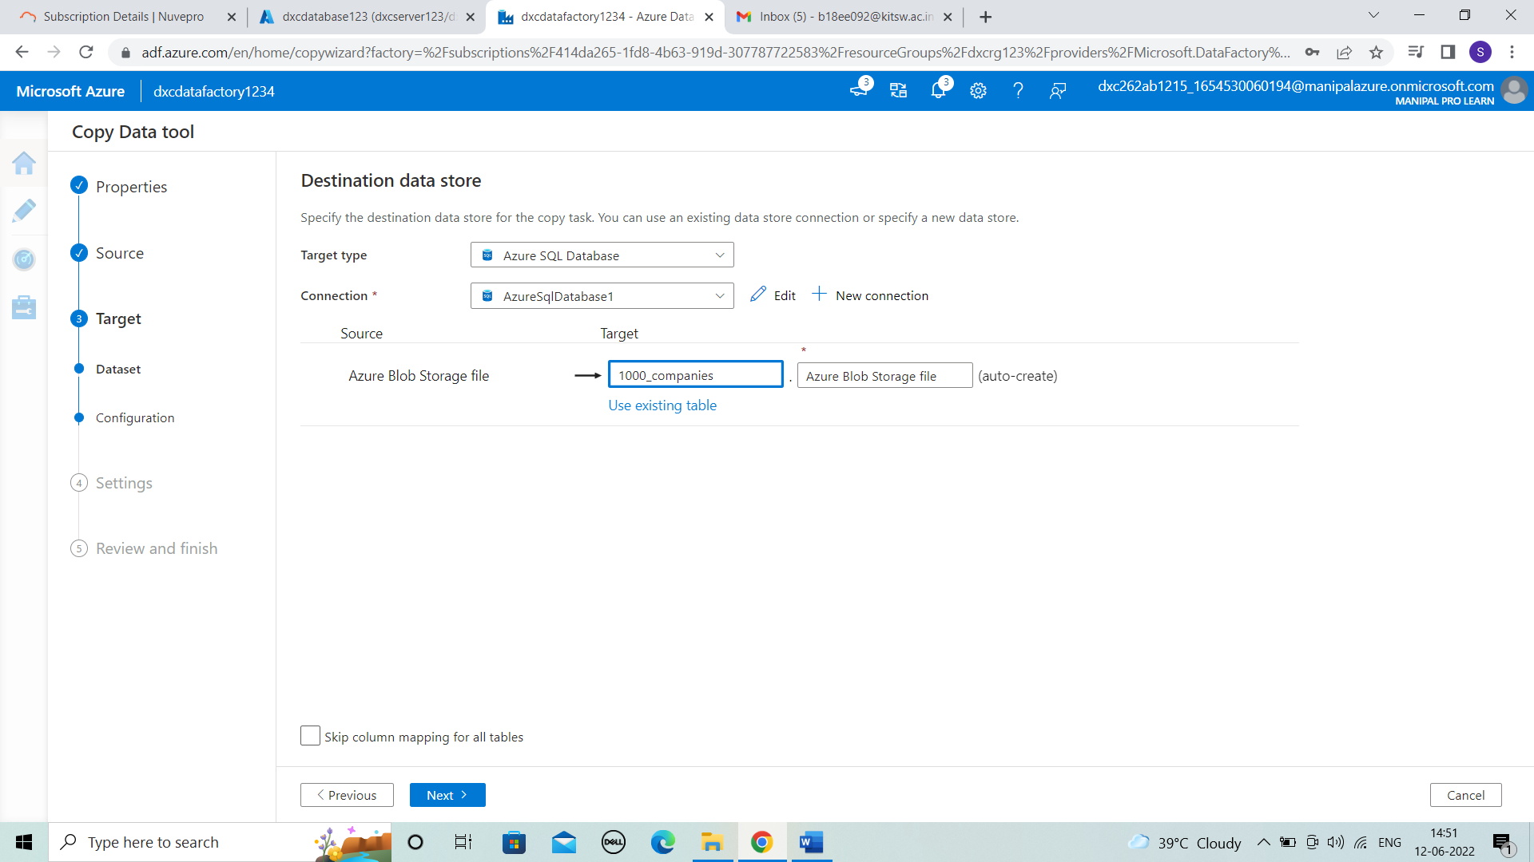



**STEP 8:** Now, check the column mapping and click on next.

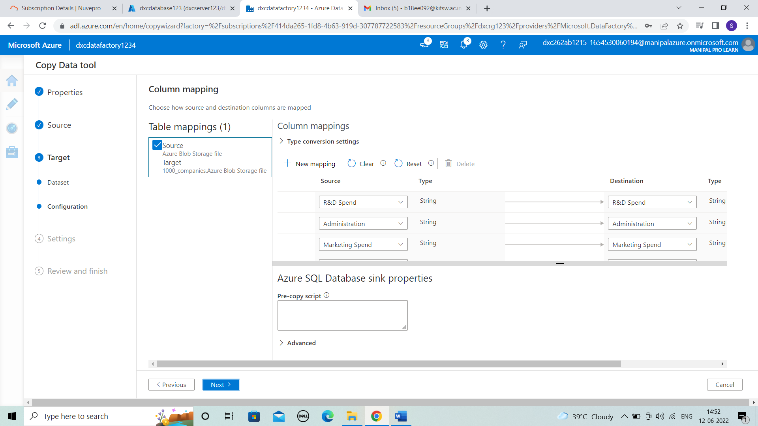



**STEP 9:** In setting task name is given as pipeline and then > next.

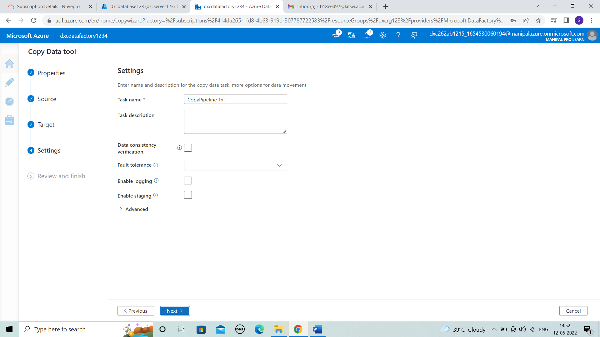



**STEP 10:** Check the summary details and then > next.

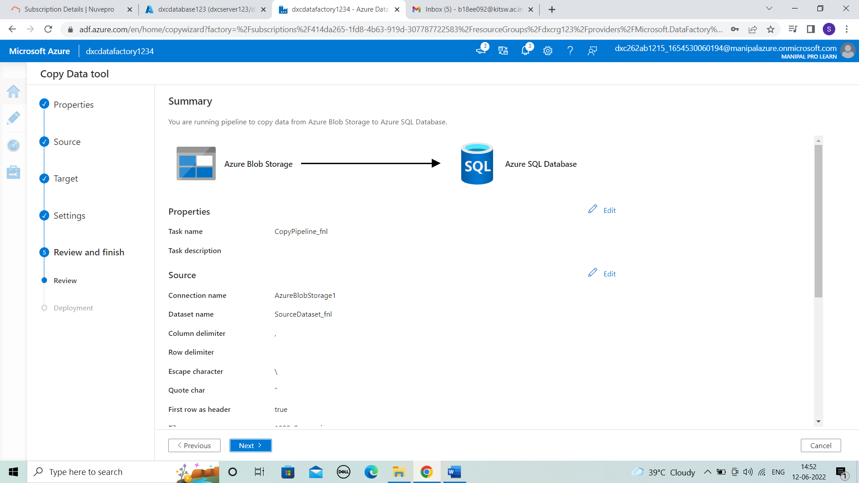



**STEP 11:** The deployment is completed. And click on finish.

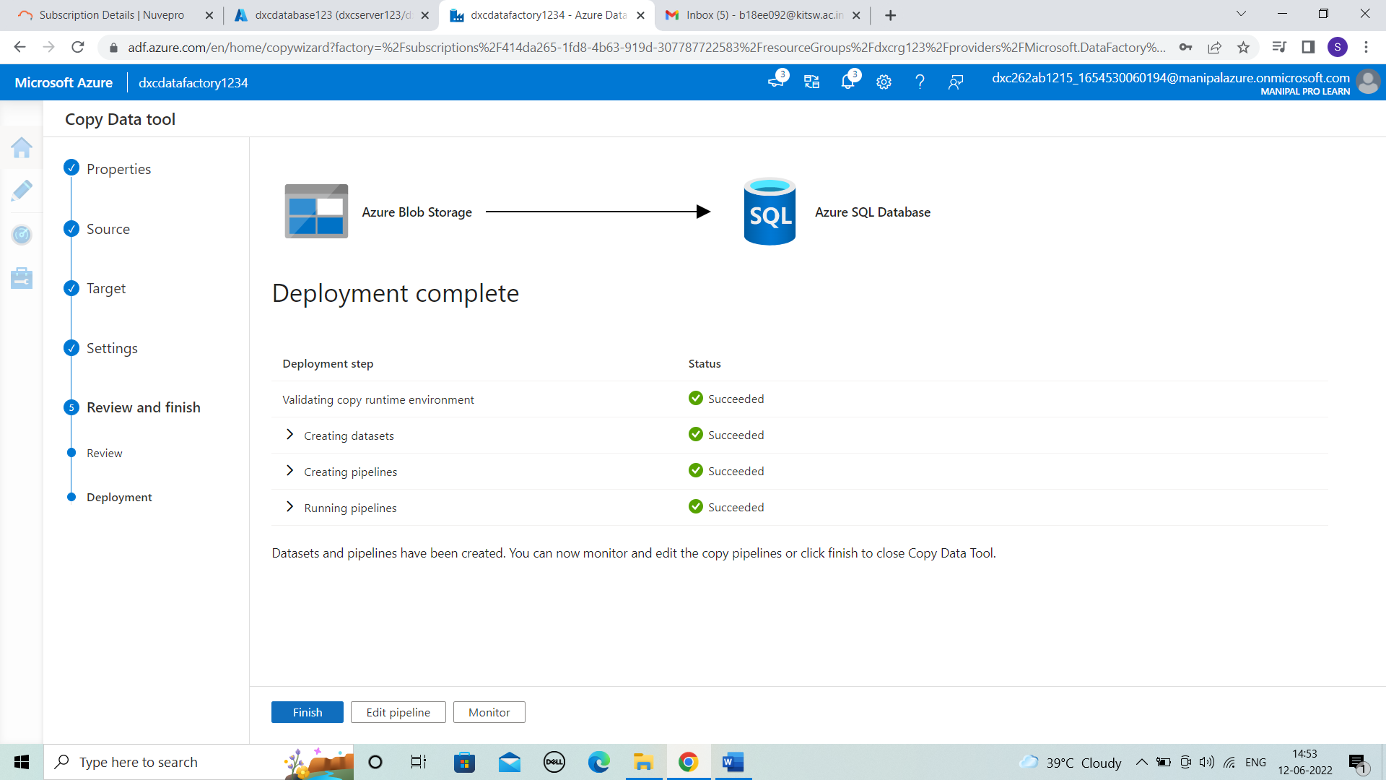



**STEP 12:** After creating the pipeline . In monitor the pipeline is viewed and it is succeeded.

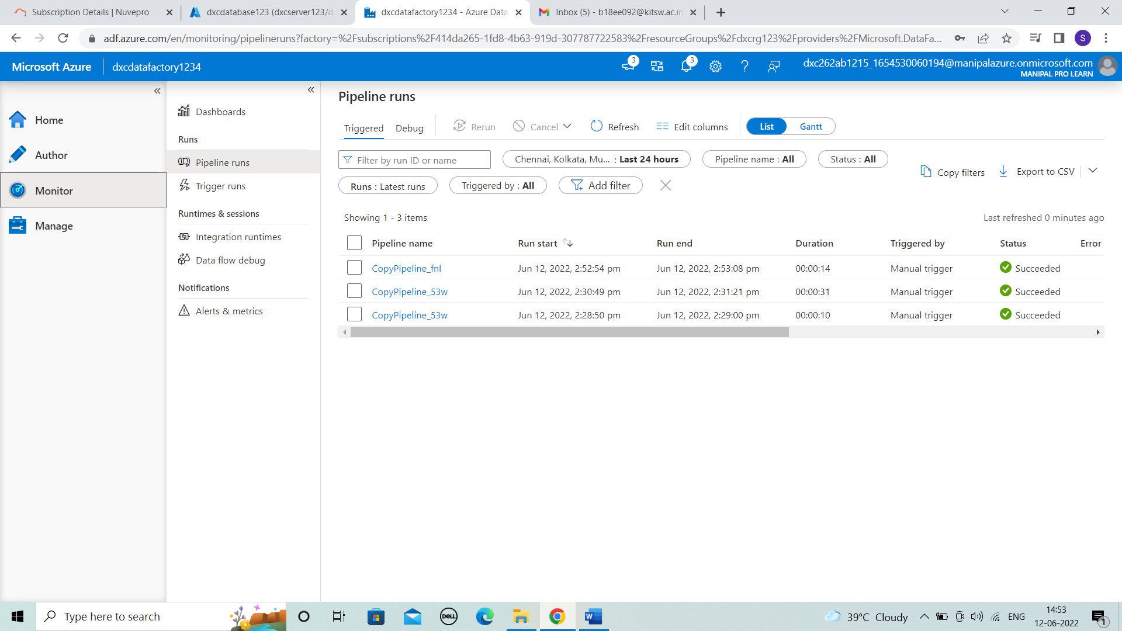



**STEP 13:** Coming to database to check the pipeline successful by the data is available in it . Login with details shown and allow it by updating the firewall rules.

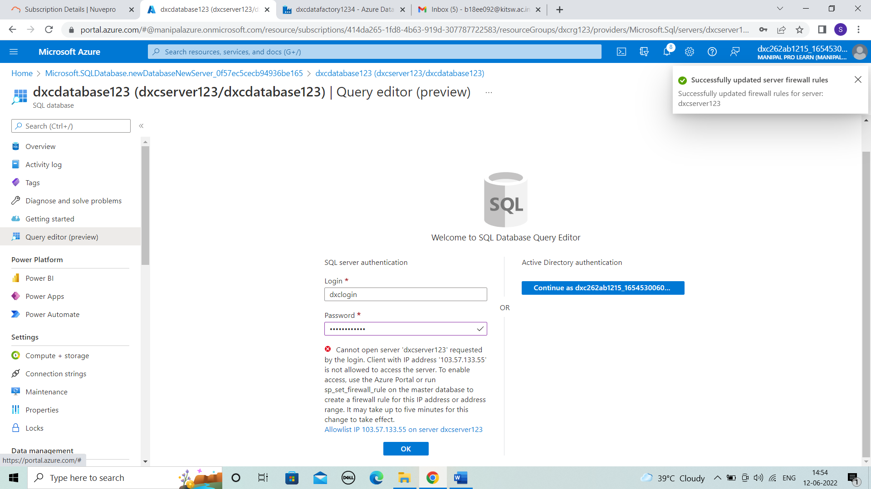



**STEP 14:** After login we can view the data in query editor .

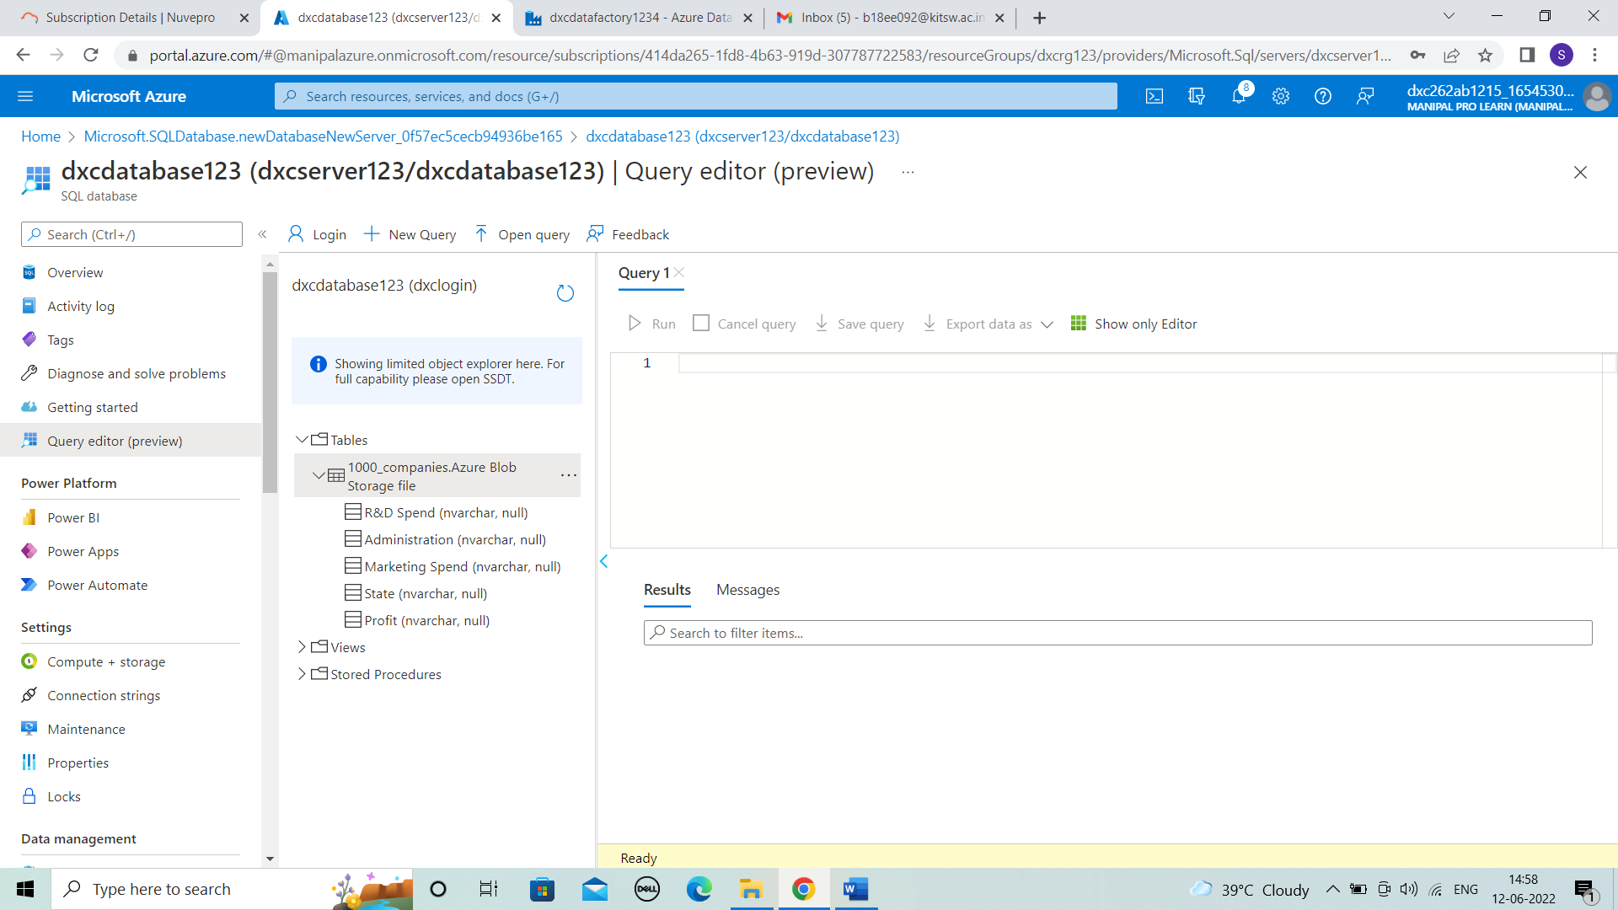



**STEP 15:** Run the data to view table .

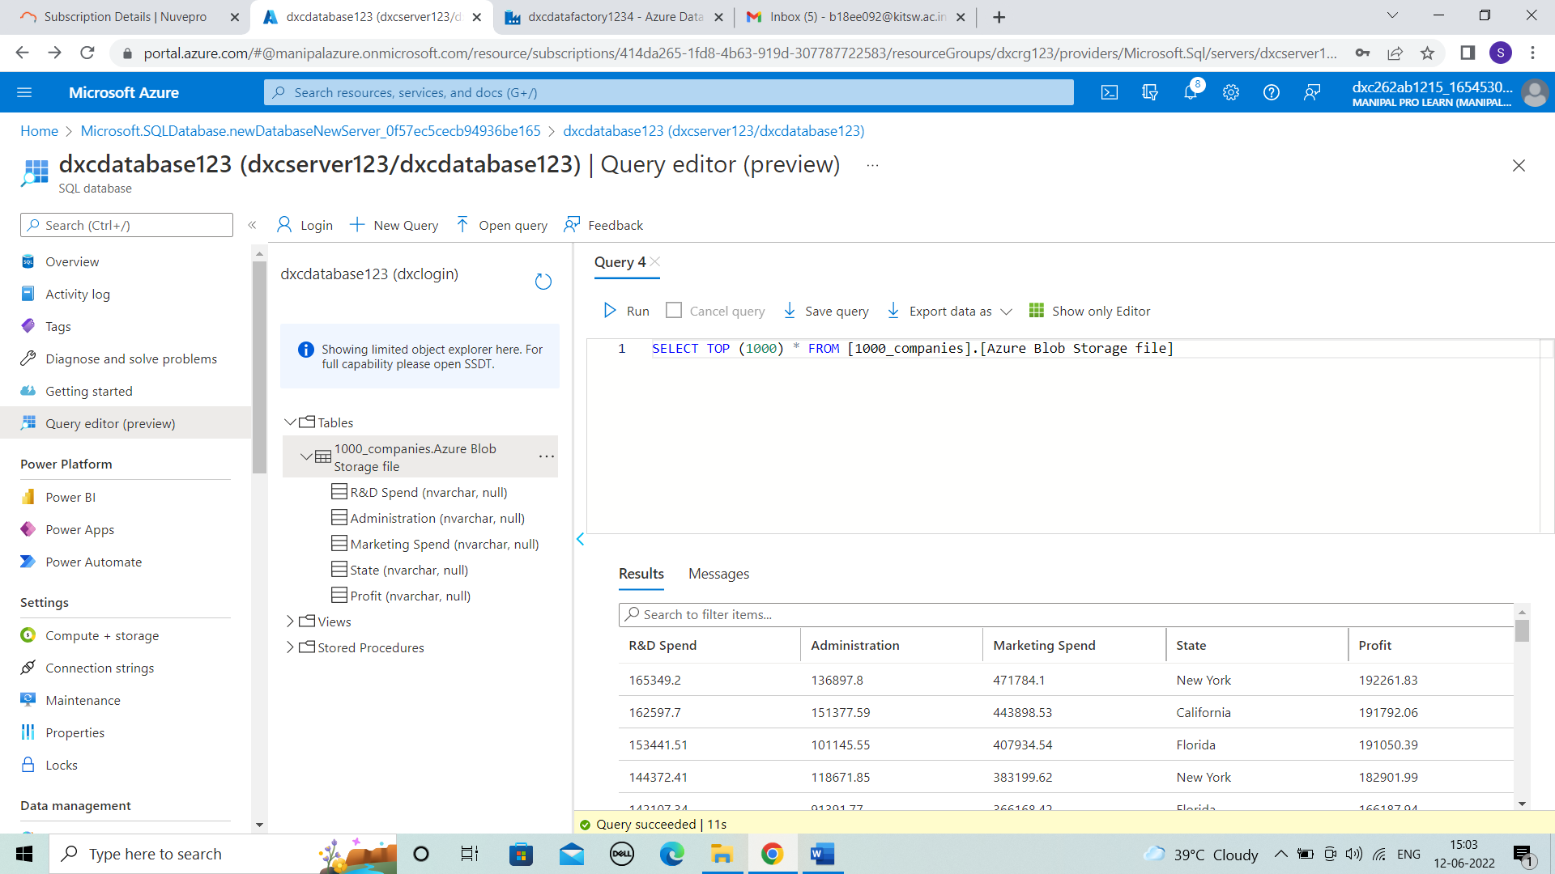



**Result:** In this project 1, We created a pipelines that will validate and copy the blob data from source to destination and then to SQL database by triggering each using Azure Data Factory.

**Conclusion:** The Blob data moved and stored into SQL database by using pipelines in datafactory.

Name: SUPRIYA BHARATHA o

Reg No: DXCAB1211

**Project 2 Name: AP Morgan Data Platform**

Date: 12th JUNE 2022

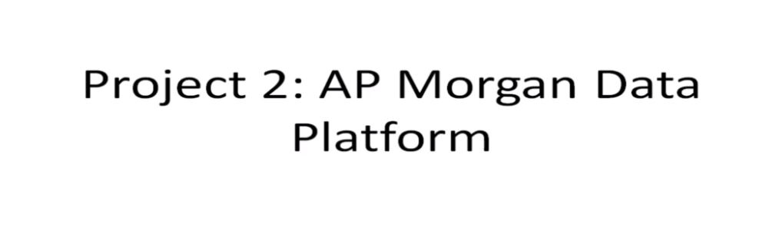

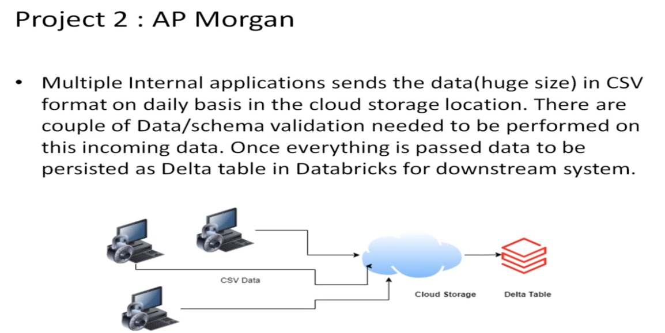

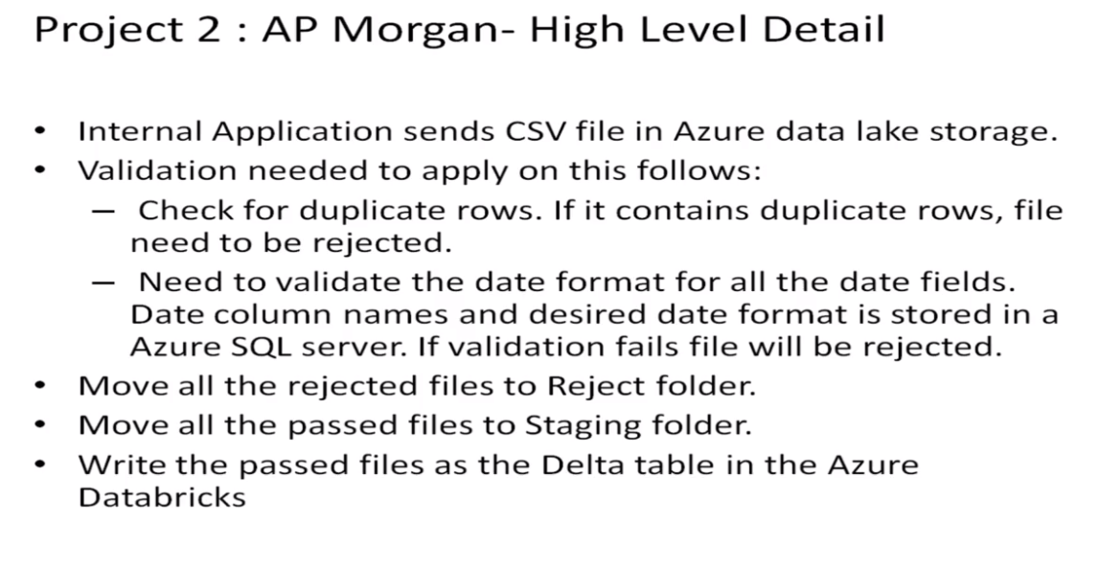

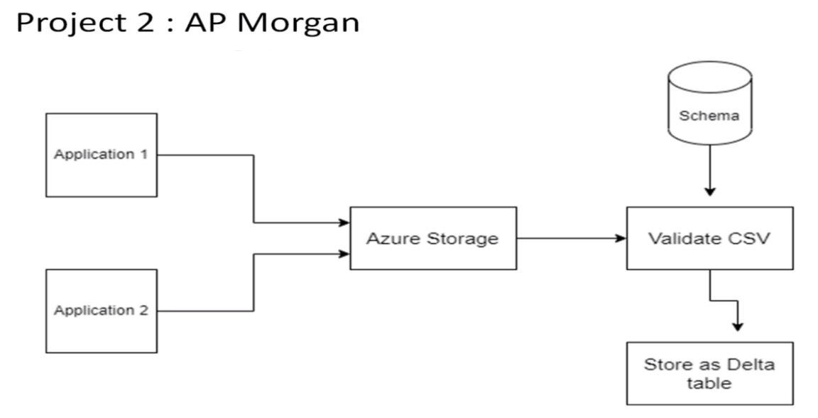

* **Practical Lab: Create a Databricks**

**STEP 1:** Search for Azure databricks and select it.

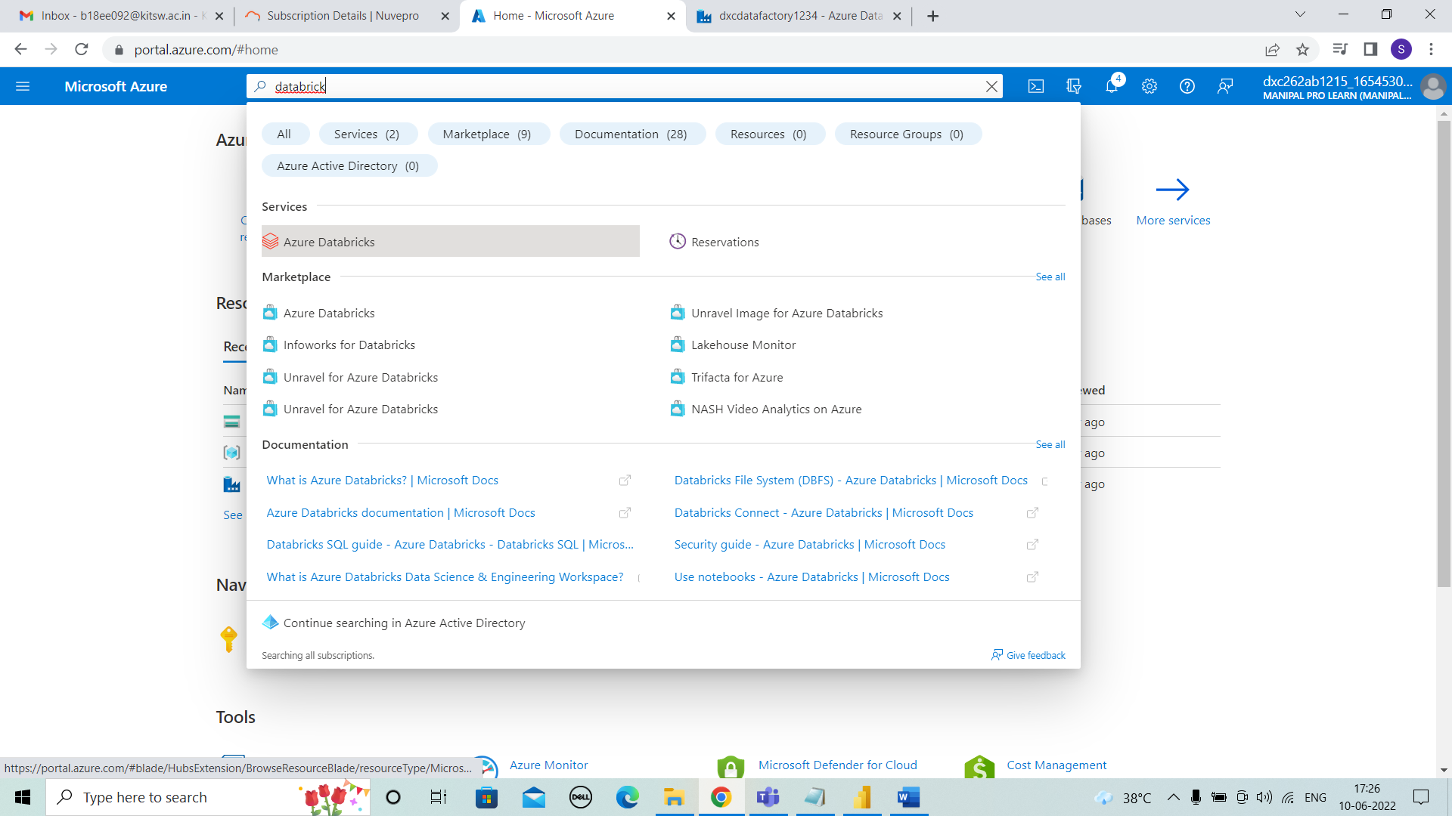



**STEP 2:** After selecting click on “ + create”.

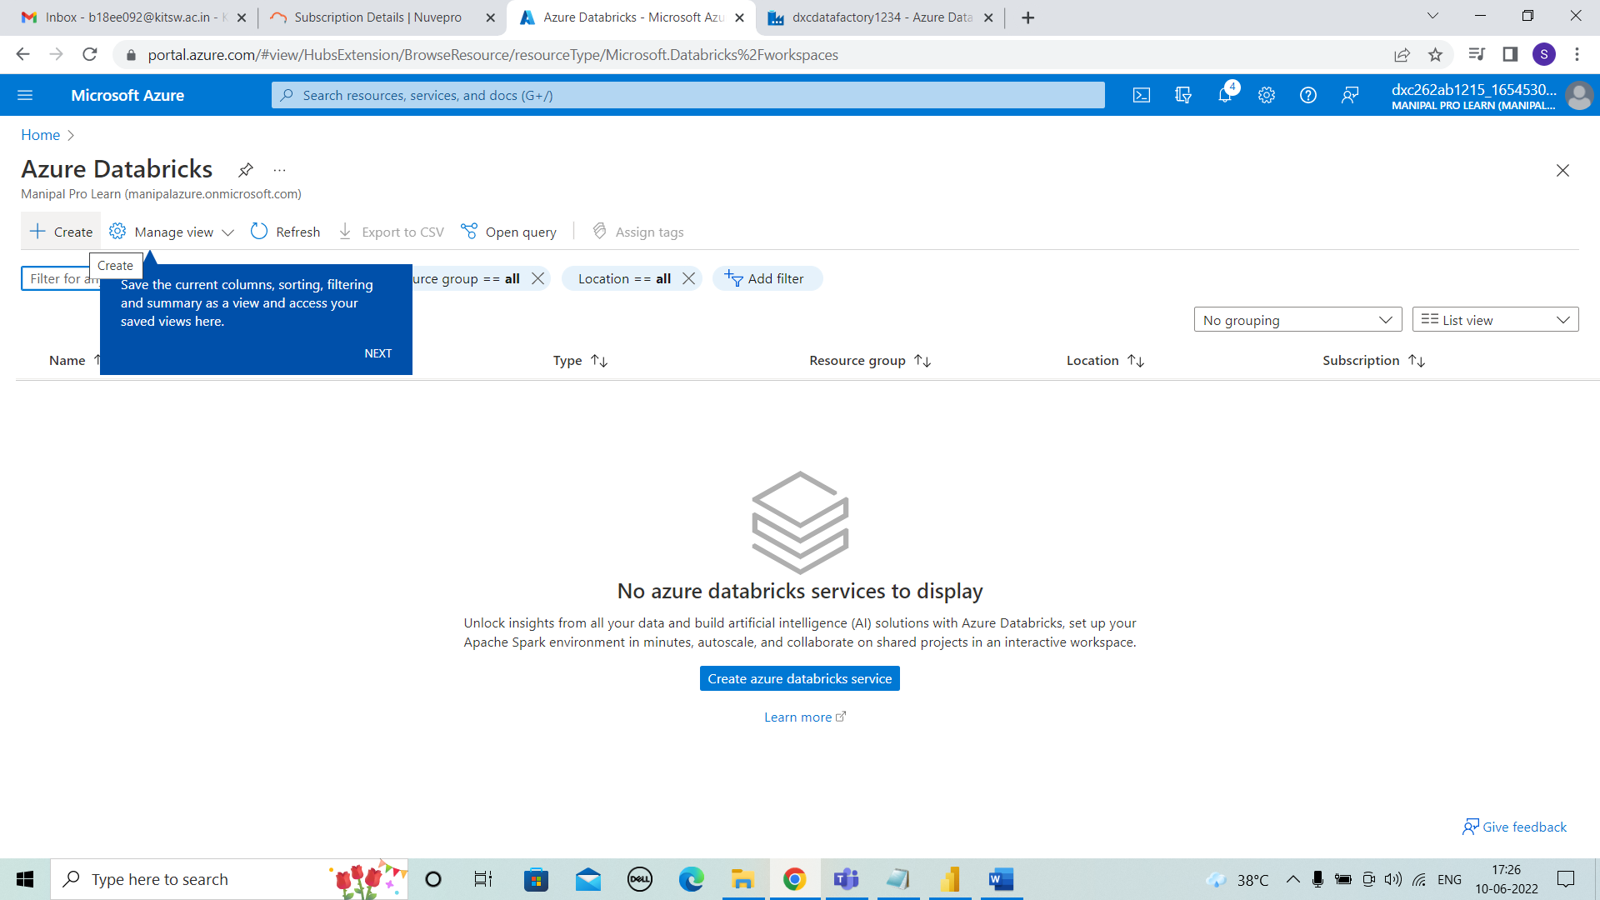



**STEP 3:** For creating enter the details of resource group, workspace name, pricing tier. And click on review + create.

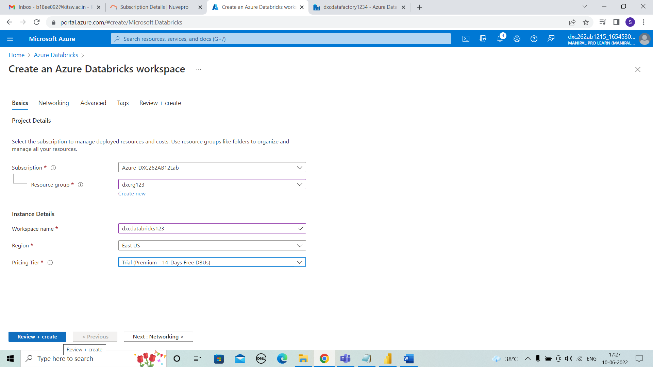



**STEP 4:** In review + create check the details, validation is succeeded. And click on create.

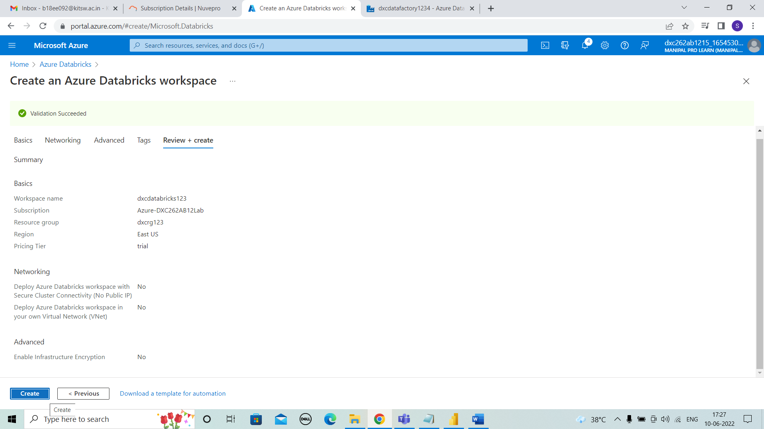



**STEP 5:** After selecting create, deployment will be in progress.

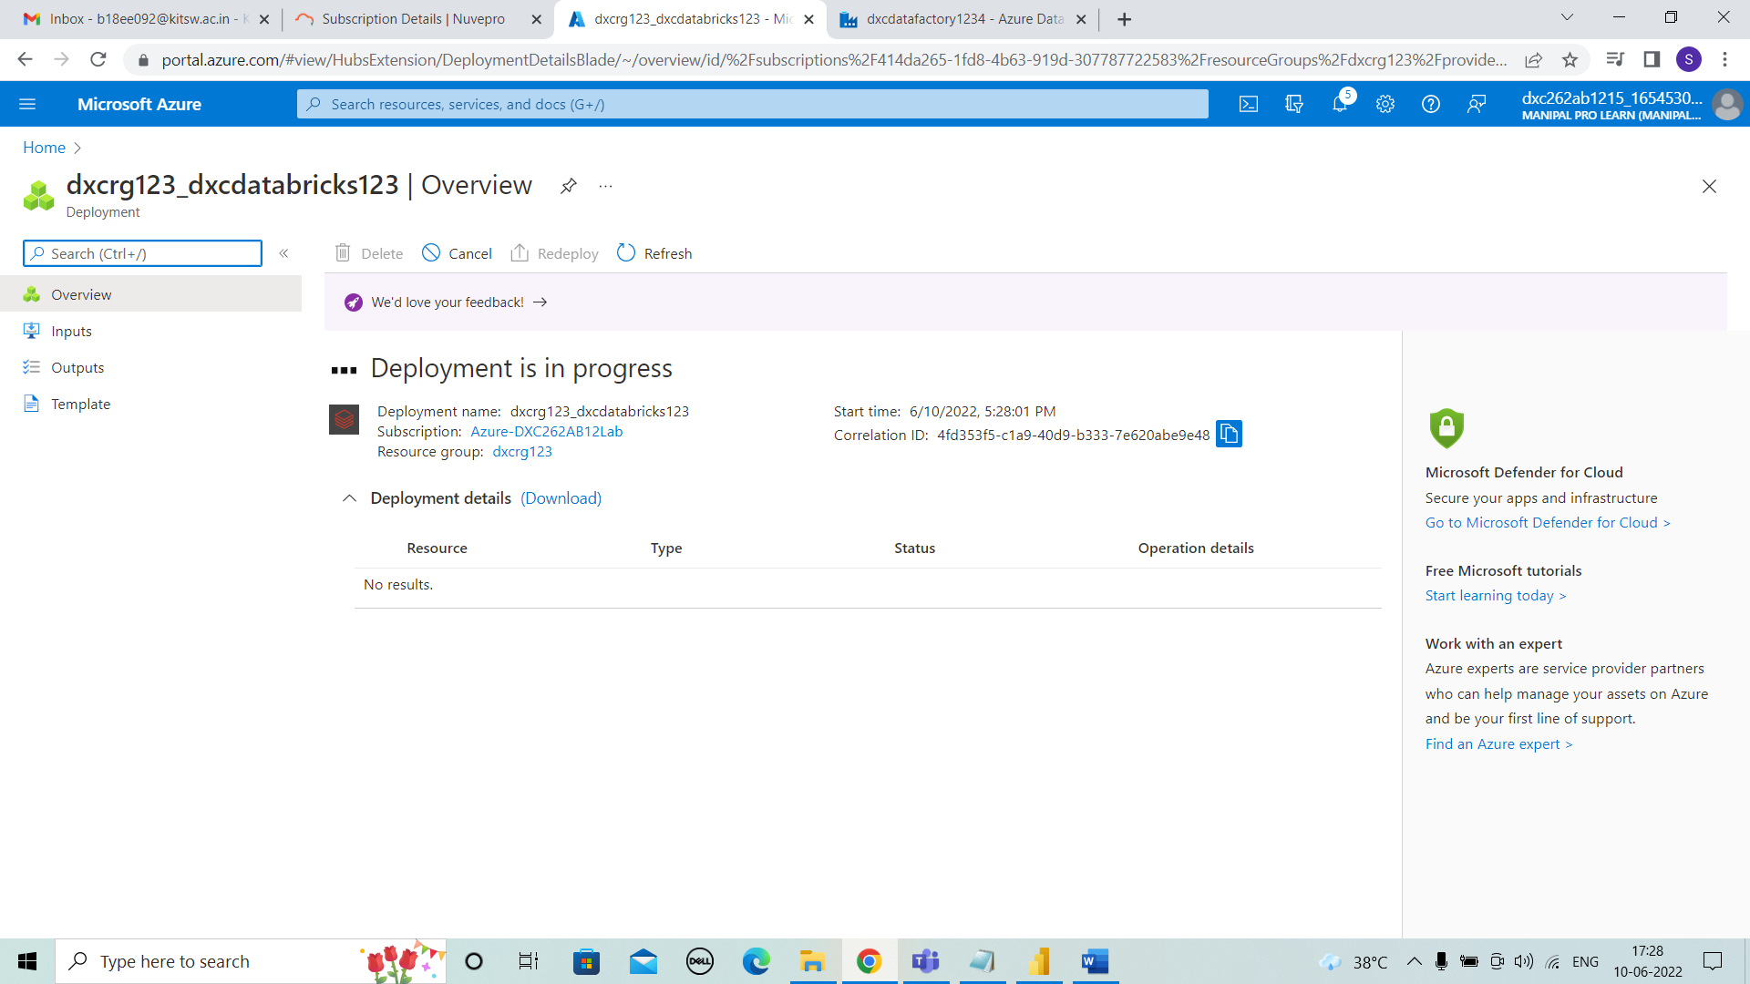



**STEP 6:** After few minutes the deployment is completed and then go to resource.

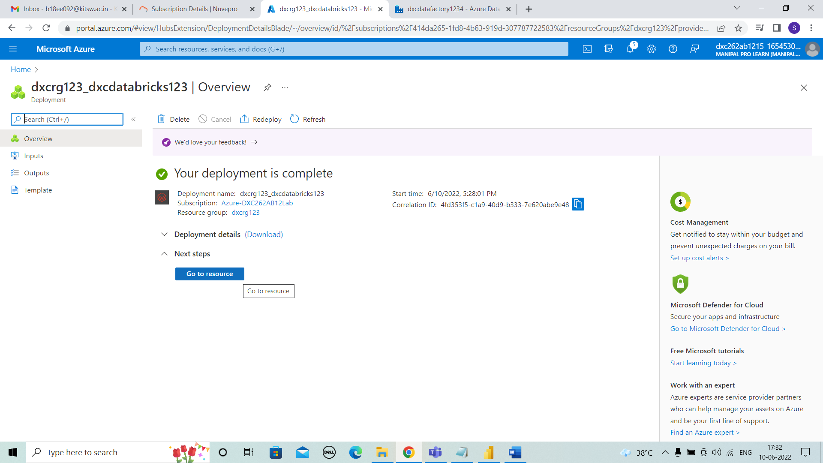



**STEP 7:** In resource we can observe the overview of databricks and we need to launch the workspace.

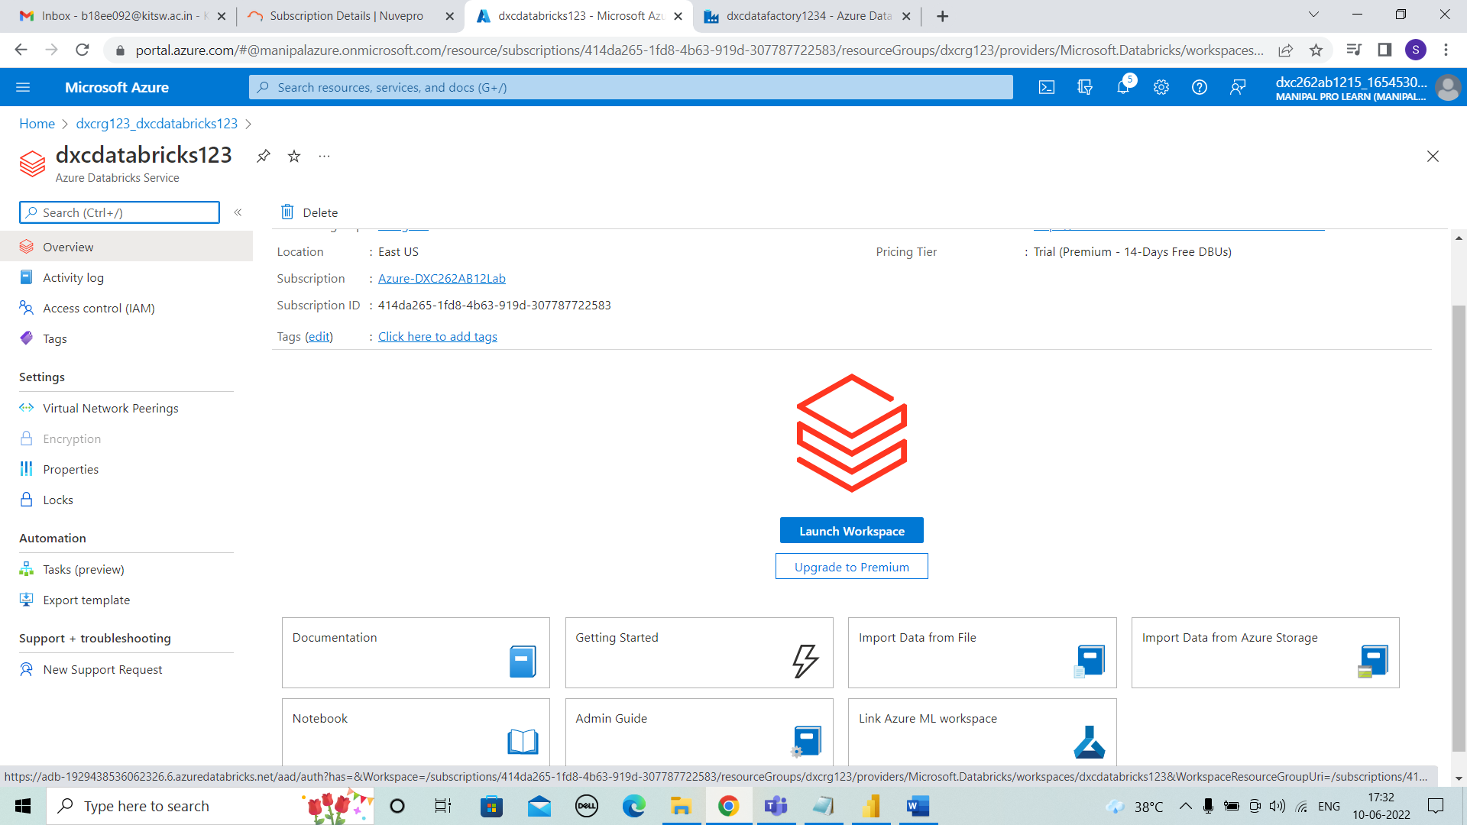



**STEP 8:** After launching the workspace we can see the page as shown below.

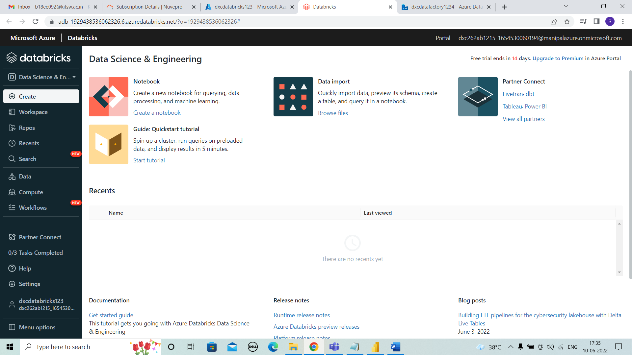



* **Practical Lab: Create Cluster in Azure Databricks**

**STEP 1:** For creating cluster, select compute on left side of tab shown and click on create cluster.

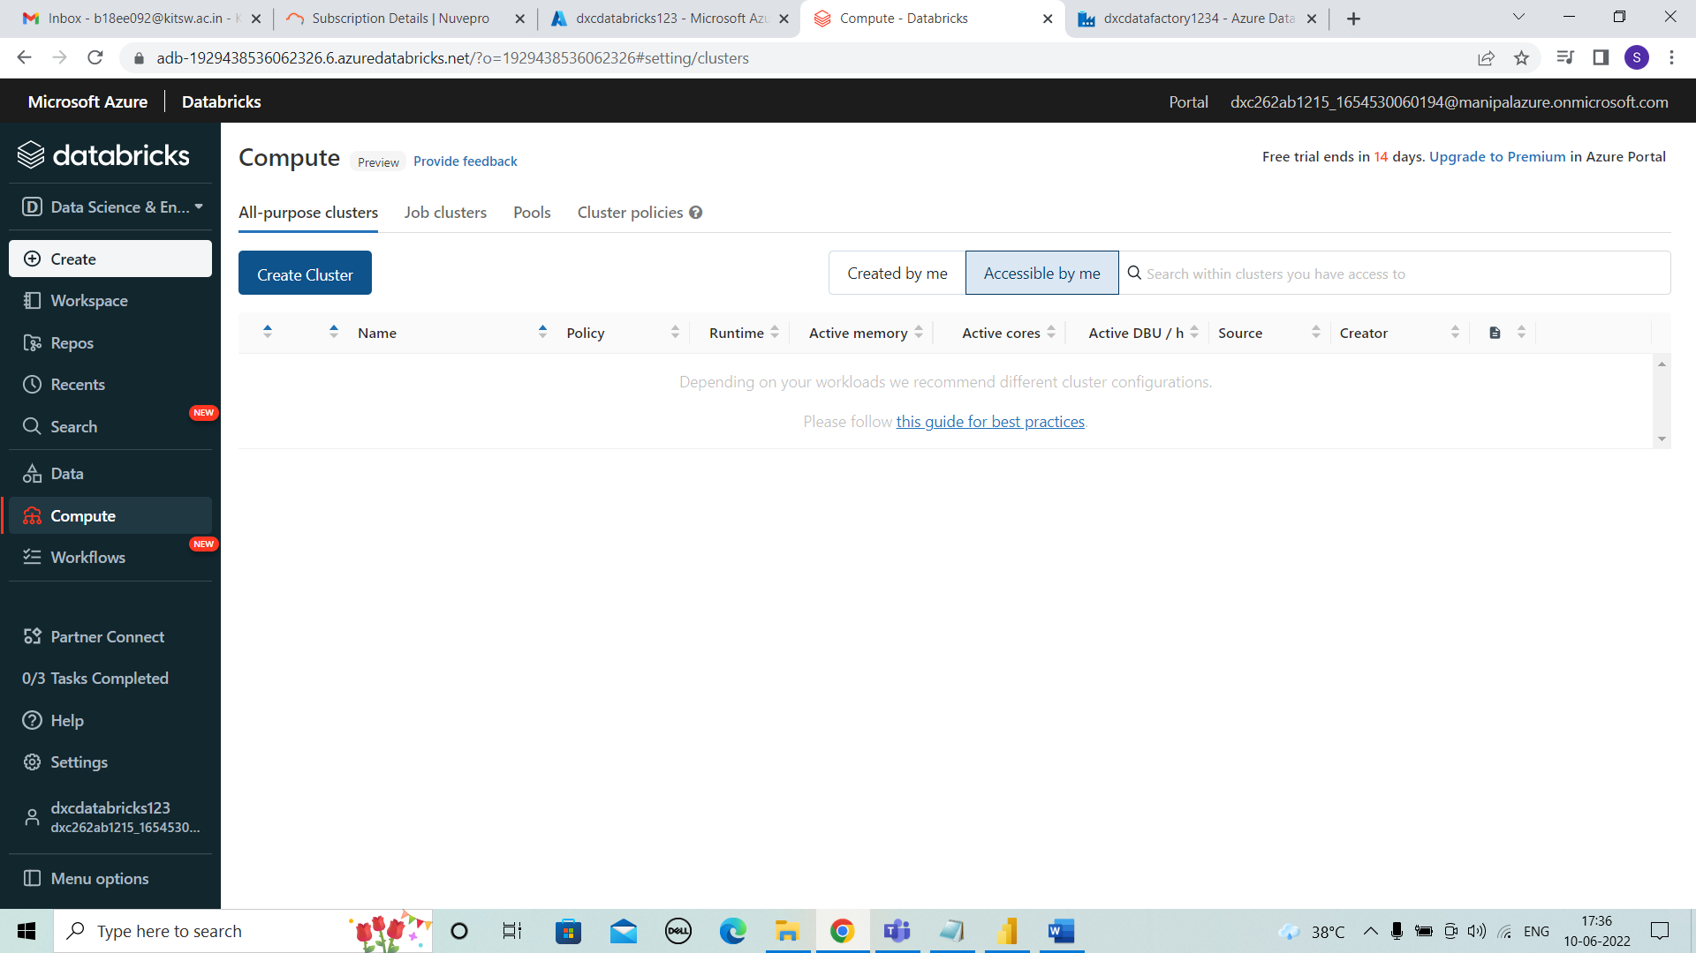



**STEP 2:** We need to enter the details of cluster name, cluster mode, runtime version, terminate time for new cluster . And click on create.

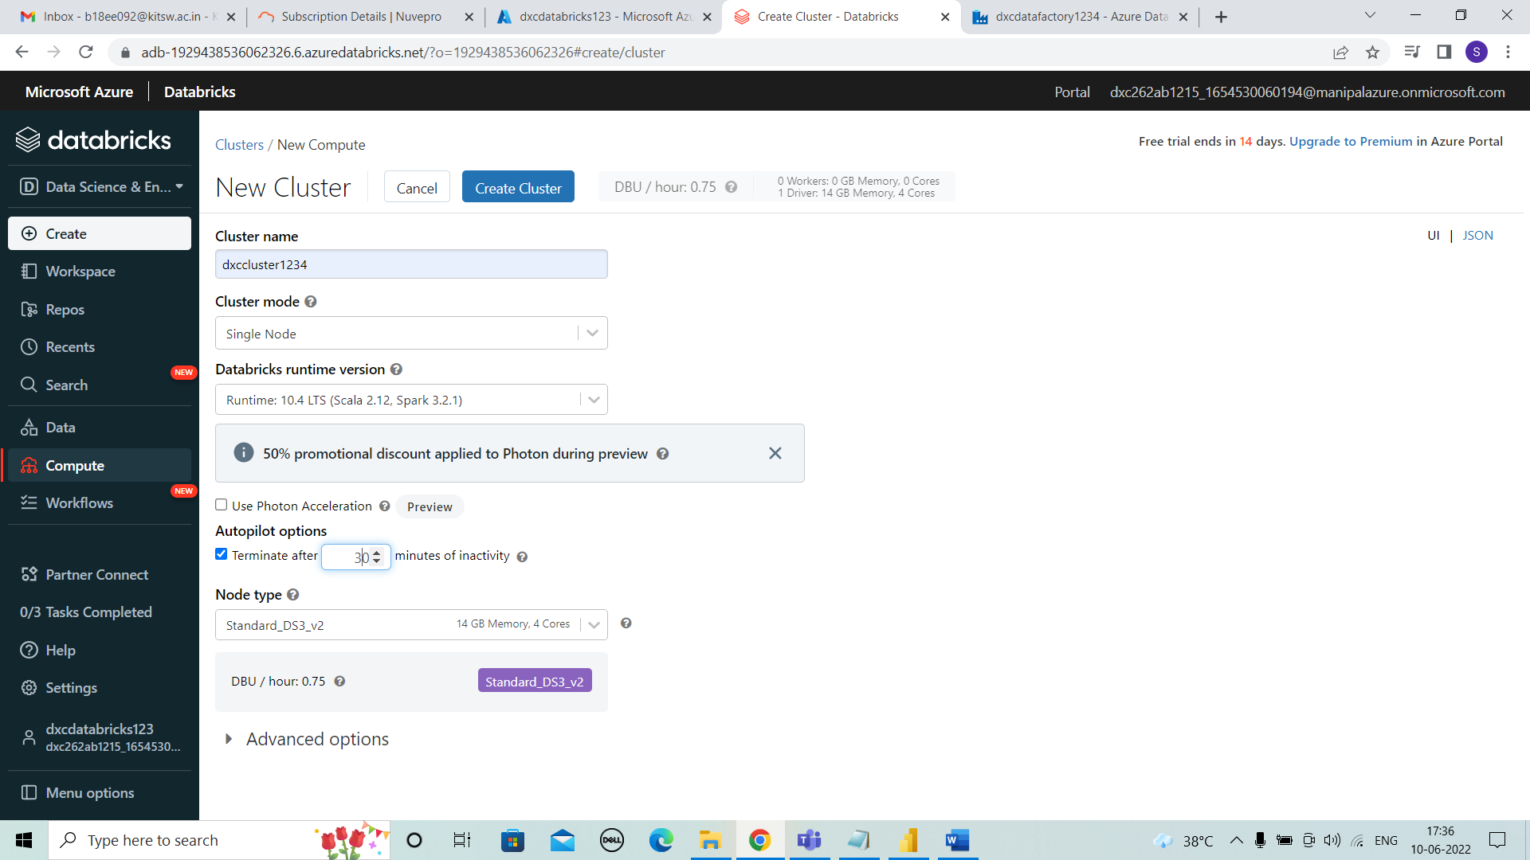



**STEP 3:** The cluster is getting created..

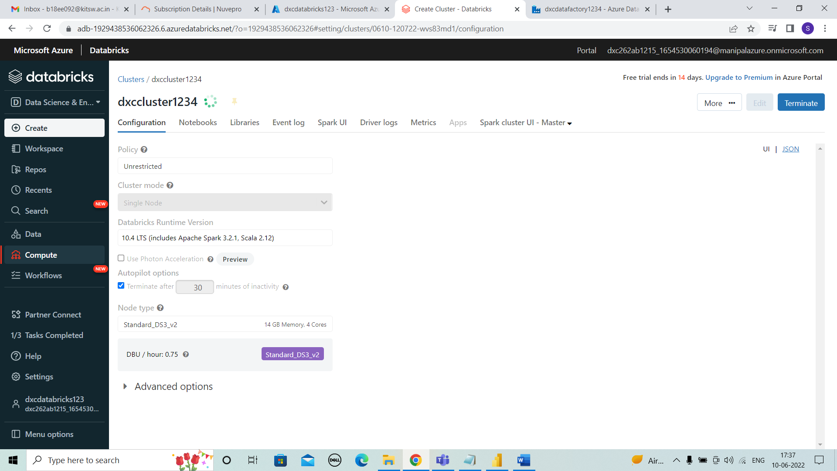



**STEP 4:** The cluster is created which is shown by tick mark after creating.

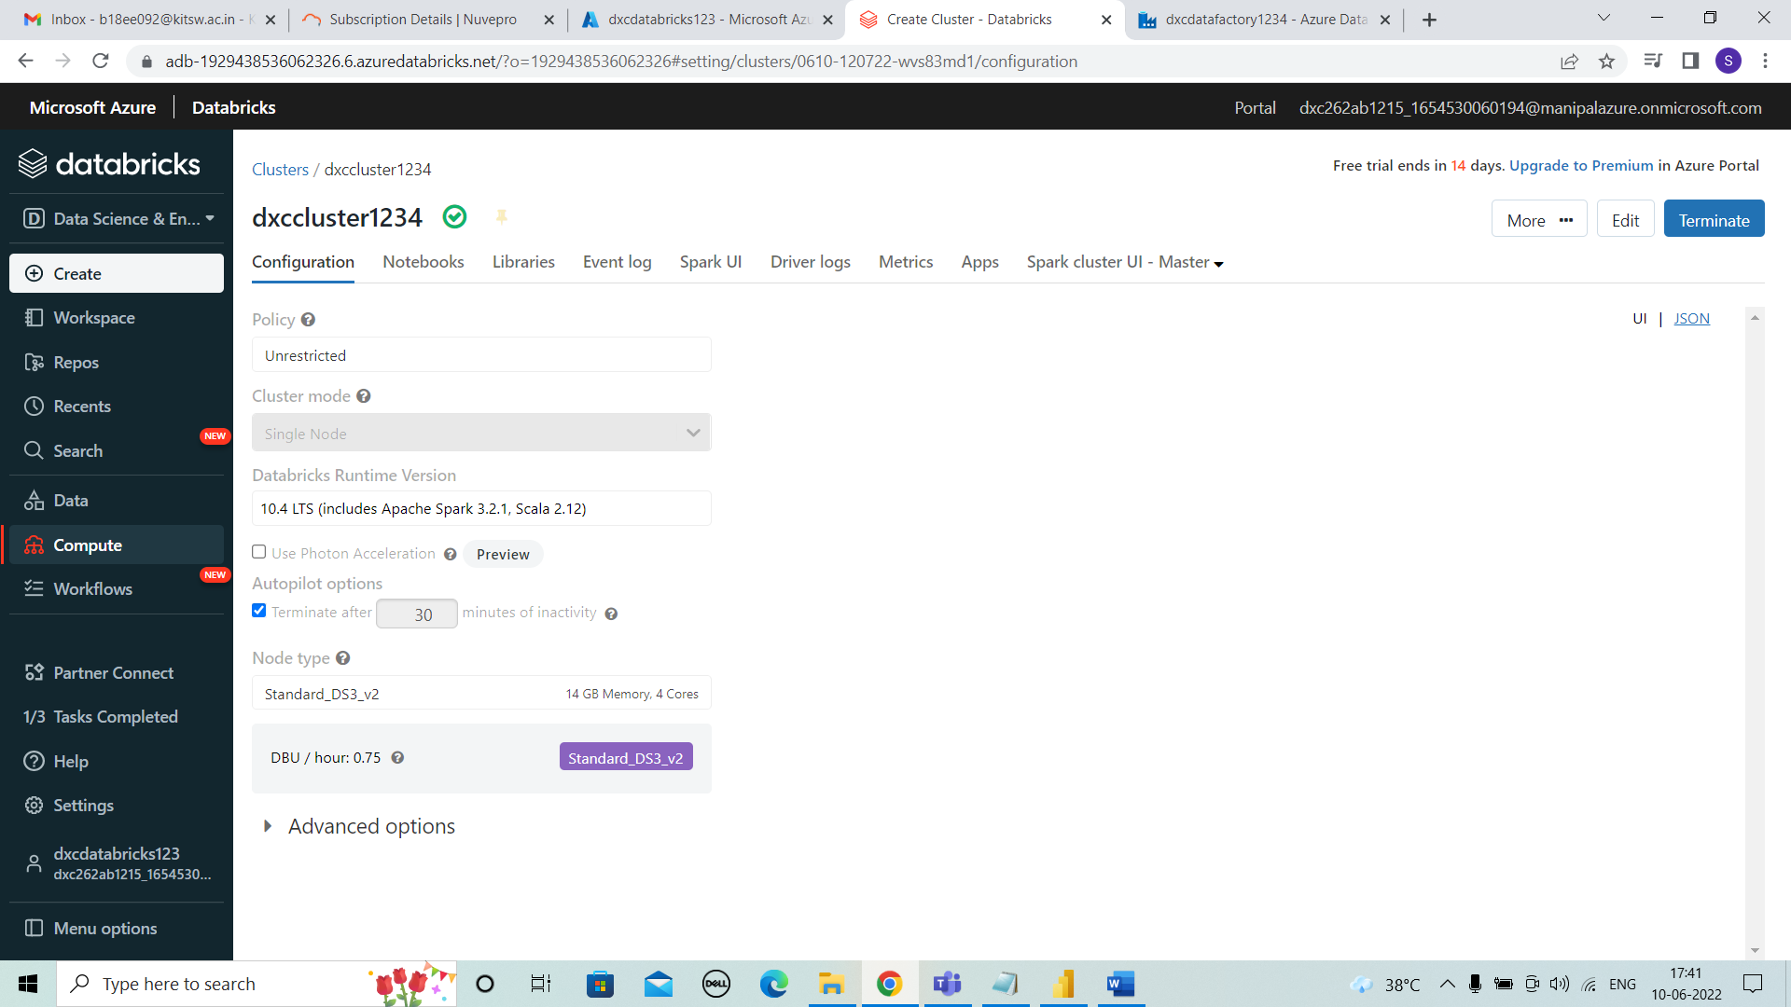



**STEP 5:** The created cluster can be viewed as shown below.

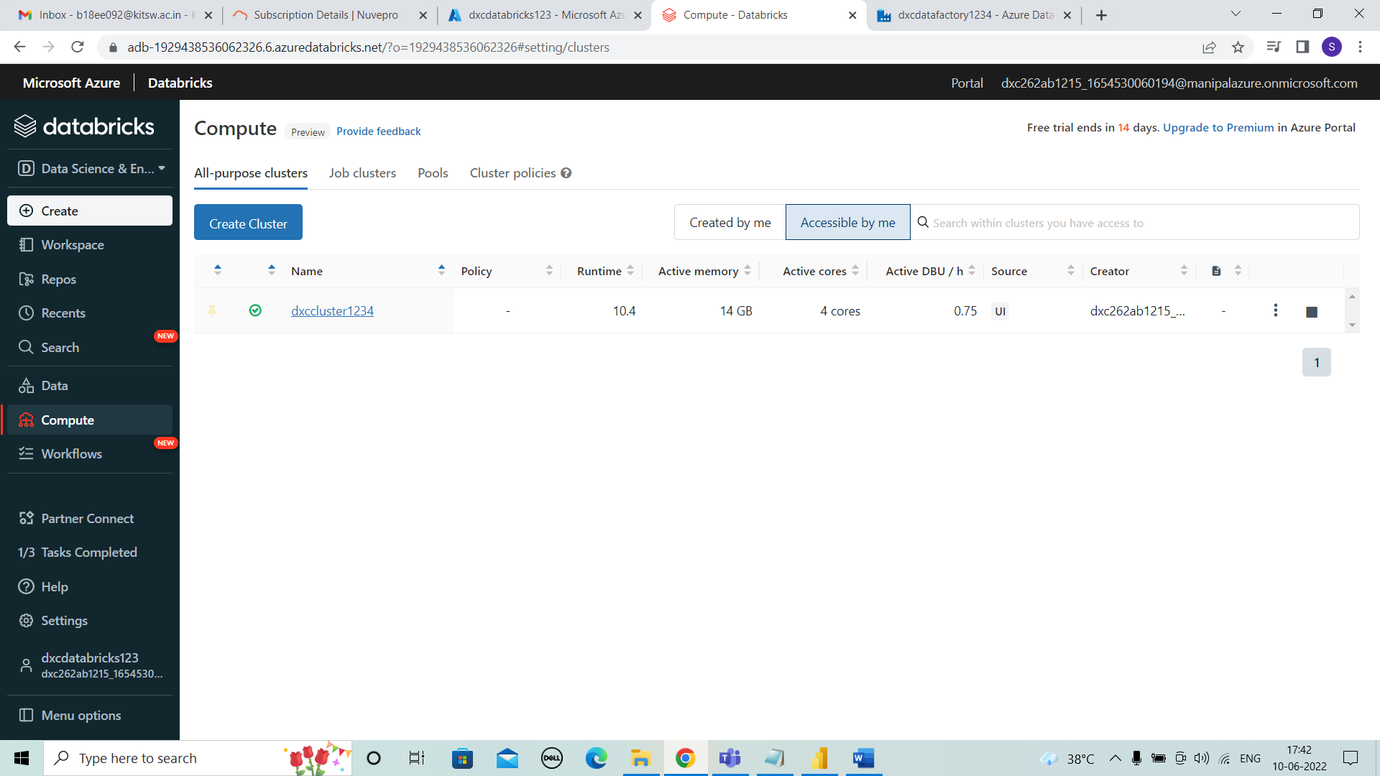



* **Practical Lab: Add notebook in Databricks and Implement the Business Logic**

**STEP 1:** For adding notebook into the databricks , we need to select workspace > Create > Notebook.

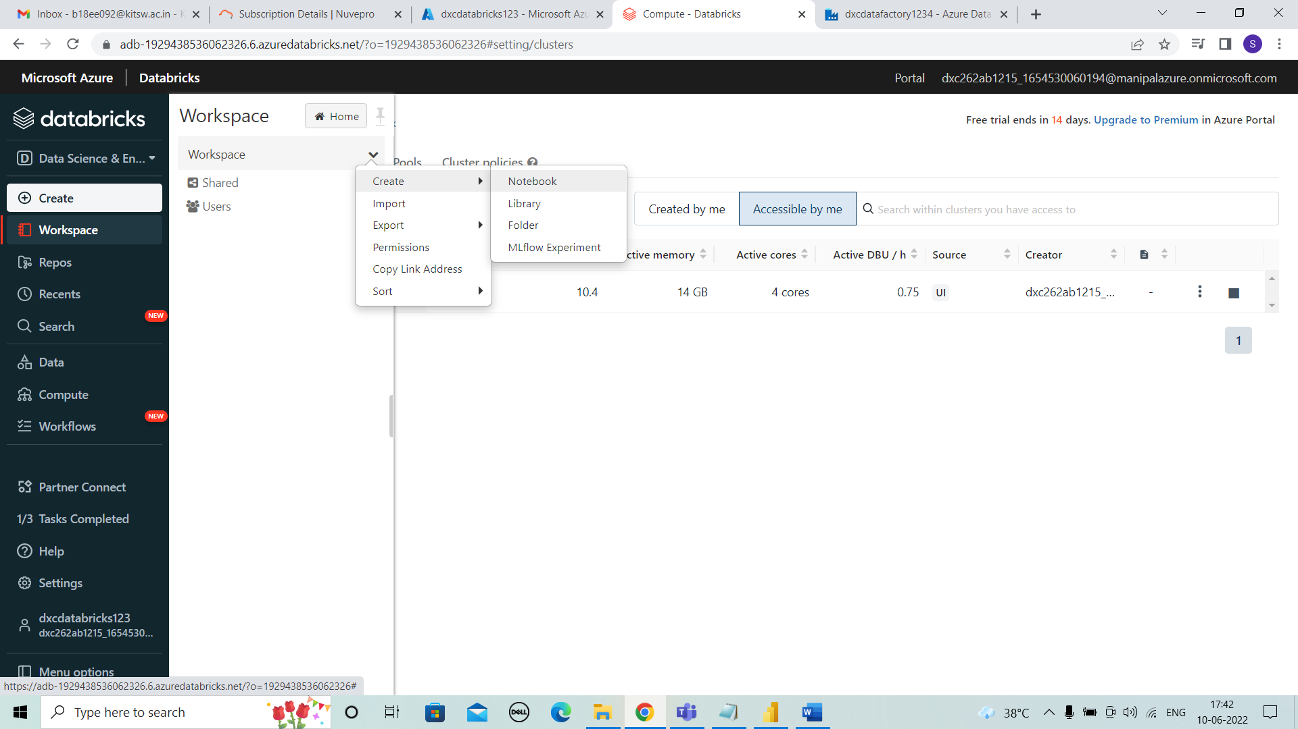



**STEP 2:** As, shown we can create a notebook by entering the name and click on create.

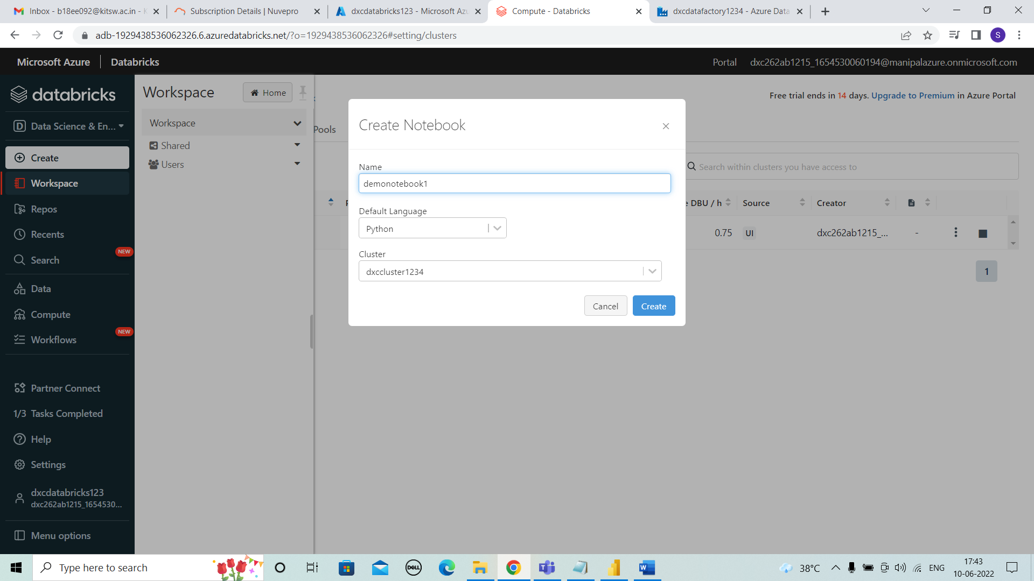



**STEP 3:** After notebook is created we can enter code and run it as shown below and view the result and run time.

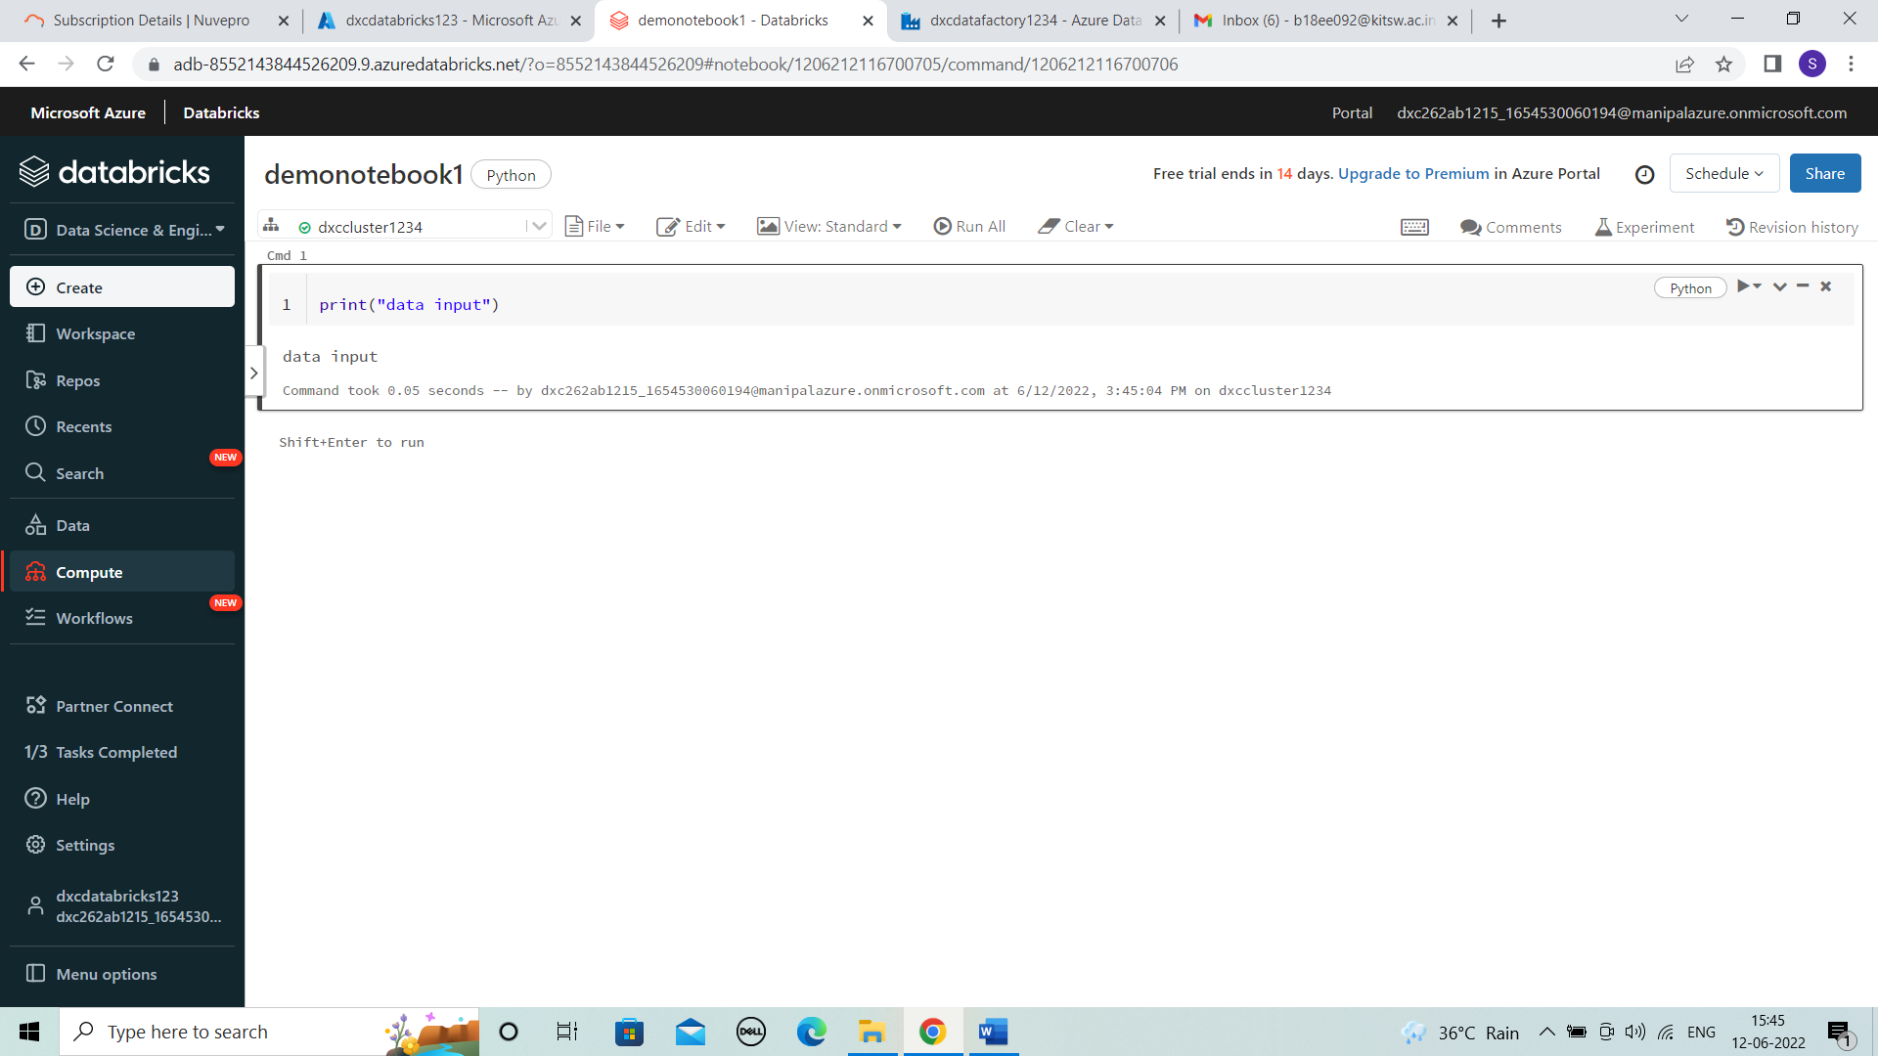



* **Practical Lab: Azure Data Factory For AP Morgan**

**STEP 1:** Search for datafactories and select it.

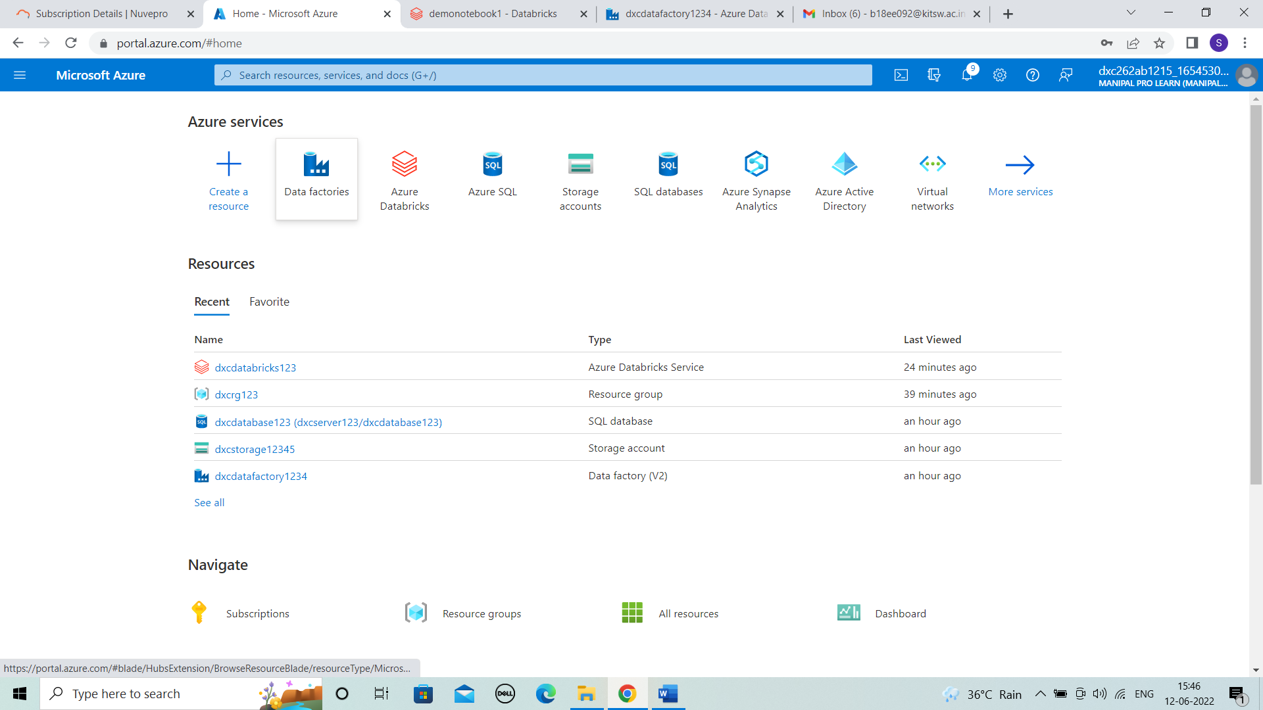



**STEP 2:** After selecting click on “+ create”.

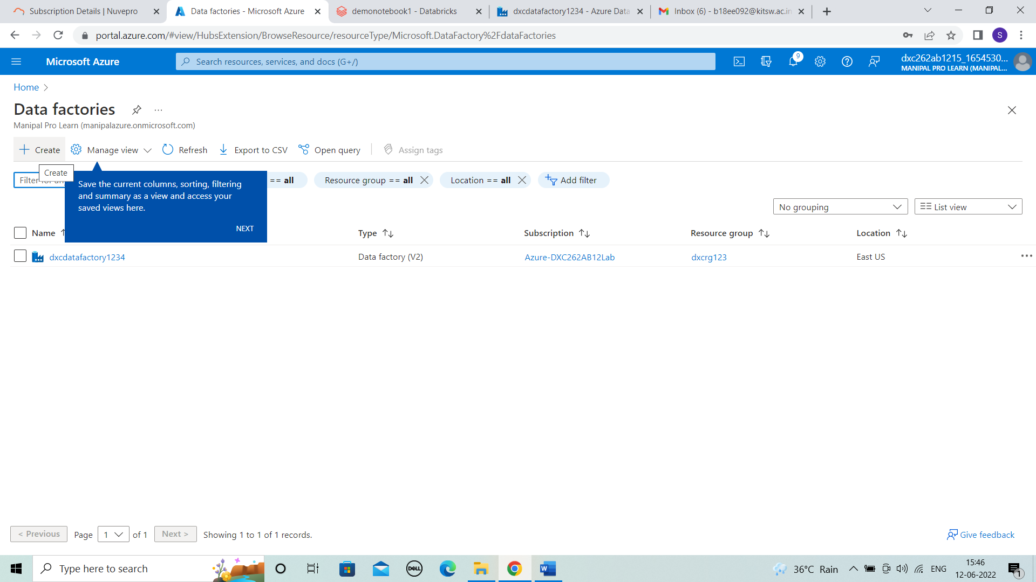



**STEP 3:** Now for creating Ap morgan enter name and resource group.

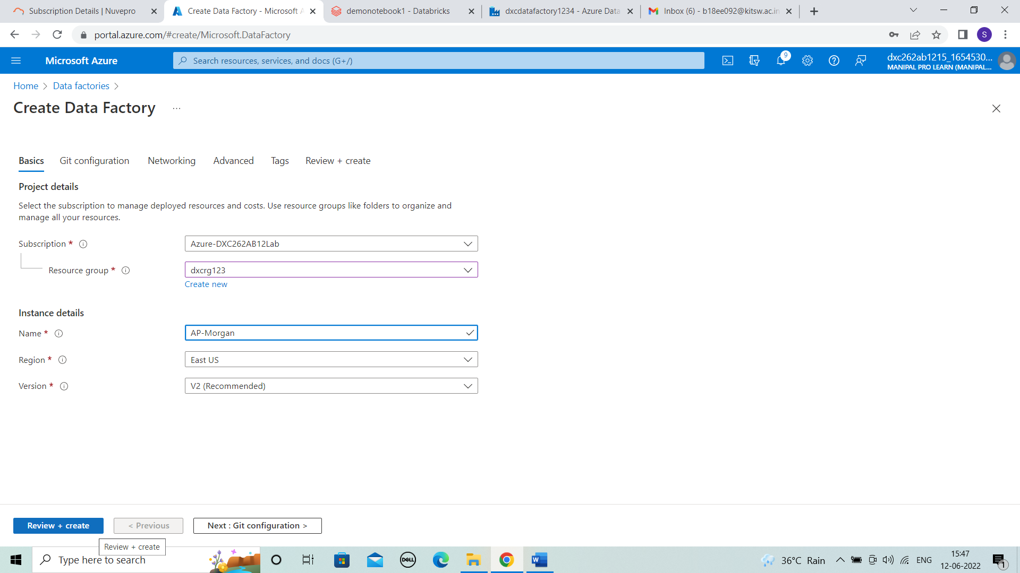



**STEP 4:** Then, click on review + create and we can view the details. Validation is passed and then create.

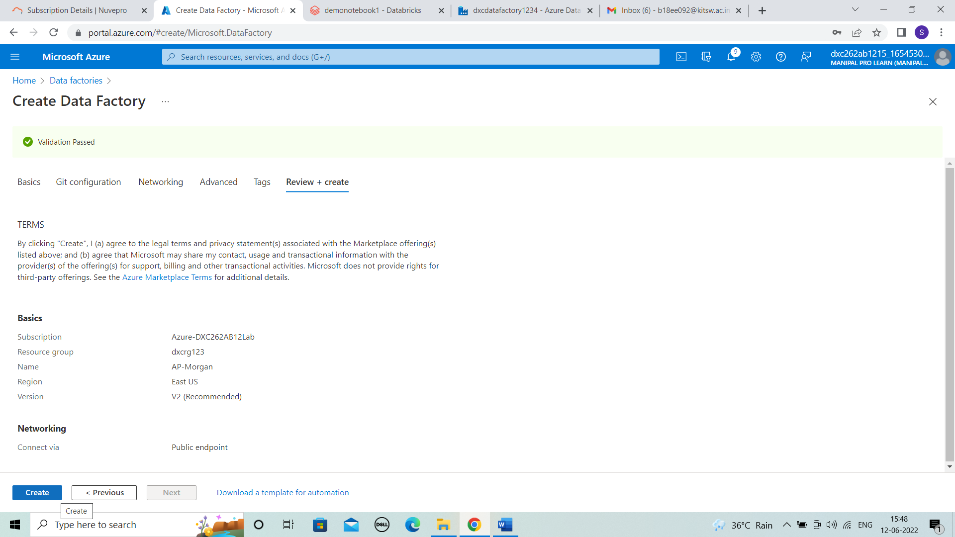



**STEP 5:** The deployment is completed and go to resource.

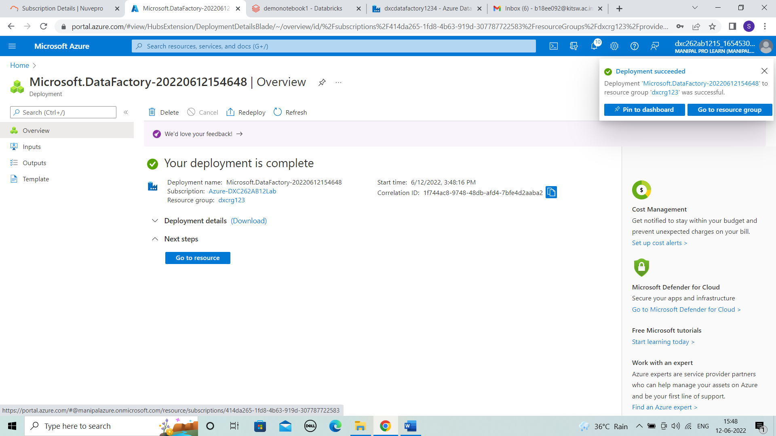



**STEP 6:** In resource we can view overview and then open azure data factory studio.

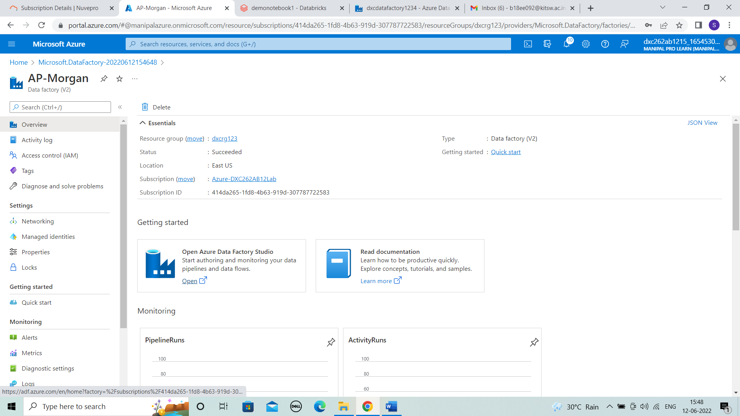



**STEP 7:** The data factory page of AP-Morgan is shown in new page.

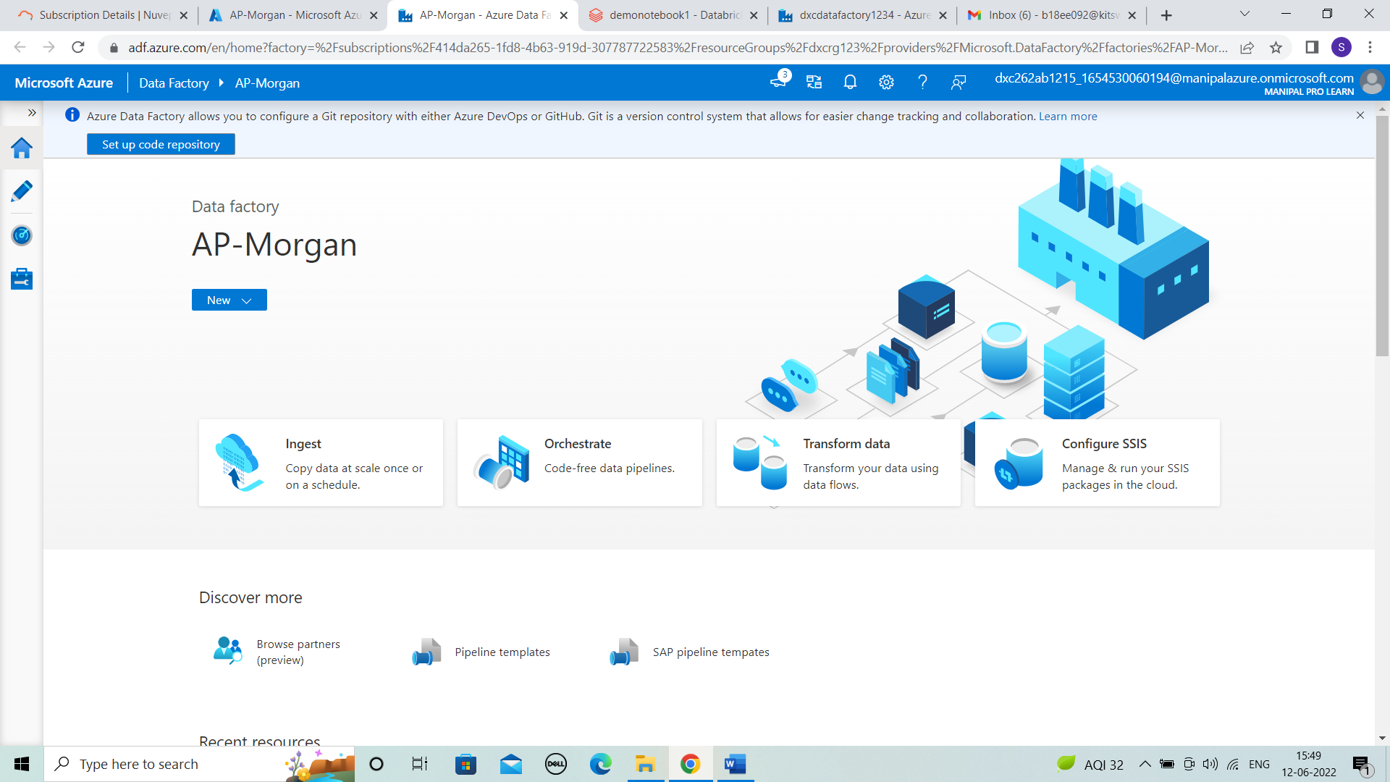



* **Practical Lab: Create Azure Databricks Linked Service in ADF**

**STEP 1:** Click on author .

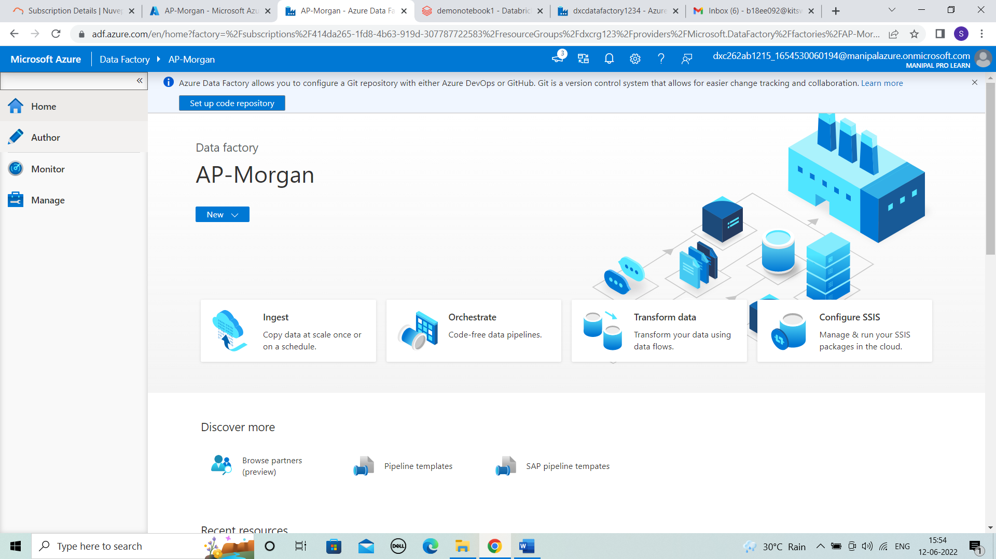



**STEP 2:** In author, click on “+” > pipeline to create a pipeline that will connect Data Bricks notebook with Data Factory.

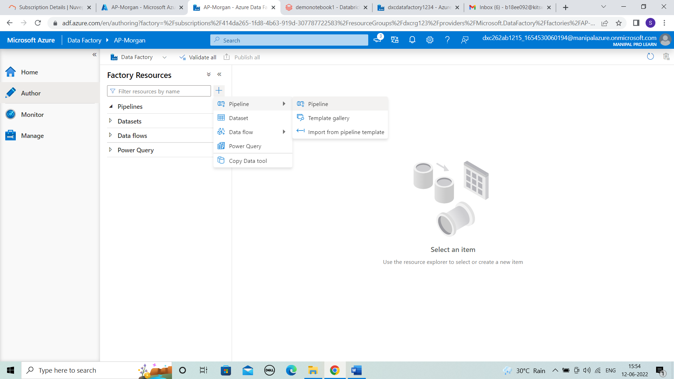



**STEP 3:** Create a pipeline by dragging the notebook from databricks.

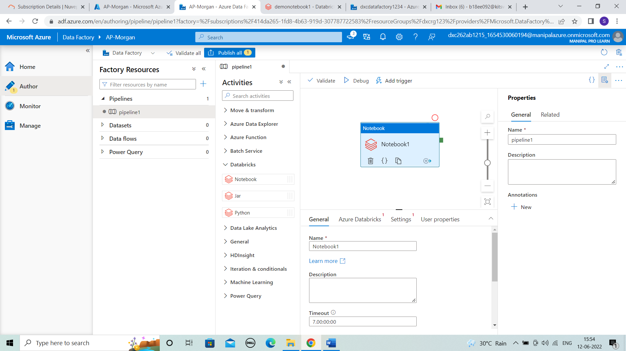



**STEP 4:** In azure databricks we can add new databricks linked service .

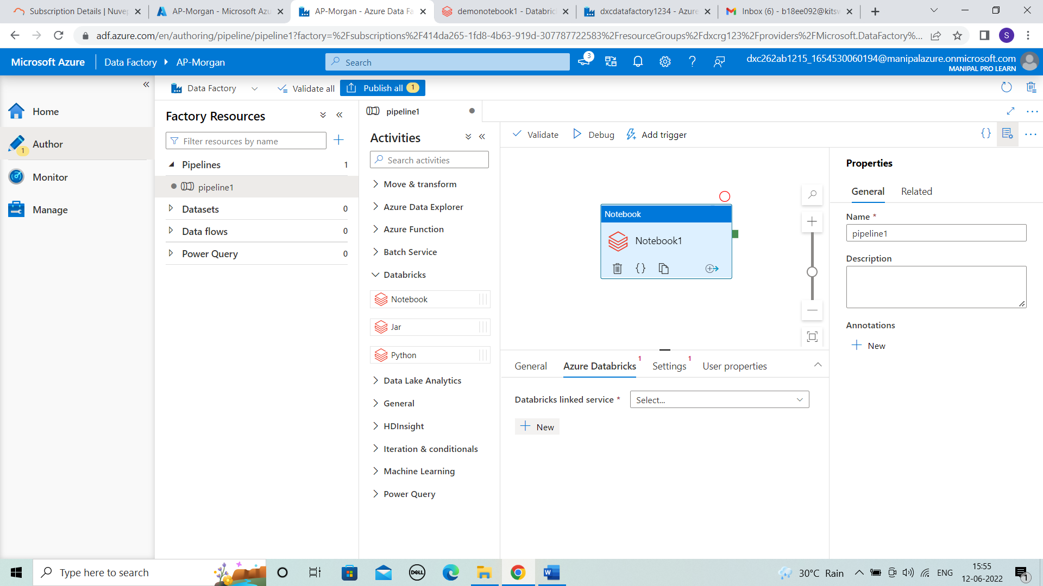



**STEP 5:** In databricks linked service we can enter the details shown and we need the access token.

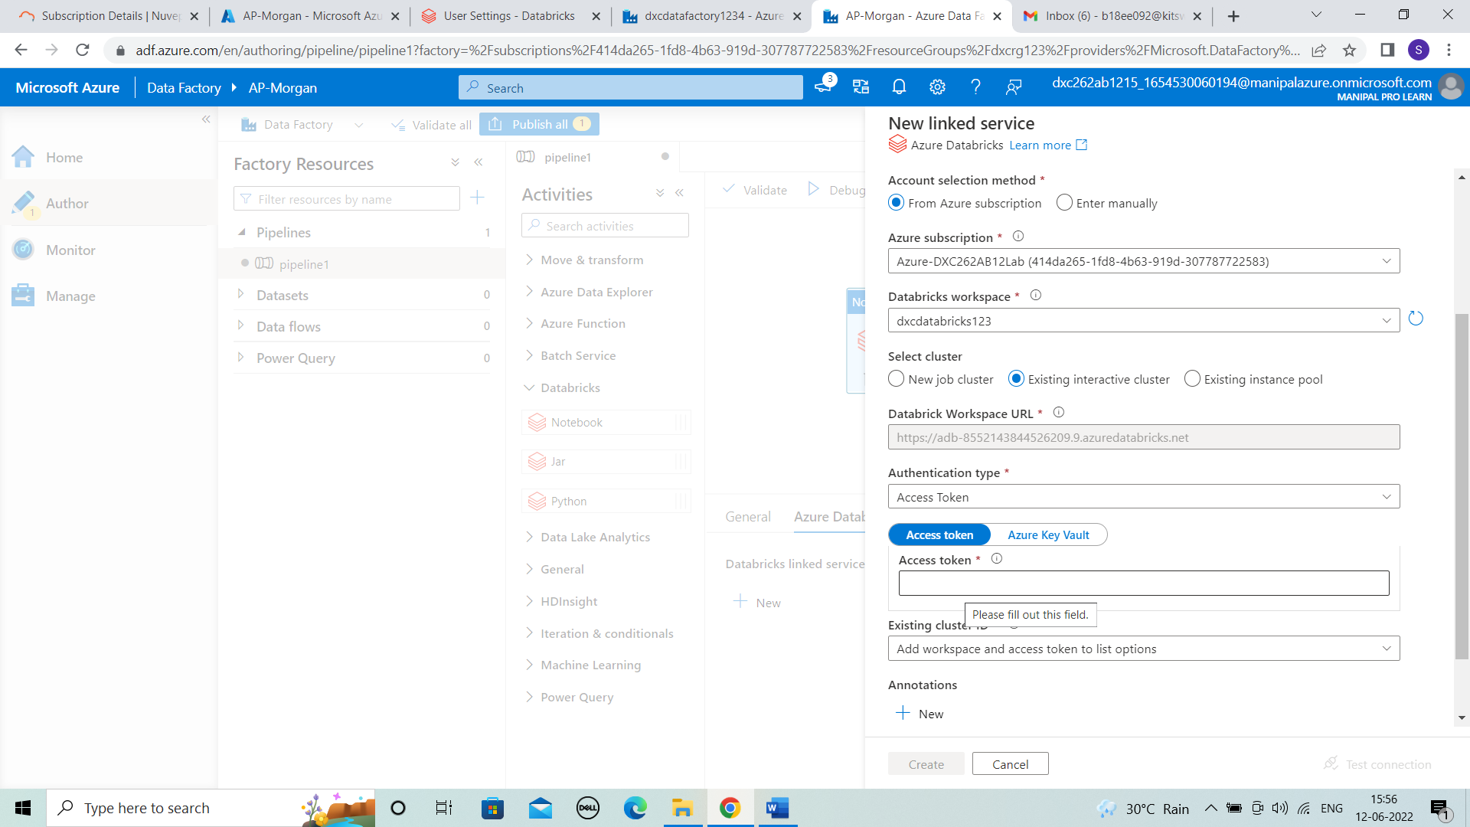



**STEP 6:** To get the token details comeback to databricks and click on settings > Usersettings > generate new token.

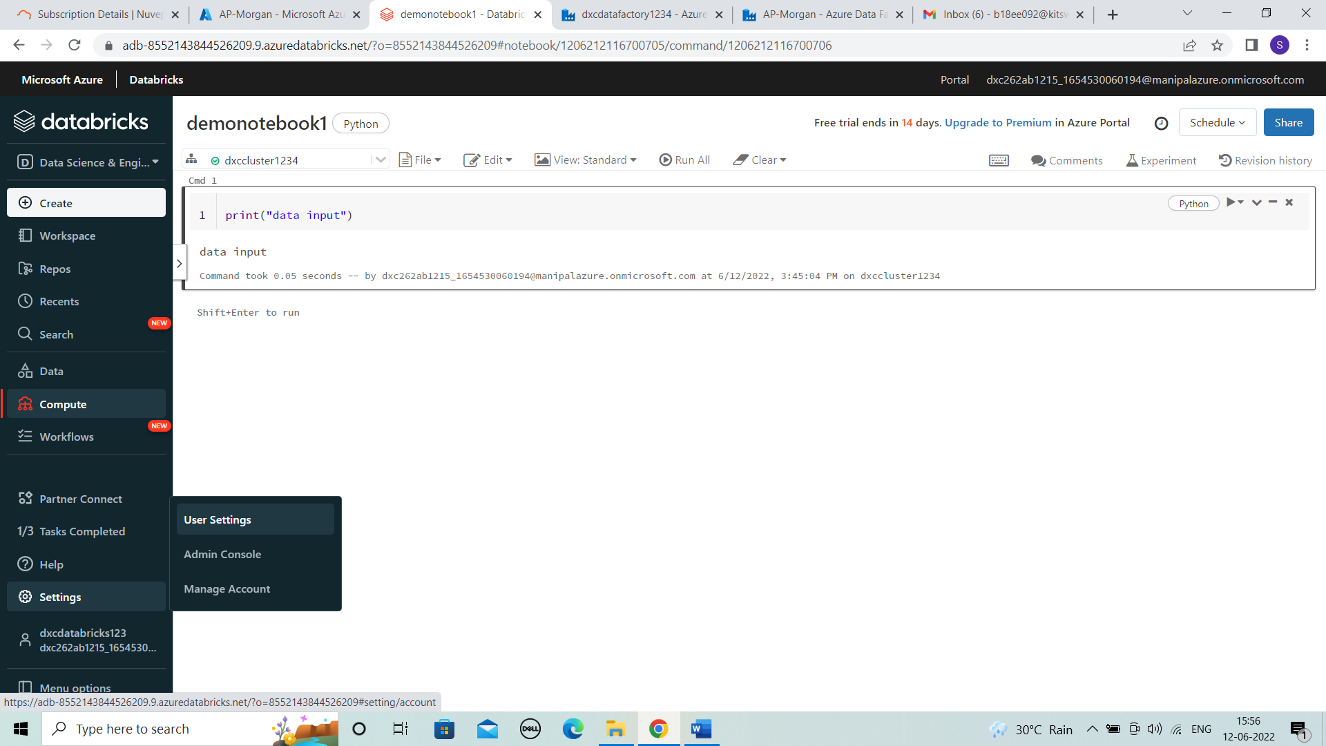



**STEP 7:** Comment the Ap-morgan and lifetime the generate.

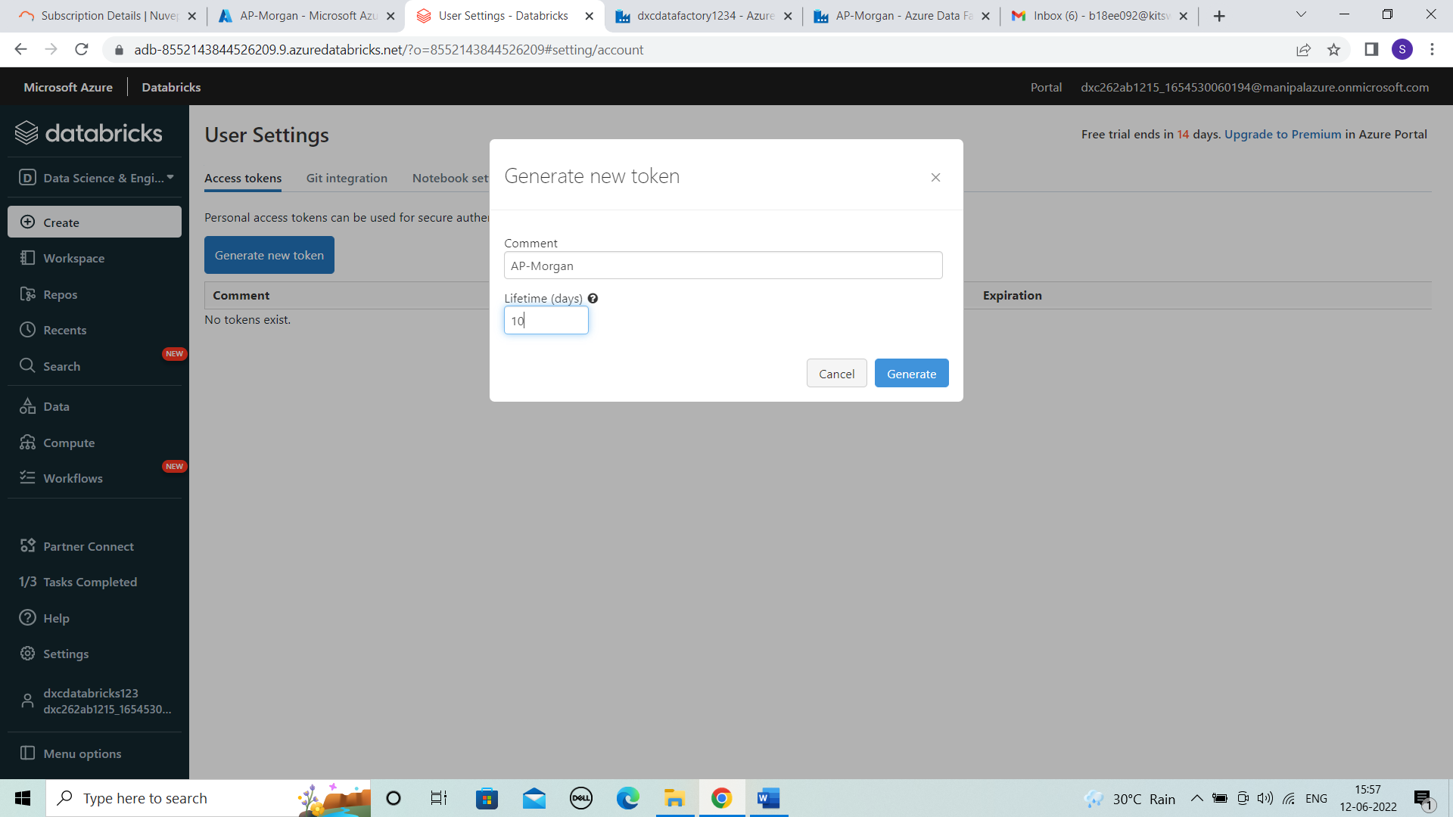



**STEP 8:** We get the token.

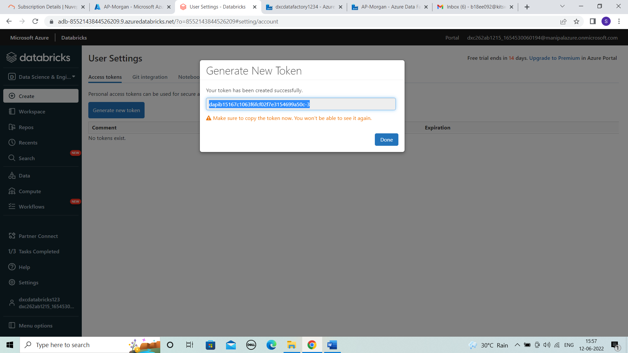



**STEP 9:** Enter the token details in previous new linked service page then test connection.

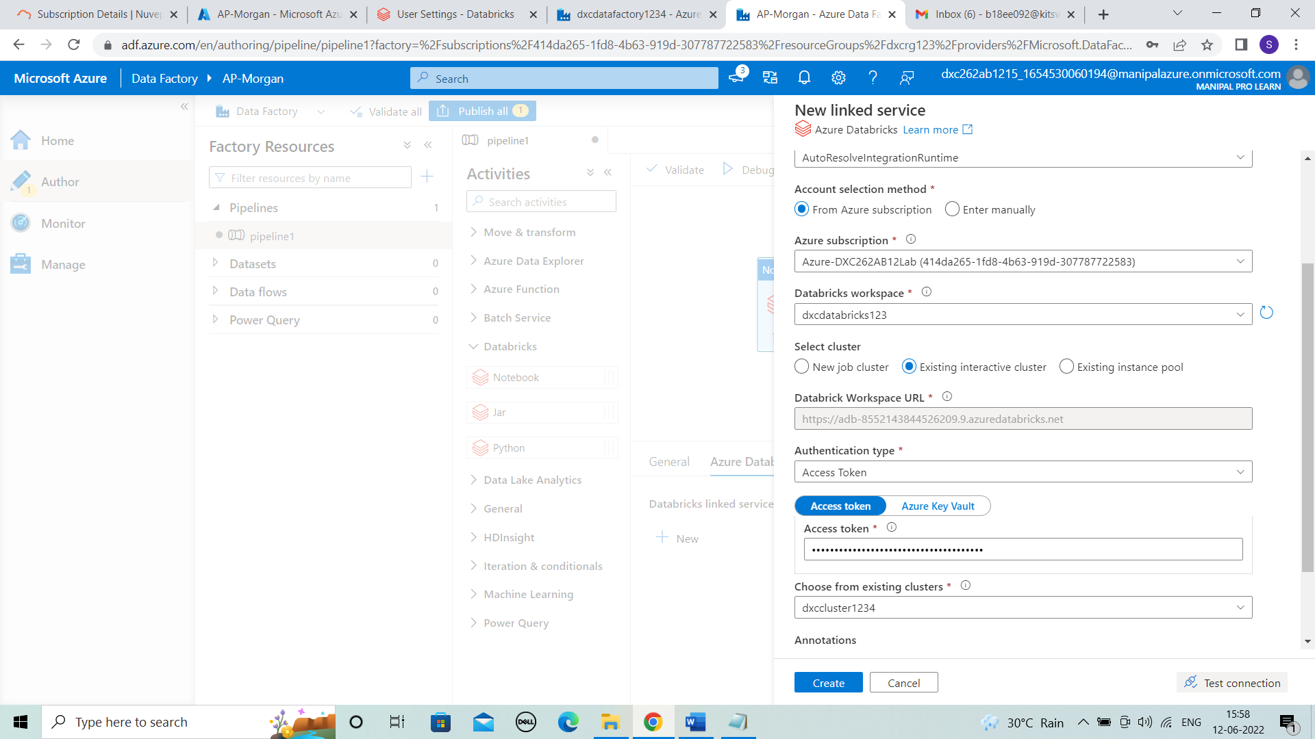



**STEP 10:** After the connection is successful , click on create.

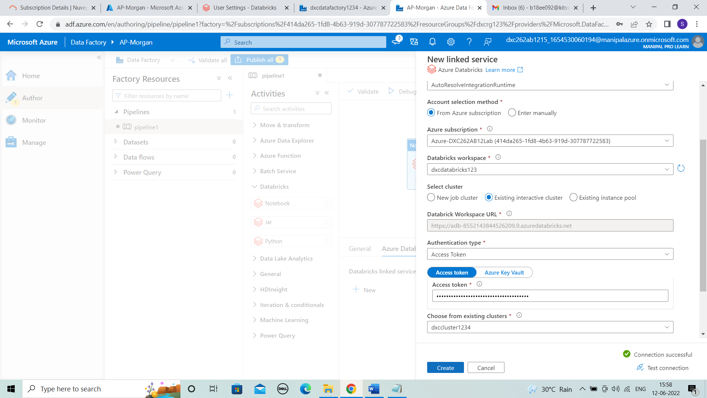



**STEP 11:** It is successfully created then enter the notebook path by browsing.

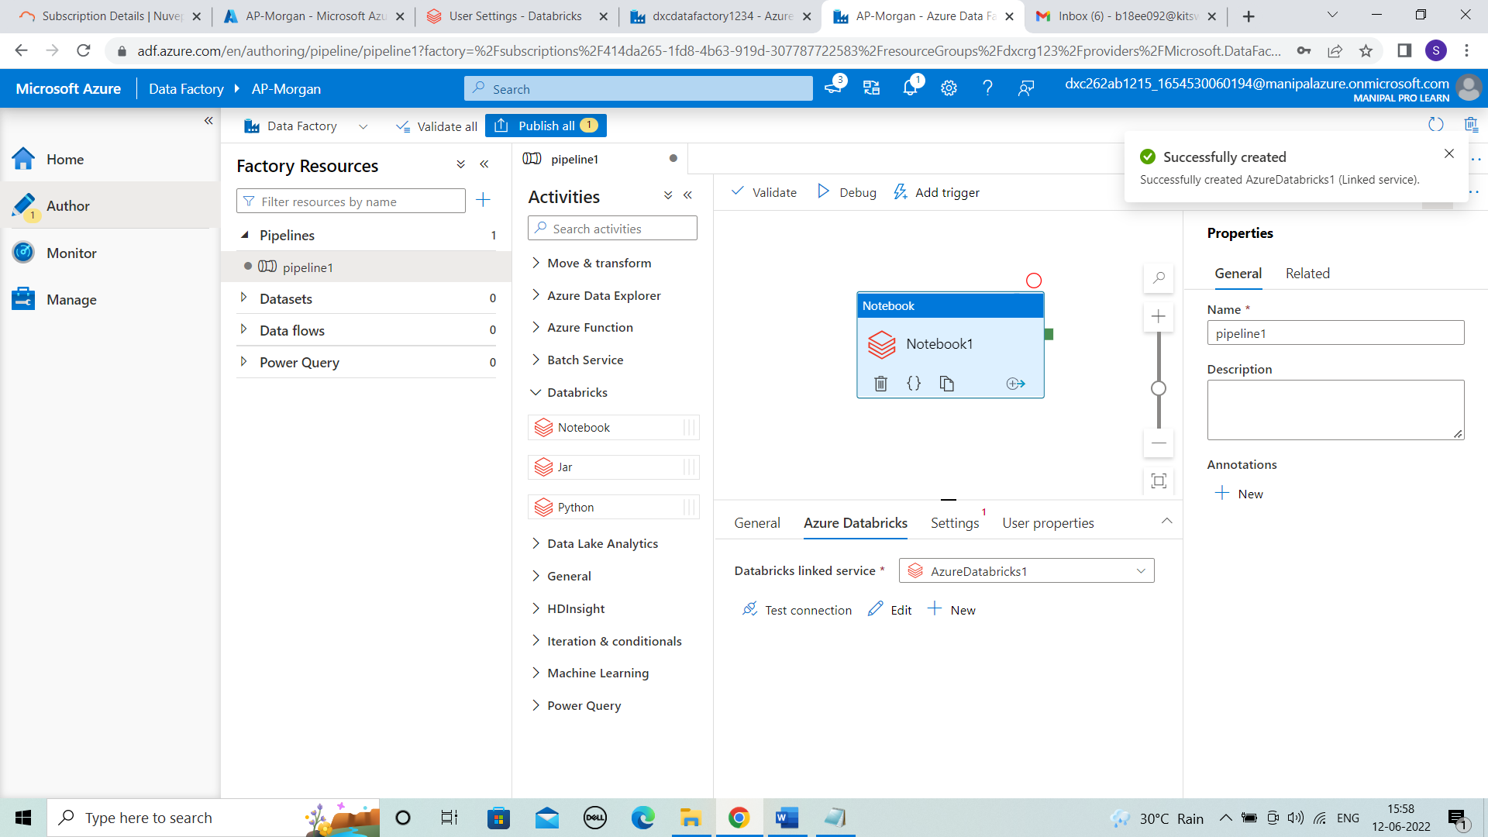



**STEP 12:** Validate the notebook.

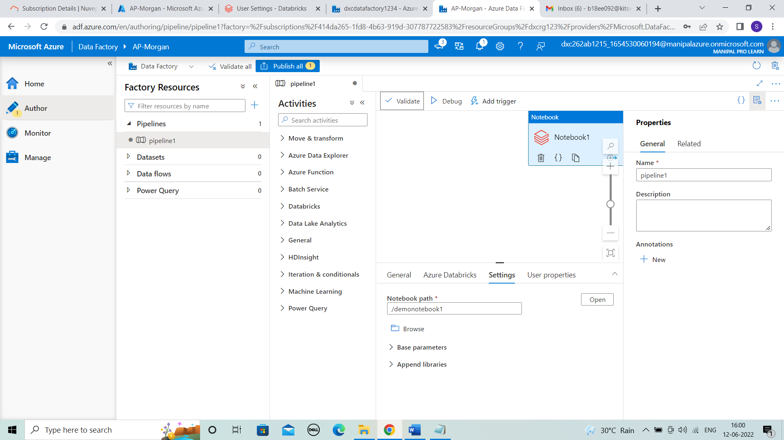



**STEP 13:** After the pipeline is validated click on publish.

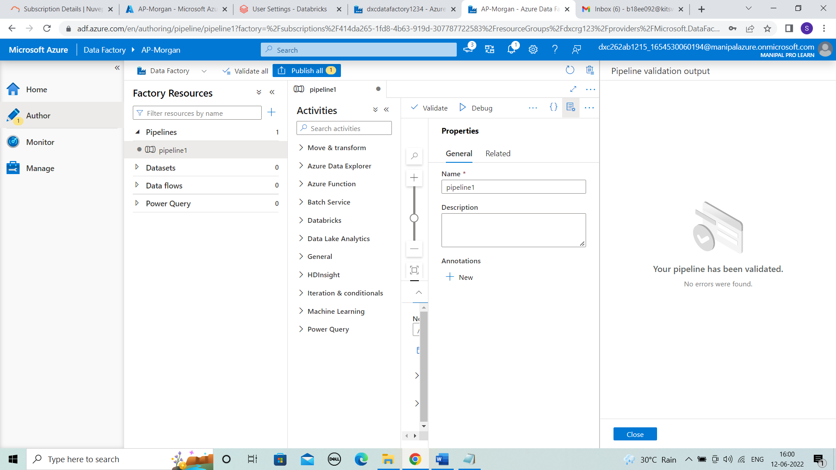



**STEP 14:** The publishing is done .

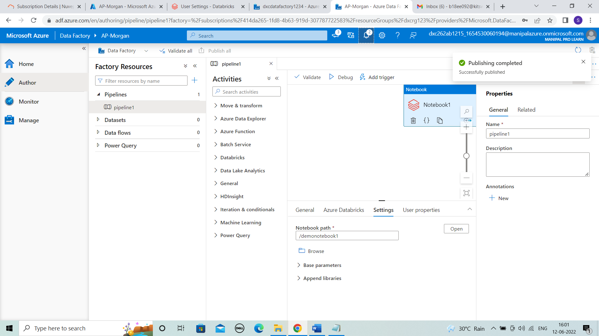



**STEP 15:** Click on trigger > trigger now. The pipeline is successfully ran.

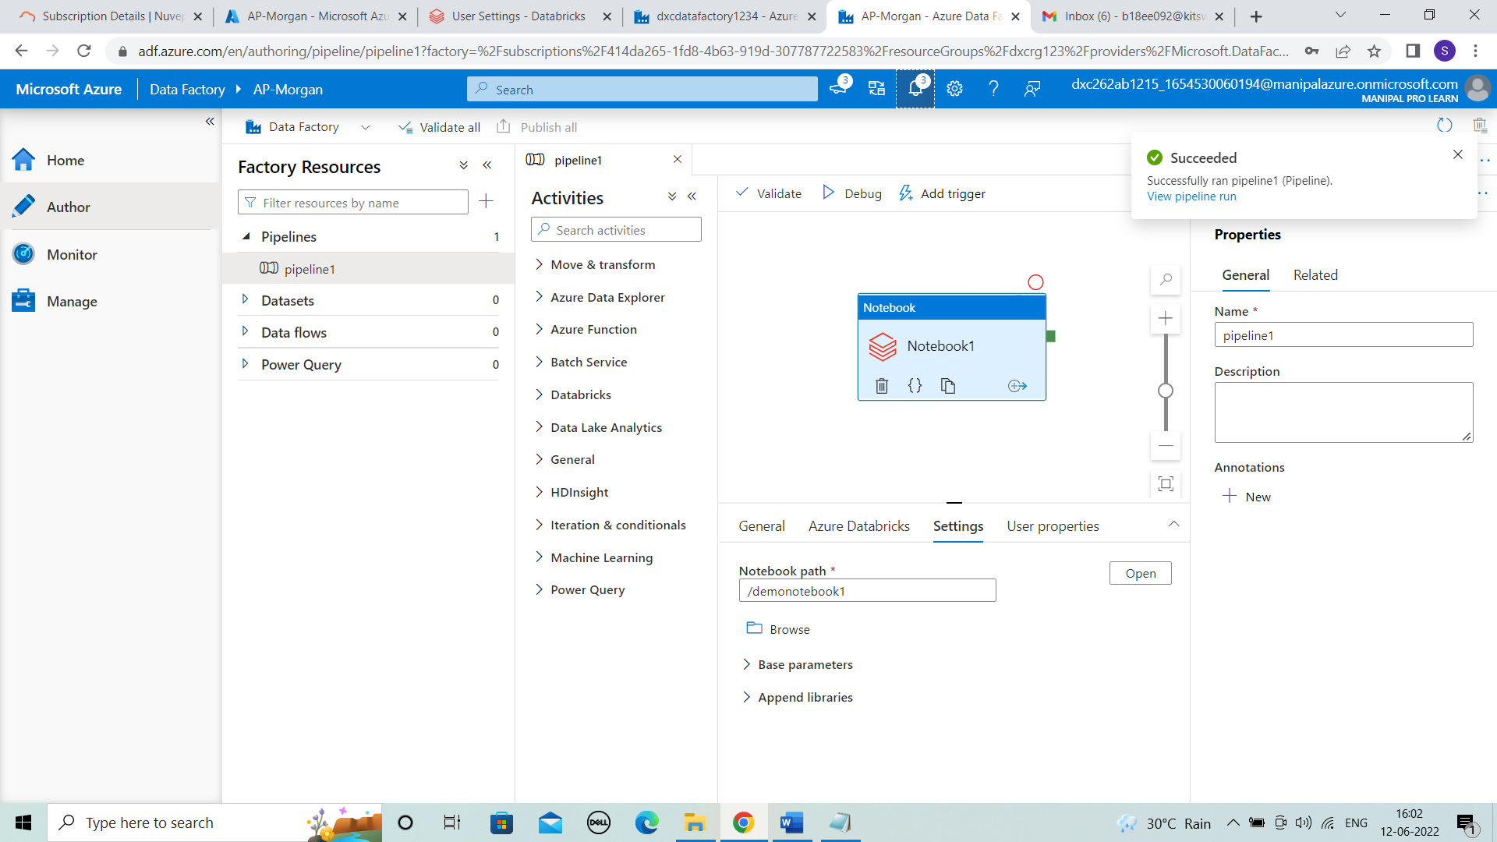



**STEP 16:** We can view the pipeline runs in monitor .

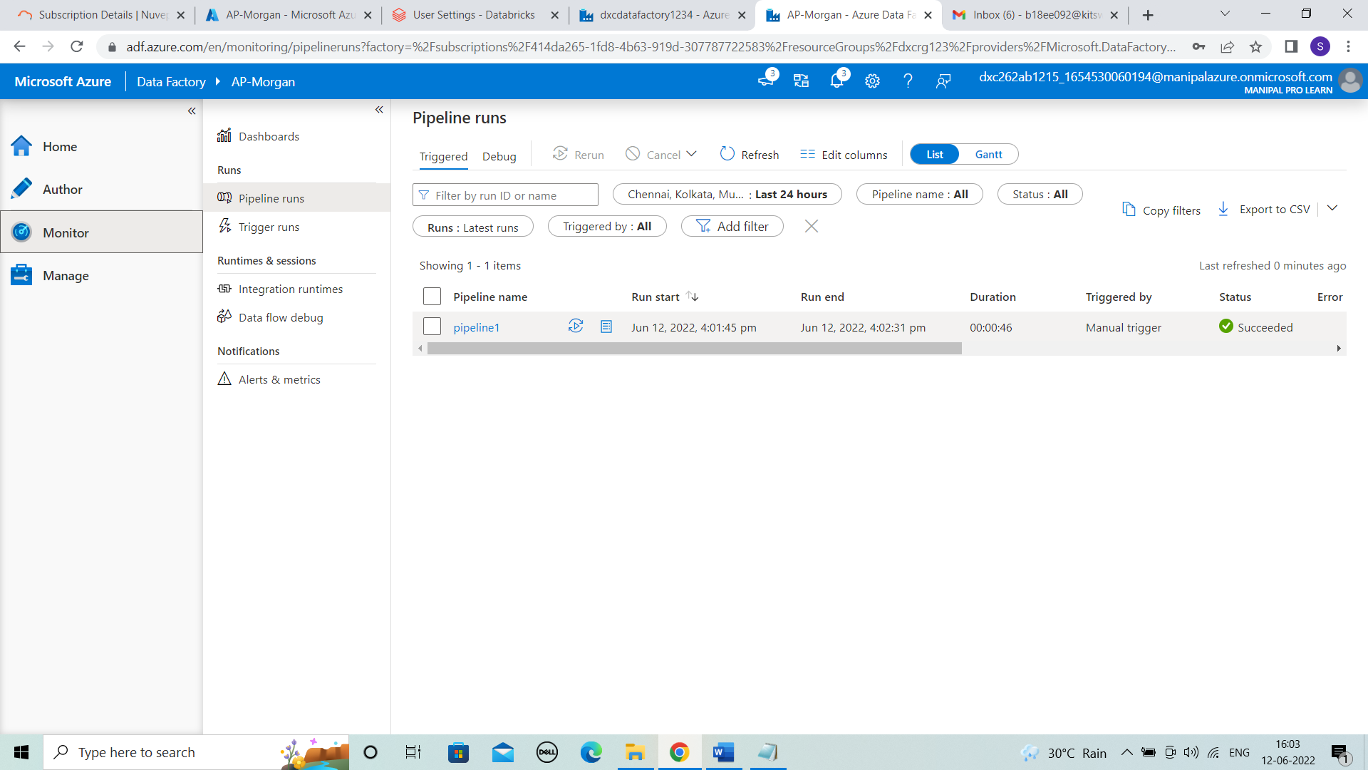



**Result:** In this project 2, We created the azure databricks notebook and linked it to azure datafactory which is named as AP-Morgan.

**Conclusion:** Azure datafactory is linked with the databricks.